

|  |
| --- |
| **Penetration Testing Report**  *This report is being produced for a company that has requested a penetration test to be done on their website, this will go through what vulnerabilities were found and what can be done to fix them.*  **Snow White**  CMP319: Web Application Penetration Testing  BSc Ethical Hacking Year 3  2024/25 |

*Note that Information contained in this document is for educational purposes.*

Abstract

This paper will be about a penetration test on a company's website, to see what vulnerabilities they may have and how these can be rectified. This paper will also include ways to keep the company safe and to mitigate any vulnerabilities they may have on their website.

This paper documents a web application pen test that was performed on the web application Bumtree store to identify any security and functionality flaws. This was carried out by using OWASP Web Security Testing Guide v4.0 and executing these steps defined by the methodology which applied to the scope of this test and the technology that is being used by the web application.

This security test on Bumtree website has identified numerous security flaws/vulnerabilities many of which were severe. This test has concluded that the state of this web application is highly insecure. The flaws that were discovered and their suggested countermeasures have been documented in this report.

Contents

1 Introduction 1

1.1 Background 1

1.2 Aims 2

2 Procedure and Results 3

2.1 Overview of Procedure 3

2.2 Information Gathering 4

2.2.1 Fingerprint Web Server 4

2.2.2 Review Webserver Metafiles for Information Leakage 4

2.2.3 Enumerate Applications on Webserver 6

2.2.4 Review Webpage Content for Information Leakage 6

2.2.5 Identify Application Entry Points 7

2.2.6 Map Execution Paths Through Application 7

2.2.7 Fingerprint Web Application Framework 8

2.3 Configuration and Deployment Management Testing 10

2.3.1 Test Application Platform Configuration 10

2.3.2 Enumerate Infrastructure and Application Interfaces 14

2.3.3 Test HTTP Methods 14

2.3.4 Test HTTP Strict Transport Security 15

2.4 Identity Management Testing 16

2.4.1 Test Role Definitions 16

2.4.2 Test User Registration Process 16

2.4.3 Testing for Weak or Unenforced Username Policy 17

2.4.4 Testing for Account Enumeration and Guessable User Account 20

2.5 Authentication testing 20

2.5.1 Testing for Credentials Transported over an Encrypted Channel 20

2.5.2 Testing for Default Credentials 21

2.5.3 Testing for Weak Lock Out Mechanism 22

2.5.4 Testing for Weak Password Policy 22

2.6 Authorisation Testing 22

2.6.1 Testing Directory Traversal File Include 22

2.6.2 Testing for Insecure Direct Object References 23

2.7 Session Management Testing 23

2.7.1 Testing for Session Management Schema 23

2.7.2 Testing for Cookies Attributes 24

2.7.3 Testing for Session Fixation 25

2.7.4 Testing Session Timeout 26

2.7.5 Testing Session Hijacking 26

2.8 Input Validation testing 30

2.8.1 Testing for Reflected Cross Site Scripting 30

2.8.2 Testing for Stored Cross Site Scripting 31

2.8.3 Testing for SQL Injection – MySQL 32

2.8.4 Testing for Local File Inclusion 34

2.8.5 Testing for Incubated Vulnerability 34

2.9 Testing for error handling 35

2.9.1 Testing for Improper Error Handling 35

2.10 testing for Weak Cryptography 35

2.10.1 Testing for Weak Transport Layer Security 35

2.10.2 Testing for Sensitive Information Sent via Unencrypted Channels 36

2.10.3 Testing for Weak Encryption 36

2.11 Business Logic Testing 37

2.11.1 Test Ability to Forge Requests 37

2.11.2 Test Integrity Checks 37

2.11.3 Test number of Times a Function Can Be Used Limits 38

2.11.4 Test Defenses Against Application Misuse 38

2.11.5 Test Upload of an Unexpected File Types 39

3 Discussion 41

3.1 Vulnerability Disclosure and Countermeasures 41

3.1.1 Robots.txt file Vulnerability 41

3.1.2 Outdated Software and Service Versions 41

3.1.3 Information Leakage from phpinfo () 41

3.1.4 Information Leakage in Code 42

3.1.5 Information Leakage from Listable Directories 42

3.1.6 Information Leakage Upon Incorrect Login 42

3.1.7 Information Leakage from Error Messages 42

3.1.8 No Lockout Policy 42

3.1.9 No/Weak Password Policy 43

3.1.10 No Credential Encryption 43

3.1.11 Reversible and Insecure Cookie 43

3.1.12 Missing Cookie Attributes 44

3.1.13 No Session Timeout 44

3.1.14 Stored Cross Site Scripting 44

3.1.15 SQL Injection Vulnerability 45

3.1.16 File Upload Vulnerability 45

3.1.17 No Integrity Checks 45

3.1.18 No Transport Layer Security/Secure Socket Layer and HTTPS 46

3.1.19 Misconfigured Headers 46

3.1.20 Enable HTTP TRACE Method 47

3.2 Overall Discussion 47

3.3 Future Work 47

4 References 49

Appendices part 1 50

Appendix A – Omitted Methodology 50

Appendix B – Finances Zip File Information 51

Appendix C – Spider Scan Output 142

Appendix D – Dirb Scan Outputs 143

Appendix E – Nikto Scan Outputs 145

Appendix F – OWASP Zap Scan Report 146

# Introduction

## Background

More and more of our lives are going online and into web applications, web application security is a very prevalent topic today.

78% of small business owners in the UK currently have a website for their business. 69% of businesses who don't have a website think they should have one (Haan, 2024). As shown in the Figure below Forbes small business website statistics.

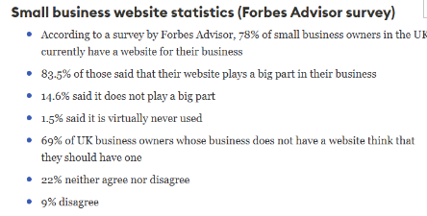 Figure 1 – Image from Forbes Top website Statistics for 2024

Over 1.1 billion websites are estimated to exist, approximately only 17.32% are active (Cardillo, 2024). With this number of websites this raises the possibility of existing vulnerabilities that can be used in cyber-attacks. To avoid these cyber-attacks, it is important to ensure that the application is not vulnerable to any of these vulnerabilities.

Performing web application penetration tests is very important. It aims to evaluate the security of applications by launching a simulated attack on them and attempting to gain access to any sensitive data. This means that any vulnerabilities present can be identified and patched before they can be exploited by a threat actor. The process for penetration testing follows a set outline of information gathering ,research ,exploitation and reporting. There are various methodologies that are being used within the industry to perform security evaluations on web applications. OWASP’s Top Ten can help in identifying what to look for during the testing process. Penetration tests are conducted by professionals and are commonly known to be anything between 3 to 14 days but differ depending on the size of the test.

## Aims

The aims of this project are to perform a penetration test on Rick Astley’s Bumtree web application and report the findings and the countermeasures of any vulnerabilities found.

To achieve this, the following will be involved:

* Following the stages of a web penetration test methodology
* Executing each step on the target web application
* Document the outcomes of each stage
* Disclose any identified vulnerabilities and their countermeasures.

# Procedure and Results

## Overview of Procedure

For this penetration test, the tester is going to use the OWASP Web Security Testing Guide v4.0 (OWASP, n.d.) for the methodology. Version 4.0 was the latest stable version released at the time of writing this report, the stable version was chosen over the more up to date version as issues could arise in the methodology during the process of the test.

This methodology was chosen as it provides a thorough pathway of steps for the tester as well as it is accredited and from a reputable institution.

This methodology has 12 steps, and they are:

1. Information Gathering
2. Configuration and Deploy Management Testing
3. Identity Management Testing
4. Authentication Testing
5. Authorization Testing
6. Session Management Testing
7. Input Validation Testing
8. Error Handling
9. Cryptography
10. Business Logic Testing
11. Client-Side Testing
12. API Testing

These stages are split into smaller steps to evaluate specific elements of the web application design more accurately, the steps are then followed lastly by the report. There are parts of the methodology that do not fit within the scope of the test that has been given, therefore some parts were excluded from the testing process. The omitted steps are specified in Appendix A – Omitted Methodology.

From section 2.2 onwards, the subsections of Procedure and Results will document the completed stages and their subdivisions identified by the OWASP Web Security Testing Guide. This will include the actions completed and their outcomes.

The tools that were used to reach the aims for this pen test are as follows:

* Kali Linux
* Curl
* Dirb
* Nikto
* OWASP Zap
* OWASP Mantra
* CyberChef
* SQLMap

## Information Gathering

### Fingerprint Web Server

The tester is starting with Fingerprinting the web server and the first thing is to identify the software specification of the server that the target is running on. To be able to achieve this, the tester would normally run a few automatic testing tools such as nmap,Nikto etc.

In this test , the tester ran a nmap command , which is the industry standard networking map software , with the -sV flag , which will display the services running on the target host device.

As shown in the below image , the command shows that the target web server is running a Unix based system with 3 services

* File Transfer Protocol using ProFTPD 1.3.4a on port 21
* Hypertext Transfer Protocol using Apache 2.4.3 with PHP/5.4.7
* 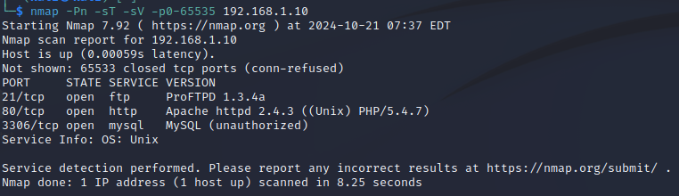 MySQL , on port 3306

Figure 1 . the output from the -sV command

From the information gained from this scan , the tester can refine possibilities for exploitation in the later stages.

### Review Webserver Metafiles for Information Leakage

In this stage the tester is checking the meta files of the website which are the files that describe the site itself. The primary metafile of note in most sites is the “robots.txt” file , which specifies which files and directories should or should not be indexed in search engines. The robot.txt file for the client’s site is accessible by appending the end of the url to “/robots.txt”.

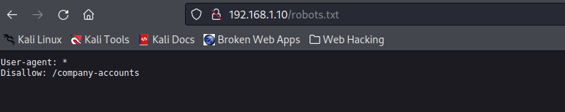 Figure 2 – Image of the “Robots.txt” on the url 192.168.1.10

As shown in the above Figure 2 , the “Robots.txt” , the only one that is disallowed is “company-accounts” which when navigated to displays a directory with finances.zip and a readme.txt as shown in Figure 2.1 below.

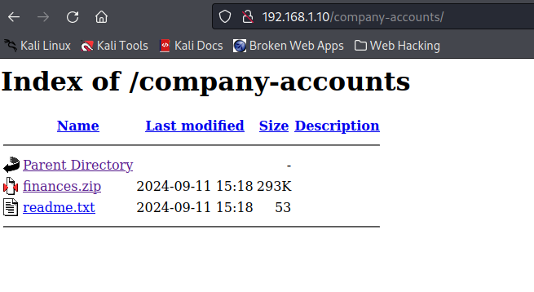

Figure 2.1 – Image of the company-accounts page

When the finances.zip is downloaded , and the files extracted in the below Figure 2.2 this is a list of the files.

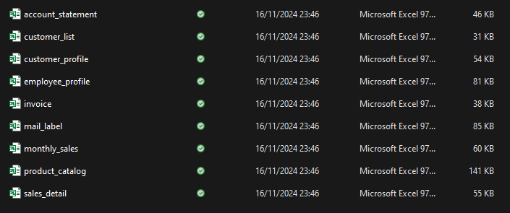

Figure 2.2 – Image of extracted Finances zip folder

The full images of the files can be seen in Appendix B - Finances Zip File Information.

### Enumerate Applications on Webserver

This stage is like the stage above in the fingerprint section , whereby the tester was trying to determine what applications were present on the server , to see if there any nonstandard ports being used etc. Because of this a similar scan was run , which can be seen in Figure 3 below.

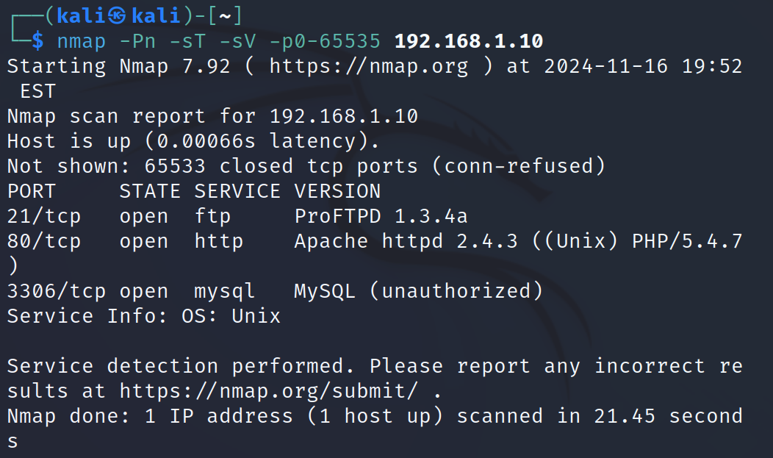Figure 3 – Image of the nmap scan run

There have been no changes from the previous scan that were detected despite the fact the scope on this scan was much wider, as a result the tester can say that these are the only external services running on the web host server.

### Review Webpage Content for Information Leakage

In this part of the test, the tester is going to be going through the code of the website to look for any information that could be leaked through comments in the code or in the metadata.

Commenting code is best practice in most cases, however leaving them up publicity can cause some serious harm.

An issue was found that when clicking on the category pages for Computers (http://192.168.1.10/categories.php?pageid=9), Cell Phone (http://192.168.1.10/categories.php?pageid=10) , Others(192.168.1.10/categories.php?pageid=11) in the code there was a comment mentioning an info.php page as shown in Figure 4 below.

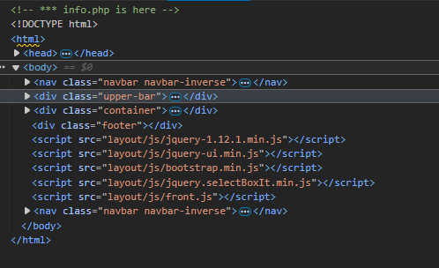  
Figure 4 – Image of the comment about info.php

### Identify Application Entry Points

At this stage of the test, the tester found it was necessary to gain information about all the possible entry points of the application i.e. places in which it is possible to enter user data. To be able to enumerate these input forms the tester conducted a manual search of the site as well as using OWASP zap to check for GET and POST requests from the fields.

The places that the tester found where this is possible are as follows:

|  |  |
| --- | --- |
| Data Entry | Input Fields |
| Login Prompt | Username, Password |
| Sign Up Page | Username, Complex password, re-type password, valid email |
| Edit Profile | Username, email, full name and profile image |
| Change Password | Old Password, New Password |
| Edit your items | Name, Description, Price, Condition, Category, Tags |
| Reply to message | Comment |
| Add new item | Name, Description, Price, Condition, Category, Tags |

### Map Execution Paths Through Application

To be able to gain a full understanding of the structure of the website, it was necessary for the tester to map this out. This was done using the tool OWASP Zap. This tool will allow the tester to find a full list of URLs associated with a specific domain which is 192.168.1.10 using the inbuilt spider tool.

The tool found 78 URLS, which can be found in full in Appendix C – Spider Scan Output. The next tool that was used was called Dirb which launches a dictionary-based attack against the site to detect any previously hidden web objects not yet identified. A small section of this scan can be seen in Figure 5 below.

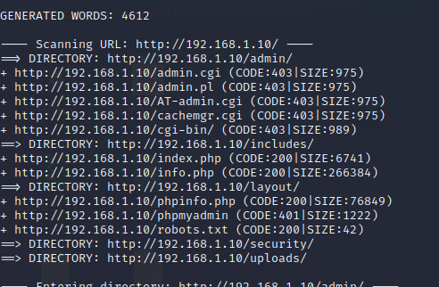 Figure 5 - Image of Dirb scan

The full output from the Dirb scan can be seen in Appendix D – Dirb Output. The next scan to be run was by a tool called Nikto which discovers vulnerabilities on the server but in this instance is being used to provide the tester with wider coverage. The full results of this scan will be in Appendix E – Nikto Scan Output but a small section will be shown below in Figure 5.1.

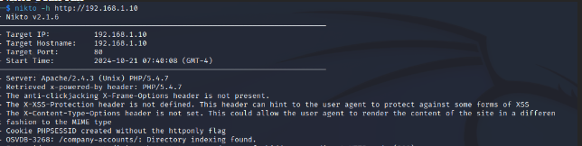Figure 5.1 - Small section of Nikto Scan

### Fingerprint Web Application Framework

In this last step of the information gathering phase of the methodology, this is a crucial step in the penetration test, which is to fingerprint the target, this is the process in which information is collected about the target system.

The tester used the curl command which is curl -I <http://192.168.1.10> to get header information from the web site address , by using this command the tester has managed to see that there is a presence of the X-Powered-By header which reveals the configuration of the server as shown in the Figure 6 below.

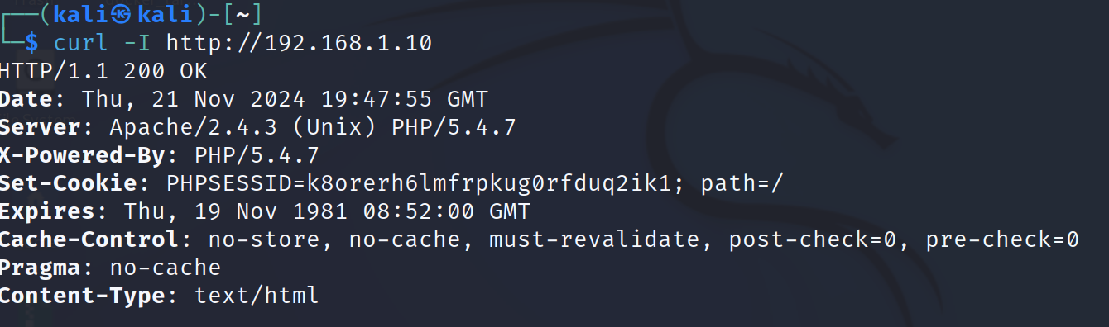Figure 6 – Image of the curl command used

As was done in the previous section , there was a Nikto scan ran which can be seen in full in Appendix E- Nikto Scan Output which has revealed other issues such as the lack of X-XSS-Protection , the anti-clickjacking X-Frame-Options is not present. , the X-Content-Type-Options as well as many other issues are shown in Figure 7 below.

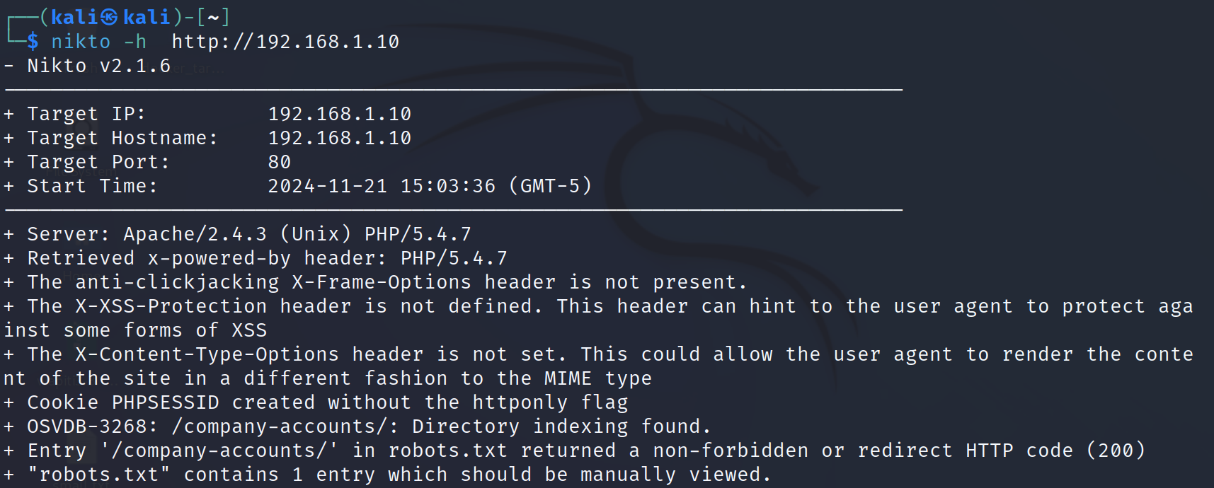Figure 7 – Image of Nikto Scan

Additionally, the tester also made use of a tool called whatweb , which is designed to identify services running for a website , this revealed the site is running jQuery 1.12.1 , PHP 5.4.7 amongst other information as shown in the Figure 8 below.

Figure 8 – Screenshot of the whatweb tool

## Configuration and Deployment Management Testing

### Test Application Platform Configuration

In this stage , it concerns three things the presence or the lack of defaults and known files , if there are any debugging files and/or extensions used in development and a review of the logging mechanisms within the application.

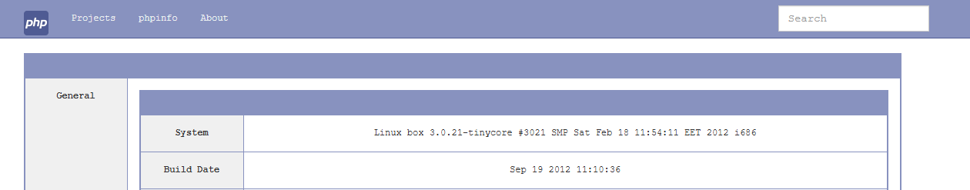The logging mechanisms are examined , and it is confirmed there is no debugging code present. It has been discovered that 192.168.1.10/info.php is easily accessed by the public and contains a lot of system information regarding the PHP and HTTP configuration as well as the operating system and software versions in use. Shown in Figure 8 and 8.1 can be seen info about the HTTP and PHP.

Figure 8 – System info visible in the info.php page

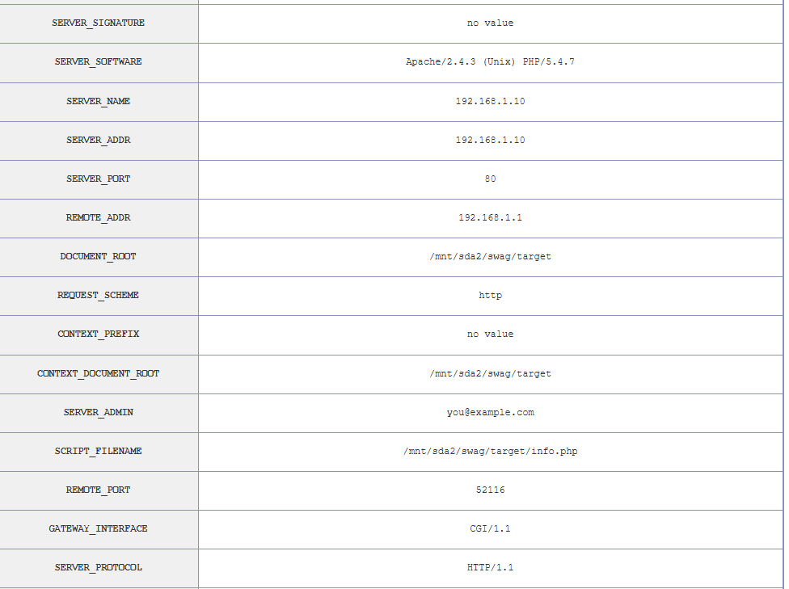 Figure 8.1 - More info from info.php

The Dirb and Nikto scans (Appendix D – Dirb Scans and Appendix E – Nikto Scans) that were conducted in the previous area managed to identify listable directories on the website that could leak possible sensitive information.

The Nikto tool shows that there are platform configuration errors that leave the target open to exploit , as the one shown below in Figure 9 allows for easy brute force filenames

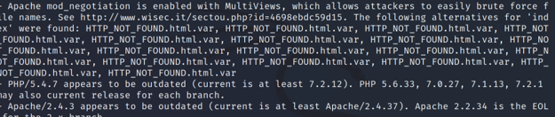Figure 9 – Image from Nikto scan

In the Dirb Scan , it shows the tester all the directories that can be found a couple that were found of interest were the /uploads , /includes, /layout , /security , /admin and /security.

In the /uploads folder , the tester was able to see folders for image uploads and another for avatars which is publicly accessible as shown in Figure 10 – 10.2 below.

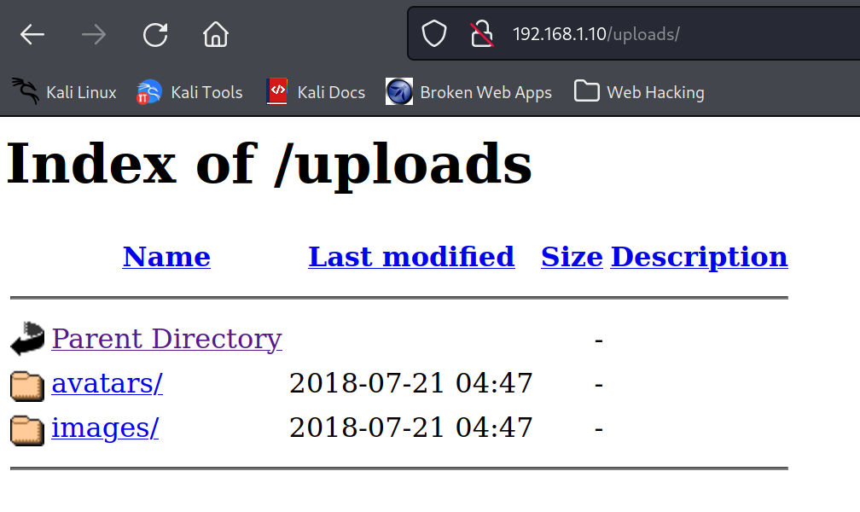Figure 10 - Image of the /uploads folder

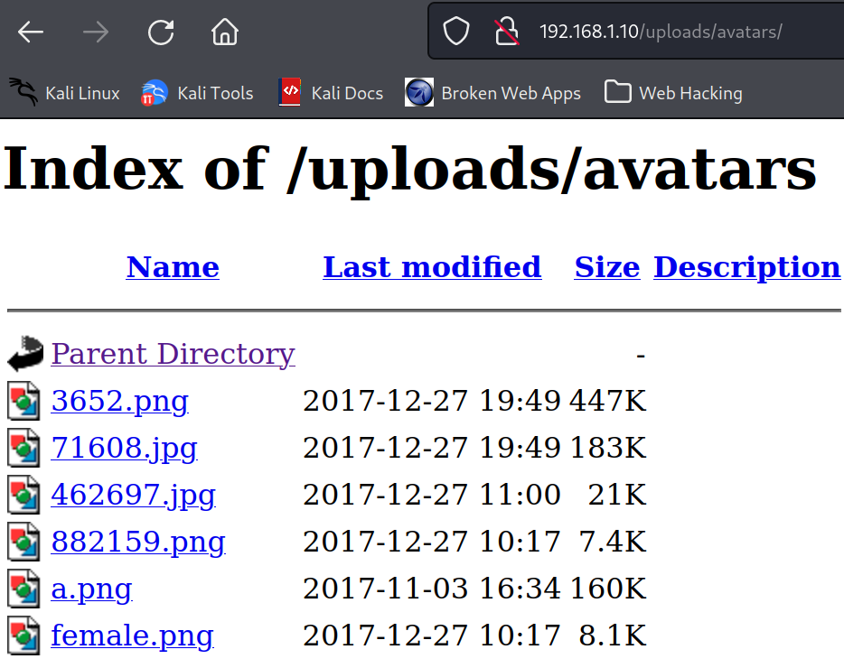Figure 10.1 – Image /uploads/avatars folder

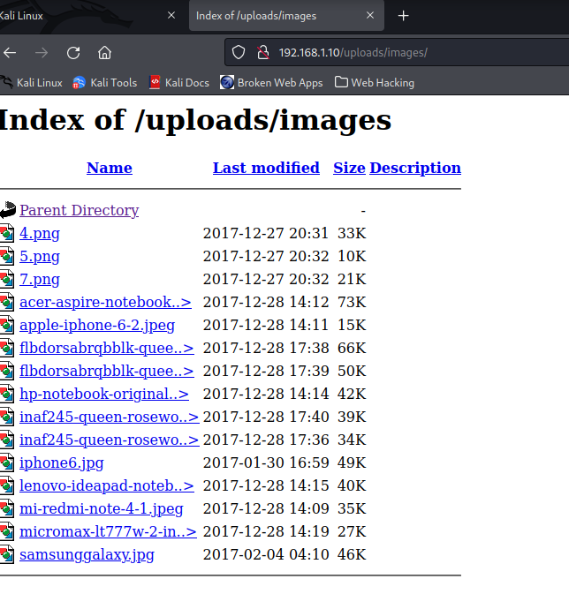 Figure 10.2 – Image of the /uploads/images folder

After these scans were performed the tester used a tool called OWASP Zap to perform an “active scan” and an “spider” against the target , this confirmed the vulnerabilities found by the Nikto scan and providing the tester with more information and context on each vulnerabilities found. Information from those scans can be seen in Figure 11 below a full report can be found in Appendix F – OWASP Zap Scan Report.

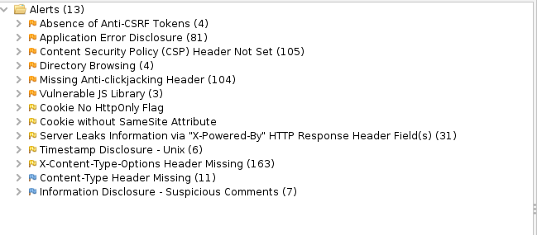Figure 11 – Image after an Active Scan and Spider attack was run using OWASP Zap

### Enumerate Infrastructure and Application Interfaces

As shown in the dirb scan , it was found to have an /admin section. When navigating to 192.168.1.10/admin it brings the tester to an admin login page as shown in Figure 12 below.

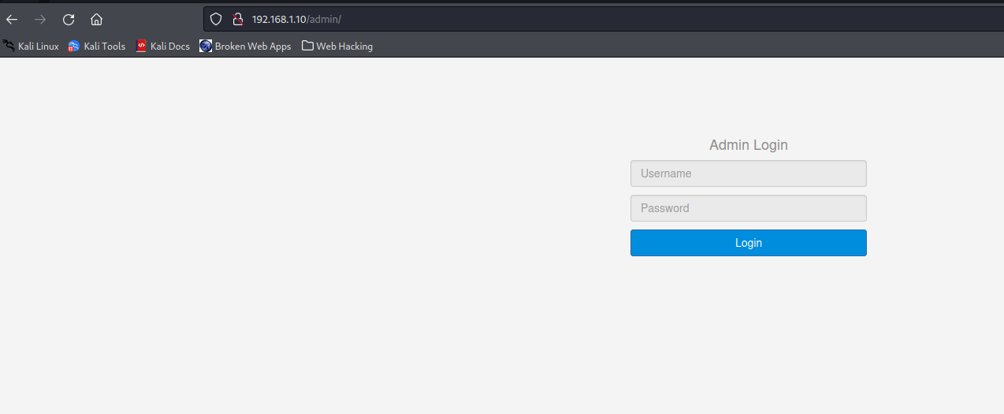Figure 12 – Admin login

### Test HTTP Methods

The next thing the tester checked was the supported HTTP methods by running another nmap scan against the target. This revealed to the tester that GET, HEAD, POST and OPTIONS methods are supported as shown in Figure 13 below. By doing a curl -v -X TRACE <http://192.168.1.10> was able to find out that TRACE was enable which can be seen in Figure 13.1 below 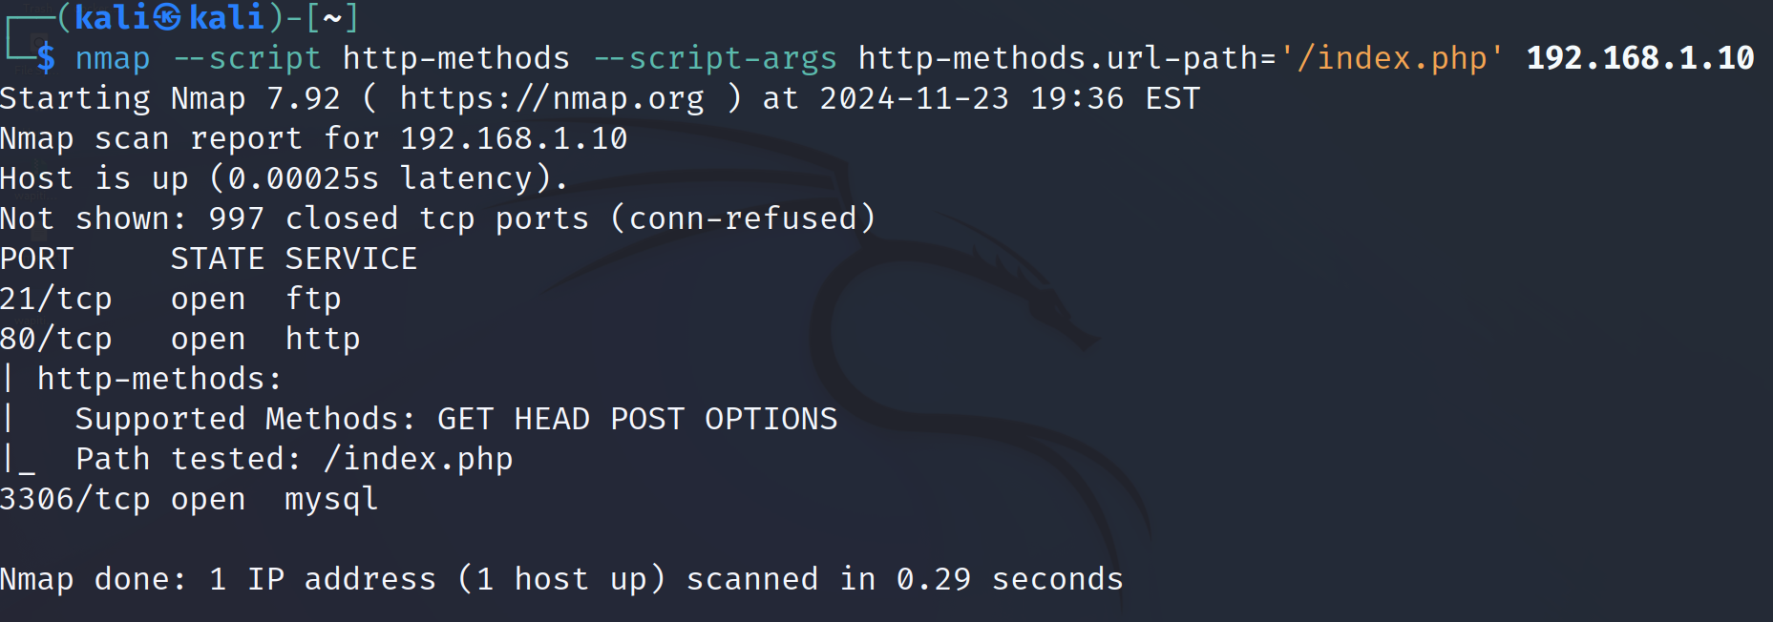 Figure 13 – Image of Nmap scan for the http methods

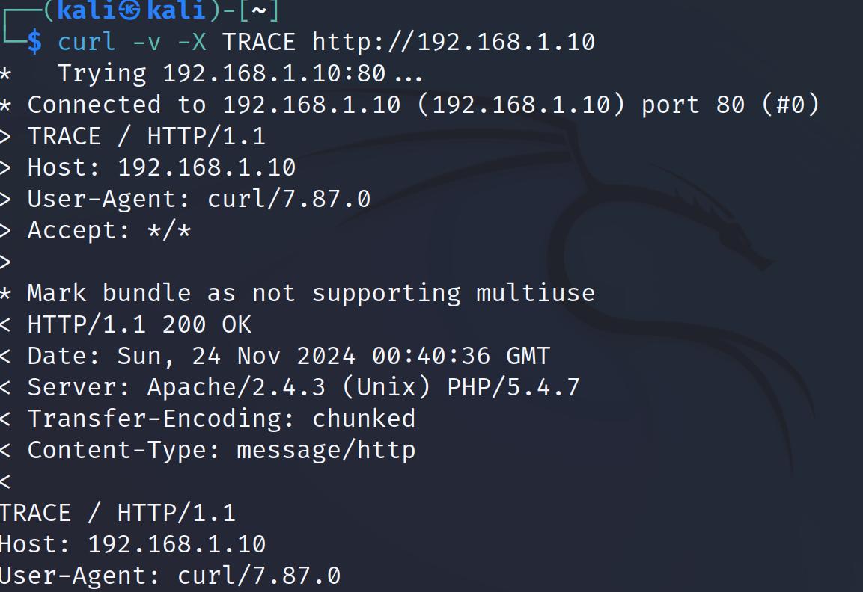Figure 13.1 – Image of curl command for TRACE

### Test HTTP Strict Transport Security

In this step , the tester tested whether the HSTS header , which lets web applications notify the browser that it should establish all connection requests to access the site through HTTPS, is present. This was done by using Curl as shown below in Figure 14 there is no HSTS header present because no information was output to the terminal. If the HSTS banner had been set up, this would have returned information about its configuration to the terminal.

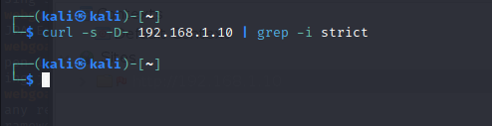 Figure 14 – Curl tested the HSTS

## Identity Management Testing

### Test Role Definitions

During this stage , the roles that are used by the application were identified, by finding the presence of an administrator and user login forms which are :

* Administrator
* Customer

With an Administrator account (section 2.8.3) it can be determined that shop items can be edited and accounts as well as removing existing user accounts.

### Test User Registration Process

The signup form for this web application requires username, a complex password , re-type password and a valid email address. For testing purposes, a new account was made as shown in Figure 15 below , the input information was accepted and a response from the server was seen in Figure 15.1 below.

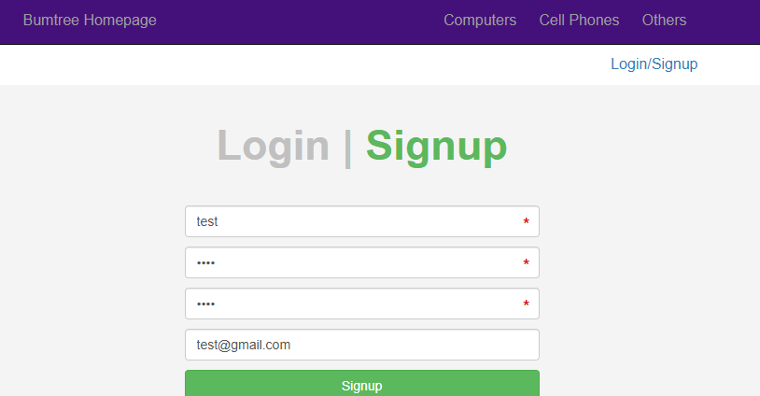Figure 15 – Signup form with new account information inputted

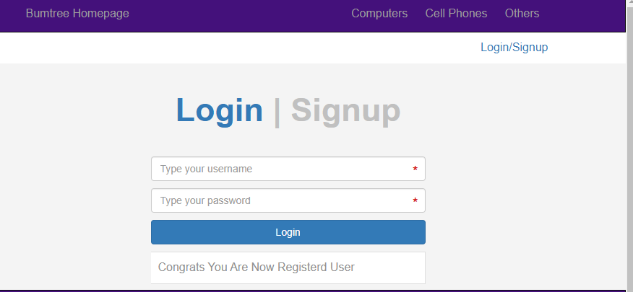Figure 15.1 – Server response after a successful signup

It was then possible to sign in with this new account, the email did not require verification, and the password test was accepted . Password policies will be discussed in a later section. Trying to create another account with the same username prompted this response from the server seen in Figure 15.2 below which means that the provided username is tested for uniqueness.

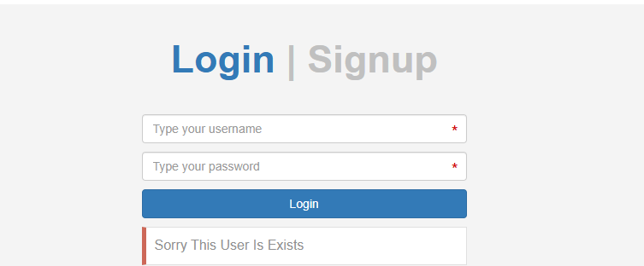Figure 15.2 Server response to registration with an existing username

### Testing for Weak or Unenforced Username Policy

When creating a new account there is no visible information informing the user that there are restrictions on user input. As a result of this the tester decide to create a new user account with the details :

Username: b

Password : test

Email : [test2@gmail.com](mailto:test2@gmail.com)

In Figure 16-16.5 you can see that you need to input a minimum of 4 characters to be able to create a user account, once the account with bbbb has been created it is possible to sign into that account.

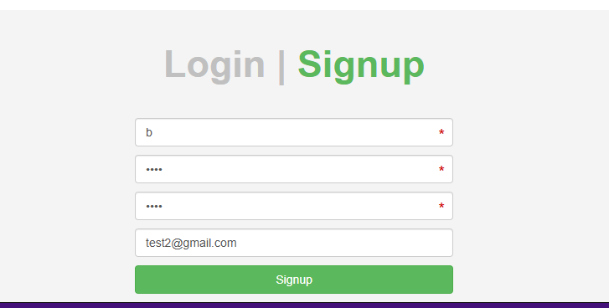 Figure 16 – trying to create an account with b

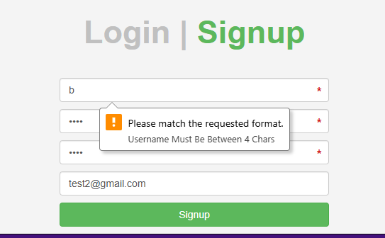 Figure 16.1 – The signup form error

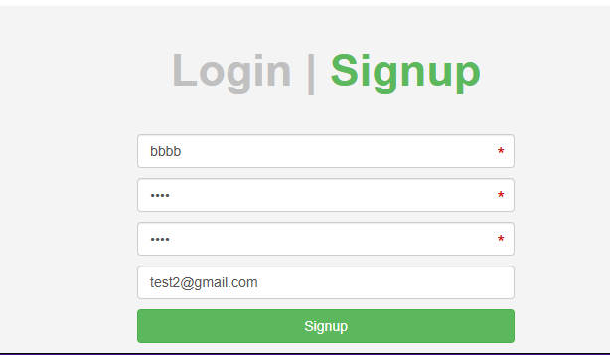 Figure 16.2 – Creating the account with bbbb instead of b

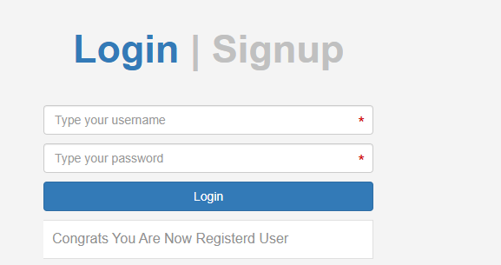 Figure 16.3 – Successful account creation

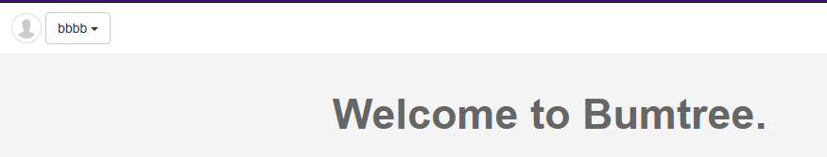Figure 16.4 – Logged in with account bbbb

### Testing for Account Enumeration and Guessable User Account

The accounts on this web application can be enumerated based on the returned error message in the case of an unsuccessful login. When logging in as an existing user with an incorrect password there is no message to screen to say that an incorrect password was entered it will just reload the page.

However, when you input an incorrect username there is an error message that pops up on the screen as shown in Figure 17 below.

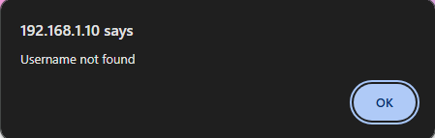 Figure 17 – Incorrect username and password

With these different responses it means that existing users could be enumerated through the login functionality.

## Authentication testing

### Testing for Credentials Transported over an Encrypted Channel

In this stage the tester is aiming to assess whether the web application causes the server or client to exchange credentials without encryption. One of the observations is that the site URLs were prefixed with HTTP as opposed to HTTPS and the browser was issuing warnings that the site was not secure for this reason.

The tester first checked the scale of the h issue by using a curl command which tests the login area of the site , the output of this can be seen in Figure 18 below. The -kis flag allows for insecure connections , includes HTTP response headers in the output and does not show any errors or progress messages. In this the presence of the unencrypted PHPSESSID and the lack of the secure flag permitting it to be transported over SSL connection. This can allow for user’s sessions to be hijacked and data to be stolen. In addition to this , during the login process the tester when checking the inspect on the website in Firefox noticed a set of request cookies , the PHPSESSID and something called a “SecretCookie” which can be seen in Figure 18.1 below.

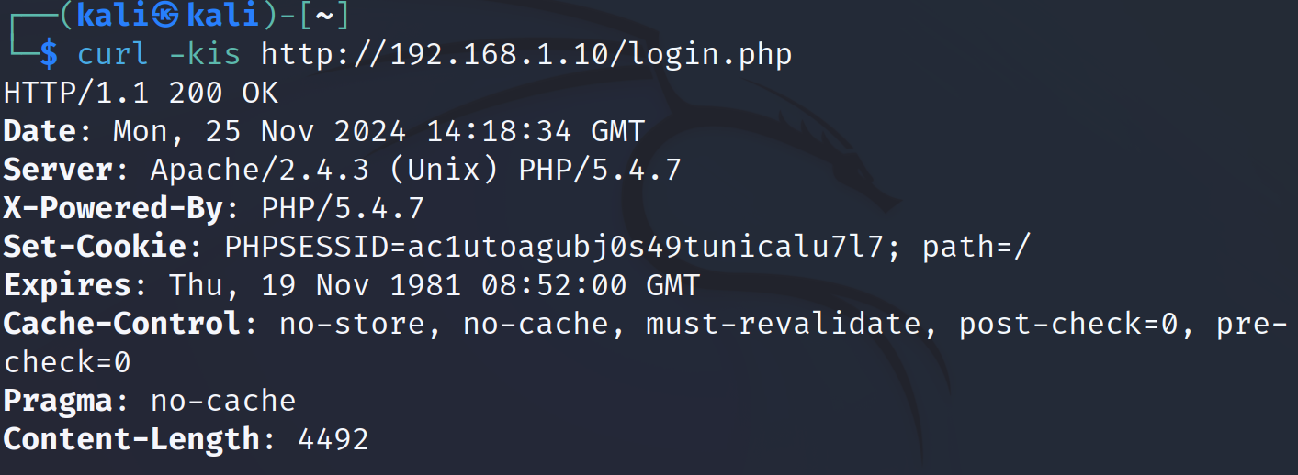Figure 18 – headers found on the login page

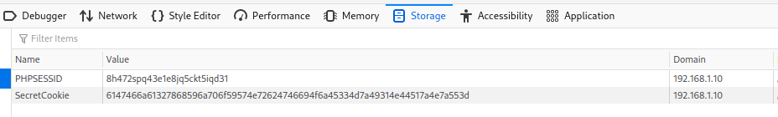Figure 18.1 – Image of the Cookie’s found

The lack of transportation over an encrypted channel can be proven further by sending a request to the server and then observing that response using OWASP Zap . A POST request to login was sent to the server as shown in Figure 19 below , the provided credentials are unencrypted as this is happening over HTTP. Cookies are also visible in the image which is also lacking the Secure attribute.

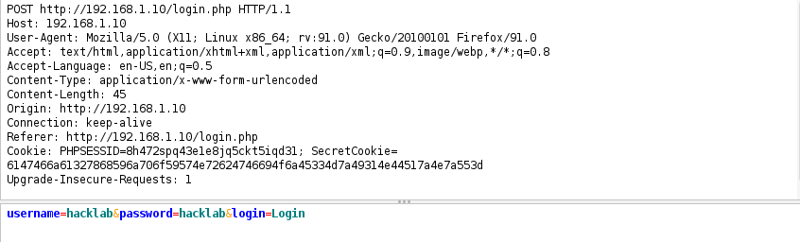Figure 19 – Unencrypted request to the server using the HTTP prefix

### Testing for Default Credentials

In this stage of the test , common username and password combinations were tried on user and administrator login interfaces. The combinations were admin/admin, user/password, guest/guest as well as others. The combination test/test was not used as an account with those credentials was created earlier in section 2.4.2 which means it was not in the database before. The passwords tried during this was also varied to include common passwords like Password1, pas123,qwerty123 however none of these were successful.

### Testing for Weak Lock Out Mechanism

The tester in this stage used the test/test account that was created in section 2.4.2 , knowing the password for this account the tester attempted to input the wrong password 5 or more times to see if there was a lock out mechanism on the user accounts. They were not locked out or rate limited , the tester then logged in successfully with their normal credentials which show that there is no lockout mechanism present.

### Testing for Weak Password Policy

By the application accepting a password of test in 2.4.2 that gave the tester a suspicion that the password policy of this web application was weak or nonexistent. In Figure 20 below it is shown that the password field does need to be 4 or more characters , it can’t be seen that it has a maximum number of characters.

From what has been found the password policy is :

* 4 or more characters
* Does not need to contain special characters(£,$,%,& etc.)
* Does not need to contain numbers
* Does not need to contain uppercase letters

For mitigating against a brute force attack , none of these policy points are advised to be used for several reasons.

This is a very weak password policy , for users to only need to use a single-word password this could result in the basic of dictionary-based attacks being successful against the target which would render the need to crack hashes non-existent in this case.

## Authorisation Testing

### Testing Directory Traversal File Include

As previously shown , file traversal is possible in this web application , by navigating to a known directory without an index page such as /layout/ , the tester was then able to view the entire contents of that directory , which include links to other directories and pages as can be seen in Figure 20 below.

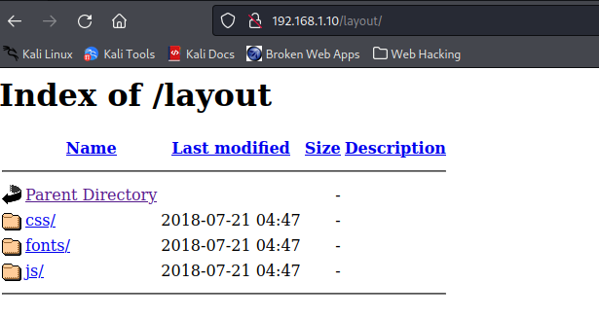 Figure 20 – Image of the file traversal in the layout directory

### Testing for Insecure Direct Object References

Testing for insecure direct object references was done in conjunction with testing for directory traversal. The url <http://192.168.1.10/itemdetails.php?itemid=79> was edited to contain the item id 78 instead of 79 which led the web page to change to item 78 , however only items that were already accessible in the shop could be accessed this way.

## Session Management Testing

### Testing for Session Management Schema

Two cookies were found to be used by site and were easily obtainable as they were transported over an unencrypted channel. The PHPSESSID and the secret cookie , the secret cookie is initialized for each unique user. When checking the cookies manager in Firefox the tester could see that the cookie was a Base64 encoded value. This value was then decoded into a hex value by using a tool called Cyberchef which can be seen in Figure 21-21.1 below. This was then further decoded to plaintext to display the user’s username and password and a third value which will be discussed in the next section. This test was run on the test/test account made earlier and had the same results.

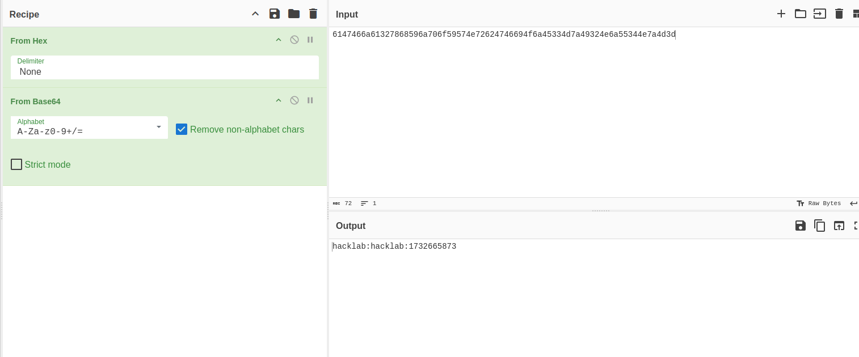Figure 21 – Cyberchef showing the output from the cookie in plain text on account hacklab

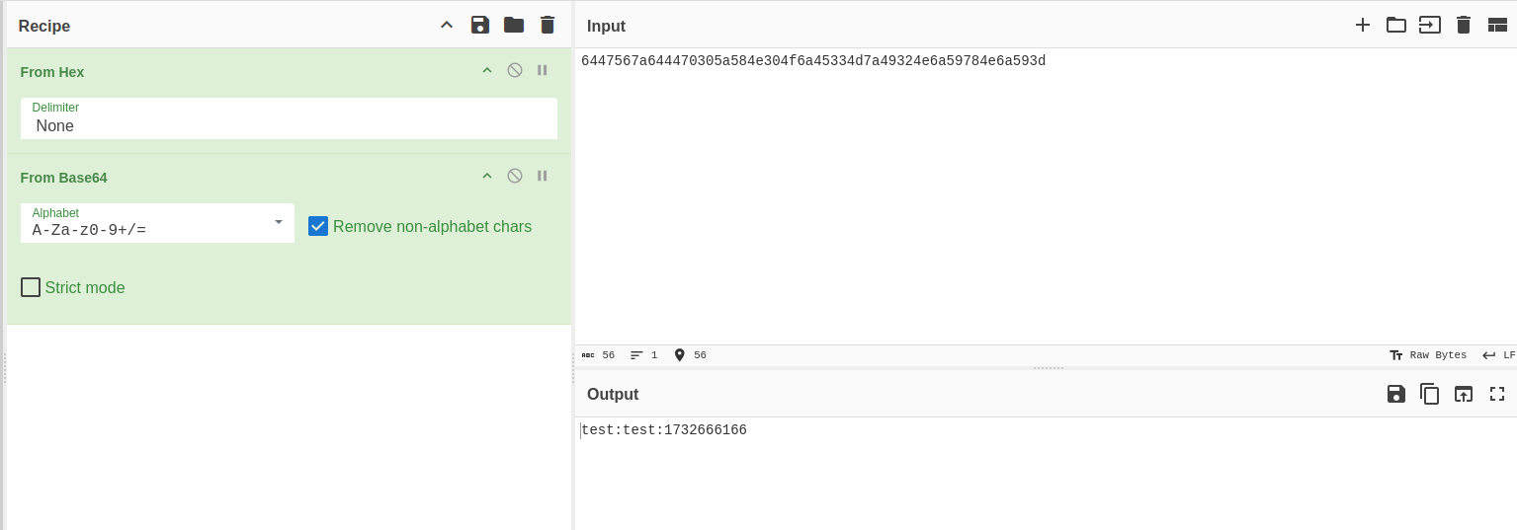Figure 21.1 - Cyberchef showing the output from the cookie in plain text on account test

### Testing for Cookies Attributes

As has been shown in previous areas of this test , the protocol the website uses is HTTP as opposed to the more secure HTTPS. This results in the cookies this site uses for authentication or other miscellaneous uses are exposed and viewable in any given session.

In the previous section , the decode value of the SecretCookie is a triple value separated by a colon. The third value after the username and password is a Unix timestamp which shows the time the user logged in as shown in Figure 22-22.1 below.

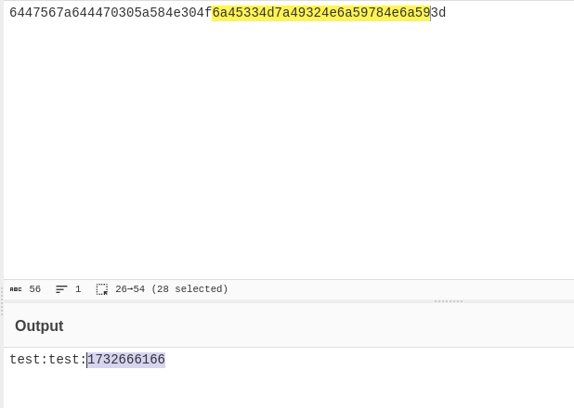Figure 22 – Third value from the secret cookie

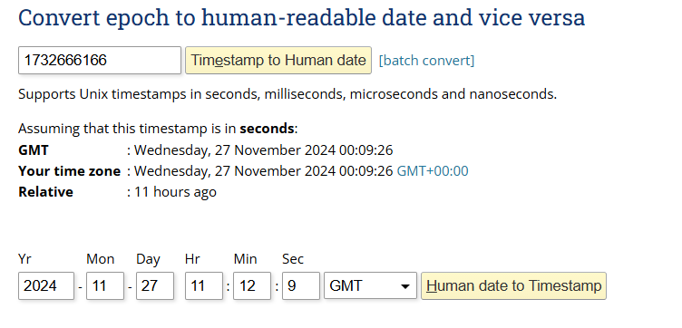Figure 22.1 – Information from the information gained from the secret cookie

### Testing for Session Fixation

To test for session fixation , the tester checked the value of the session cookie before and after authentication. As has been previously discussed the PHPSESSID was assigned when first accessing the site. This cookie does not change after the user logged in; the only difference was the SecretCookie being set. Additionally, the same cookie was still present when the user logged out and authenticated as another user. This is shown below in Figure 23-23.1.

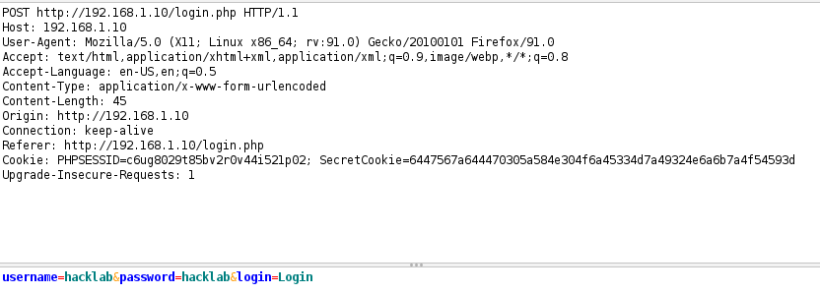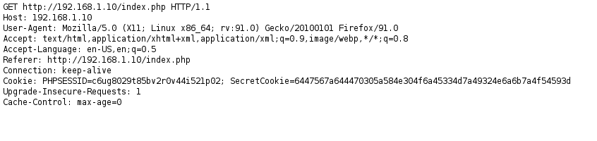 Figure 23 – PHPSESSID set

Figure 23.1 – Same PHPSESSID after Authentication

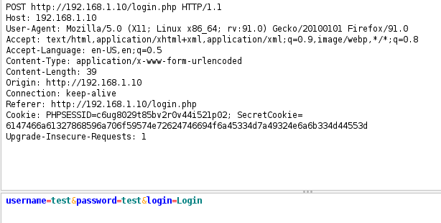Figure 23.2 – Same PHPSESSID when authenticating as different user

### Testing Session Timeout

It was concluded that there is no session timeout set as users were not logged out after a period of idleness.

### Testing Session Hijacking

The tester is going to first authenticate with a user account hacklab/hacklab in a Firefox browser window and grab the PHPSESSID and the secret cookie. Then using OWASP MANTRA logging into the test/test account made previously , the tester then made use of the Cookies Manager to change the cookie values that were given in the authentication process for the account hacklab authentication process.

This resulted in being able to session hijack , where the tester was able to switch accounts to the hacklab account without going through the proper authentication channels , which is shown below in Figure 24 – 24.5.

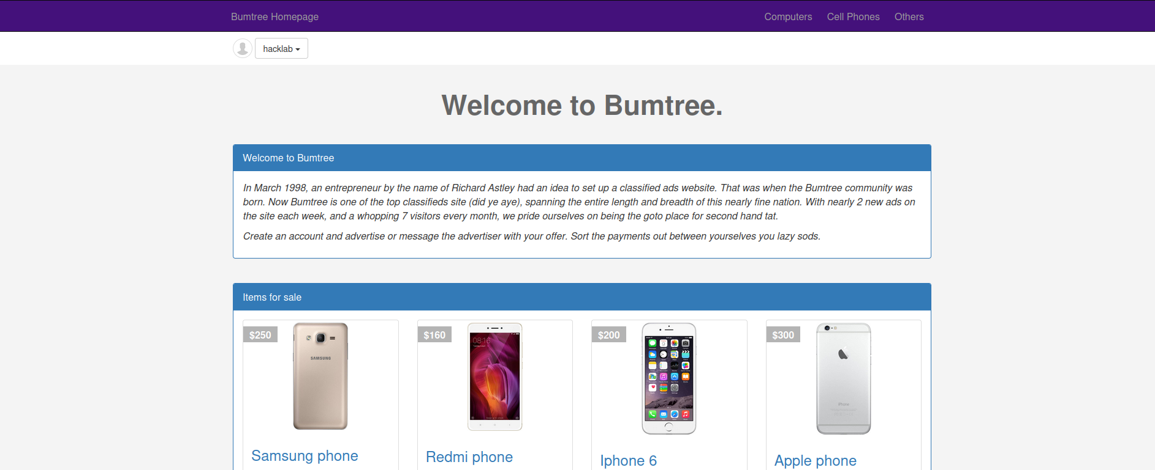Figure 24 – Hacklab account signed in on a firefox browser

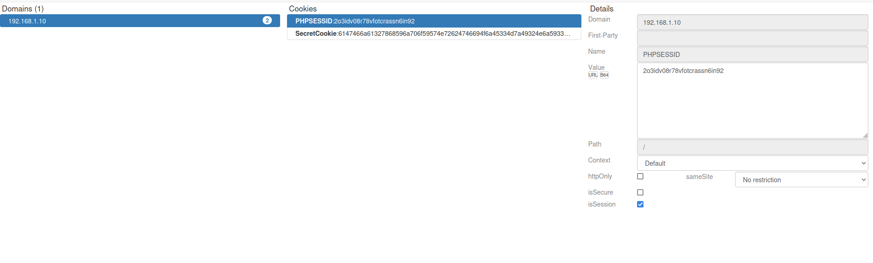Figure 24.1 – PHPSESSID and secret cookie from hacklab account

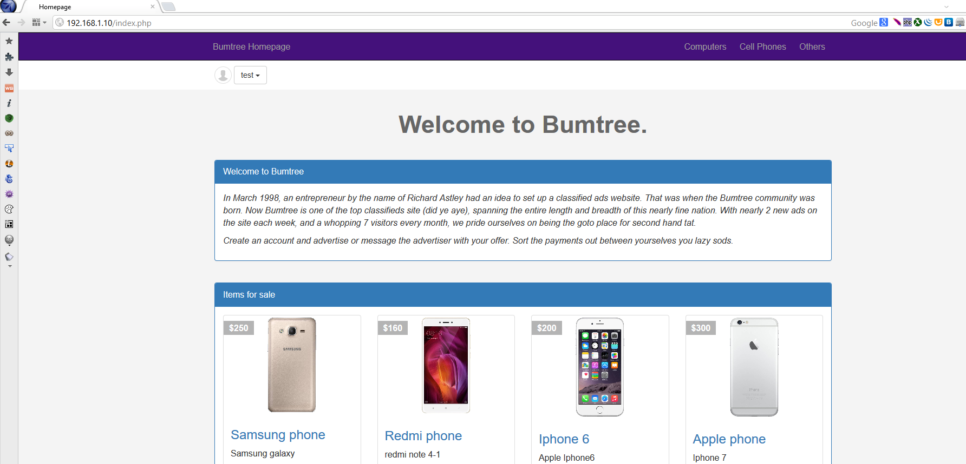Figure 24.2 OWASP Mantra window , signed in as test account

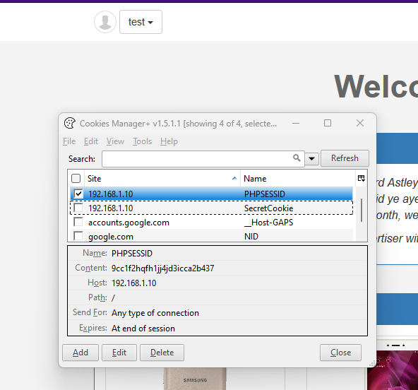 Figure 24.3 – PHPSESSID and secret cookies from test account authentication

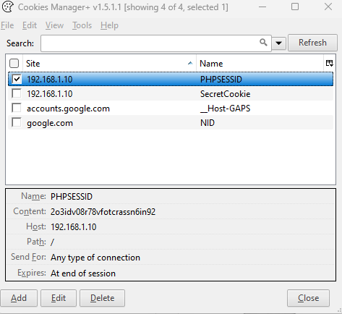 Figure 24.4 – Changing the values to the hacklab accounts PHPSESSID and Secret cookie

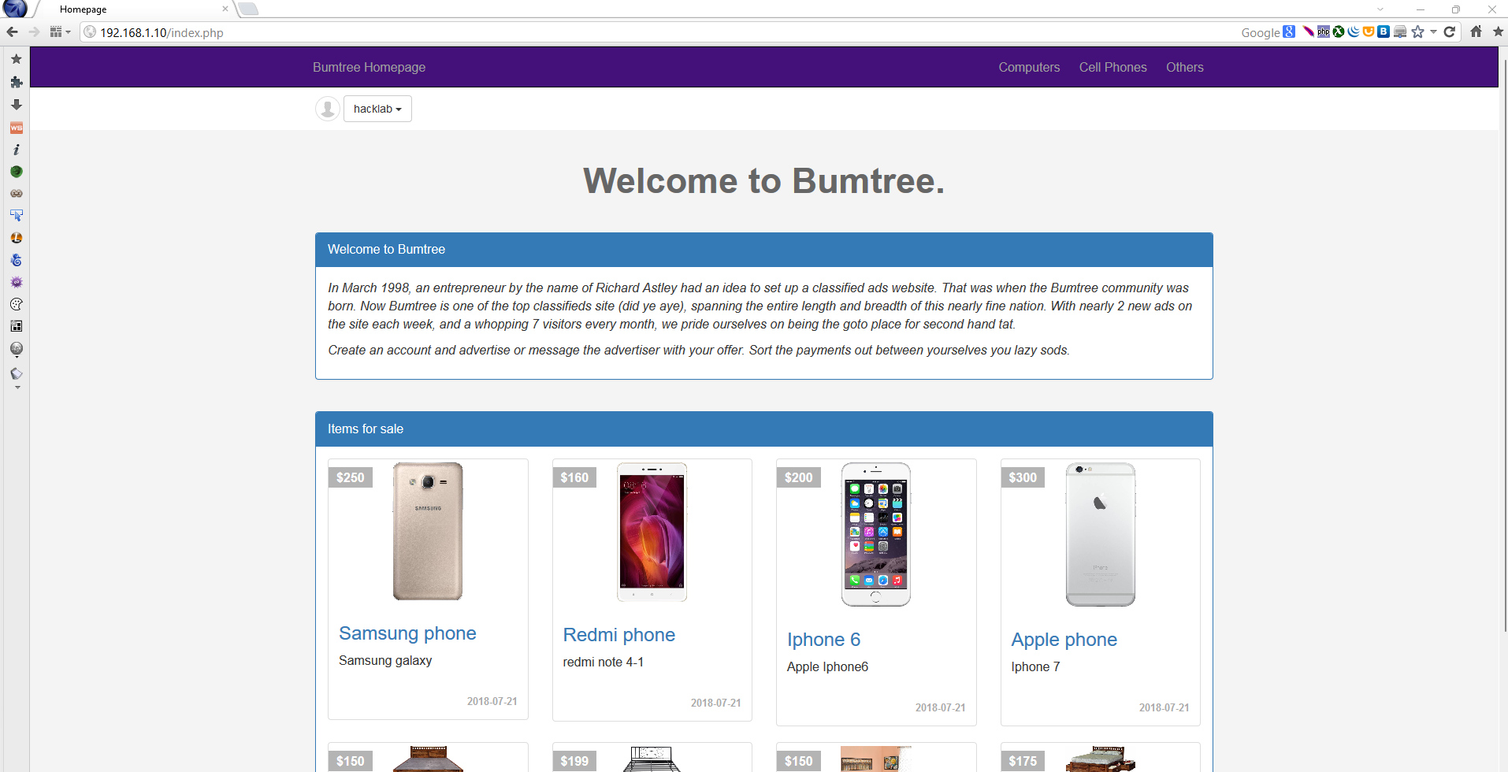Figure 24.5 – On OWASP Mantra , changed account to hacklab without proper authentication

## Input Validation testing

### Testing for Reflected Cross Site Scripting

In this section the tester checked for Reflected Cross-Site Scripting (XSS) which is when a browser has executable code injected within a single HTTP response. This attack is not persistent and will only impact users who open maliciously crafted links or a third -party web page. As was previously found in the OWASP ZAP test, the target web application is vulnerable to a cross-site scripting (XSS) attack . As can be shown in Figure 25 below , a standard XSS test was performed against the target web application. To create this test , in an input box this was inputted “<script>alert(1);</script> “ and if it is successful an alert box will pop up with the number 1 in it on resubmission of the web application. This was tested in various areas of the site in multiple input boxes , including the add items , edit profile information and it also accepted arbitrary input’s (numbers) were found to be vulnerable. The result shown in Figure 25.1 is from testing the Full Name in the My profile page using this input “<script>alert("hello");</script> “.

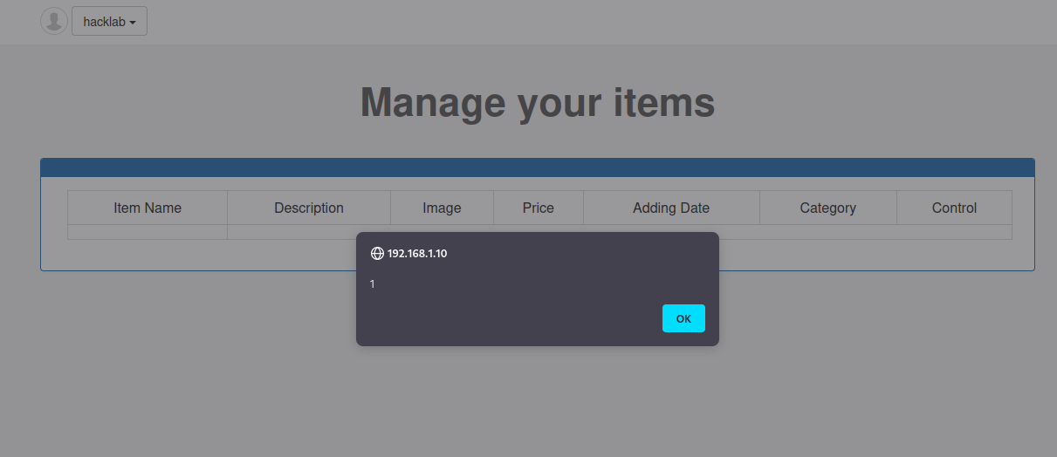 Figure 25 – Showing a successful XSS test

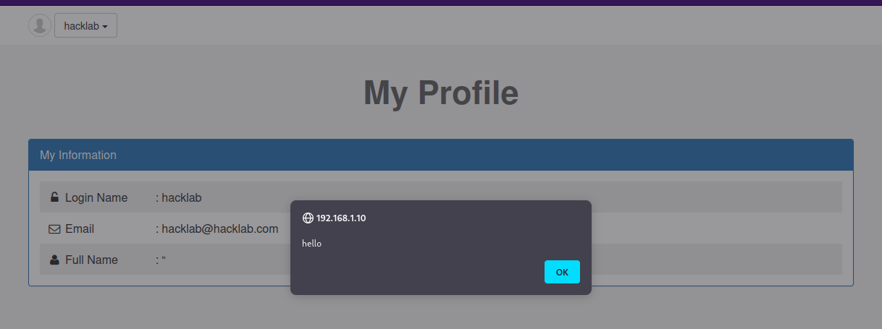Figure 25.1 – Successful XSS test using “<script>alert("hello");</script> “

### Testing for Stored Cross Site Scripting

For Stored Cross Site Scripting this can be shown when an application is vulnerable as well as an input field on the application is vulnerable and allows users to store data that has been inputted into a database. To test this the tester created a new account where each field was filed with a payload like the previous section. After gaining access to the admin panel (which will be discussed in the next section) the tester was able to view the list of user accounts on the system, including the XSS exploiting account . The results of this are shown in Figure 26 below which clearly shows that stored XSS is possible in this application.

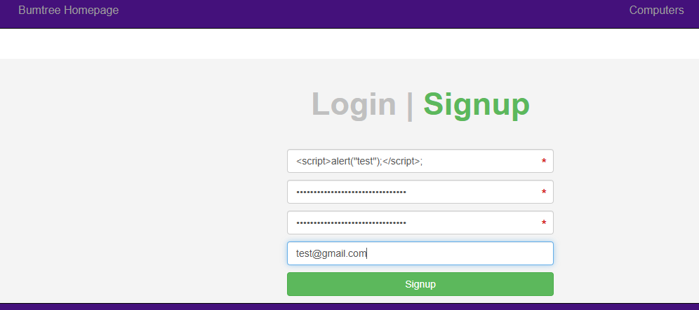Figure 26 – Creating an account using cross site scripting

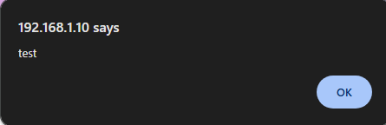 Figure 26.1 – When logging into the admin panel the alert from the script

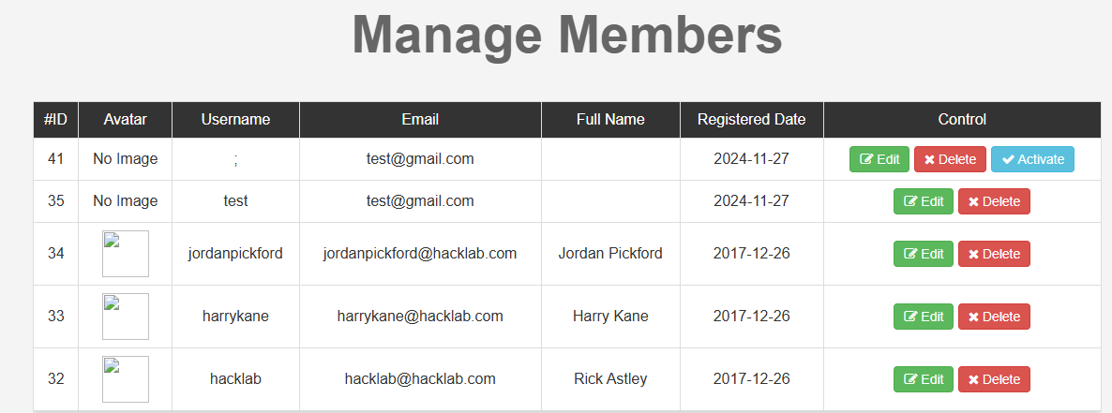 Figure 26.2 – admin table with the script account

### Testing for SQL Injection – MySQL

When using OWASP Zap it was observed that there were 2 areas for SQL Injection and 1 SQL Injection for MySQL, when looking into where these areas are the tester was then able to use OWASP Mantra to get a GET request using the live HTTP headers tool and put the info from the GET request into a txt document. One of the areas that was vulnerability was the /tags.php?name=apple this was used in a tool called SQLmap to find information out about the databases on the server as well as trying find the admin account. As shown in Figure 26.1 below the tester was able to find out that the database name is shop.

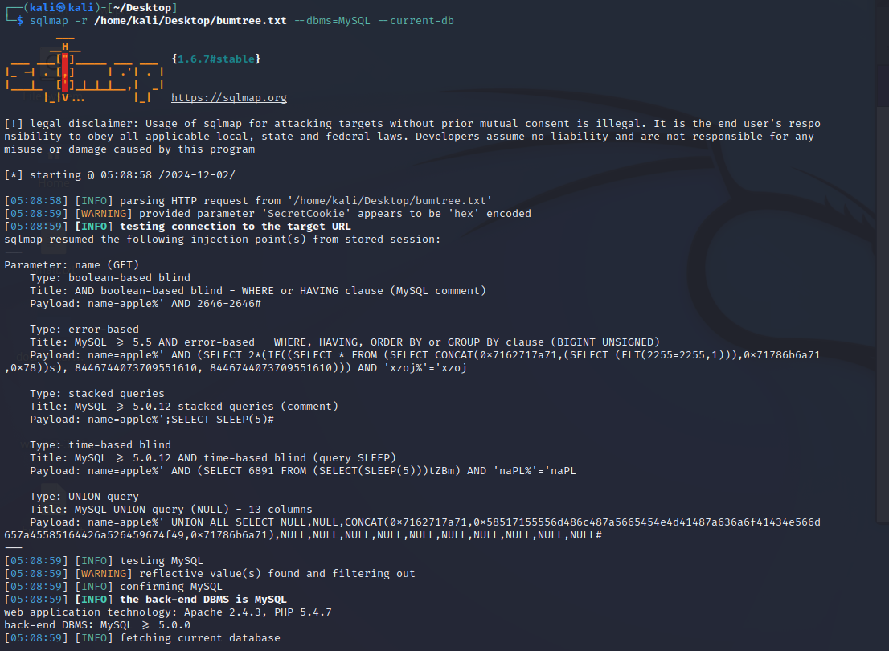Figure 27- SQL map database name

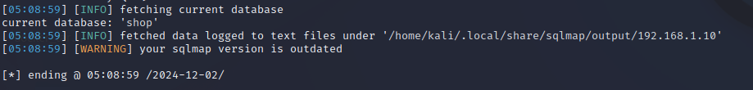

Figure 27.1- SQL Map command run to find out database name

Now that the tester has the database name , the next thing was to enumerate with the command - sqlmap -r /home/kali/Desktop/bumtree.txt --dbms=MySQL -D shop --tables

To find out what tables are the database as shown below in Figure 26.2

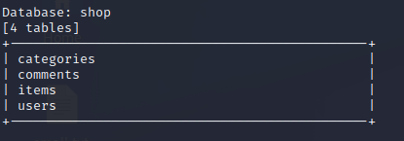 Figure 27.2 – the tables in the shop database

Now that the user can see that there is a table called users, it can be dumped to see what information can be found. As shown below in Figure 26.3, it was found that all user accounts could be dumped from this and one of them was an admin account with the password stored in plain text. 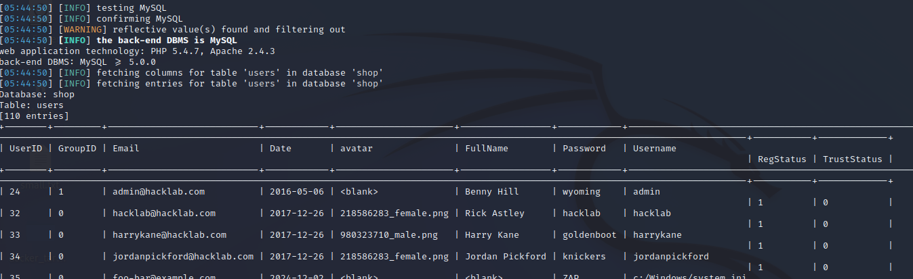Figure 27.3 – users table dumped

Now that the tester has been able to get the admin account details it is possible to login into the admin panel as shown below in Figure 27.4.

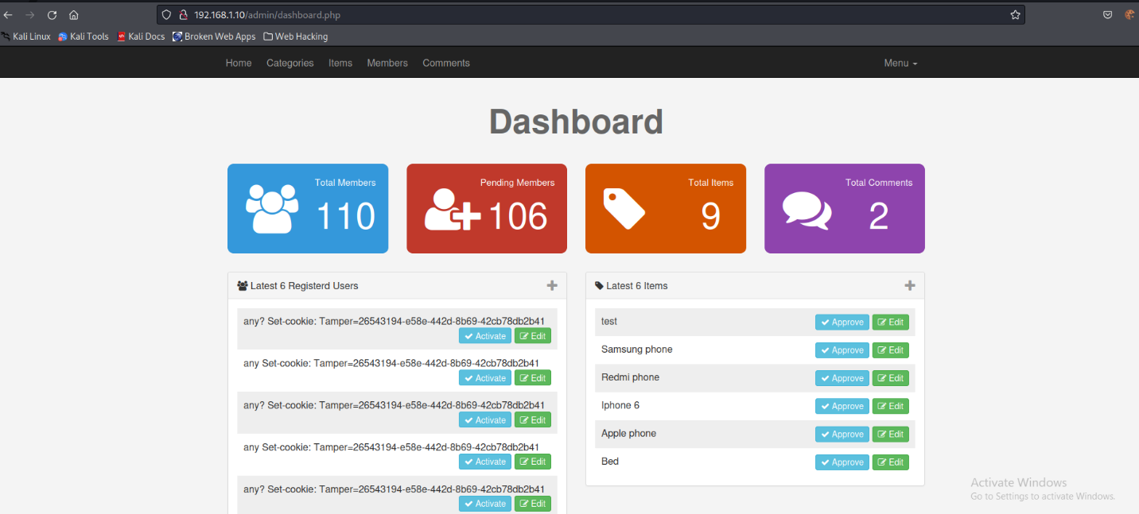 Figure 27.4 – Logged into the admin panel

### Testing for Local File Inclusion

The tester tried to test for local file Inclusion which is like the test in section 2.6. Files such as etc/passwd which should be present on a UNIX system was attempted to be accessed this way, but these tests bear no results.

### Testing for Incubated Vulnerability

In section 2.11.5 , the tester found that it is possible to test for a malicious file upload.

## Testing for error handling

### Testing for Improper Error Handling

When the tester tries to navigate to a directory or page that doesn’t exist , a 404-error page is shown with the precise details of the web-related technologies running on the server, which confirms the accuracy of earlier nmap scans done in the beginning. This can be seen in Figure 28 below.

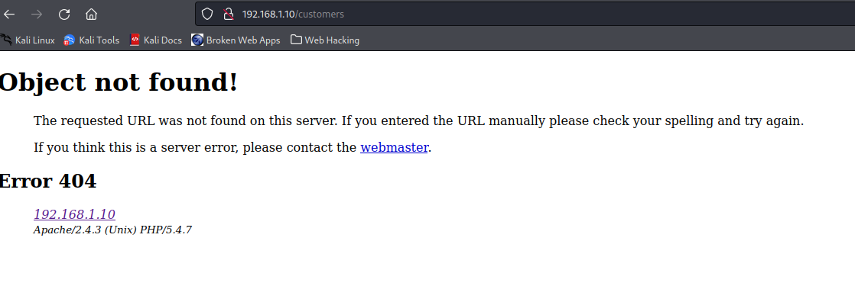Figure 28 – 404 Error page

## testing for Weak Cryptography

### Testing for Weak Transport Layer Security

As has been previously discussed , the web app lacks a valid SSL or TLS certificate , which is demonstrated by the lack of a padlock on the top right corner and the server communications using HTTP as to HTTPS. This can also be seen by doing a sslscan which was conducted by the tester which can be seen in Figure 29 below.

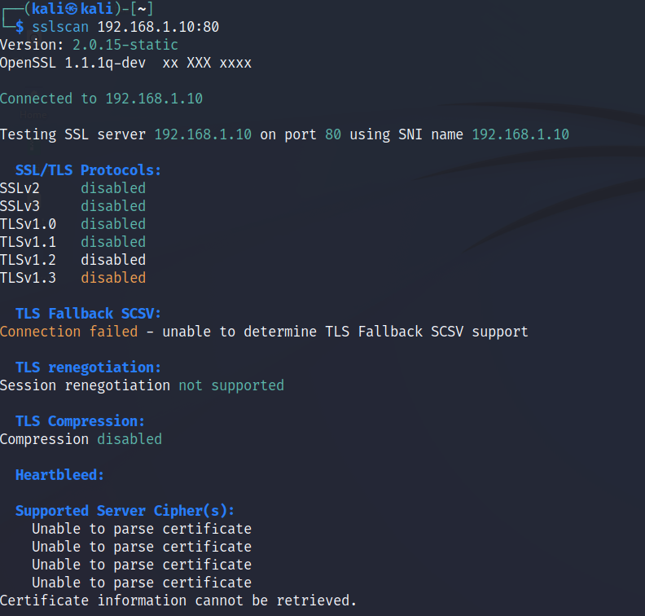Figure 29 – sslscan results

### Testing for Sensitive Information Sent via Unencrypted Channels

As was discussed in section 2.5.1 – Testing for Credentials Transported over an Encrypted Channel , sensitive information which included username and password was being sent over unencrypted channels.

### Testing for Weak Encryption

As has been previously found in section 2.8.3 the dumped users table which contains passwords is storing them in plain text which can be seen in Figure 30 below.

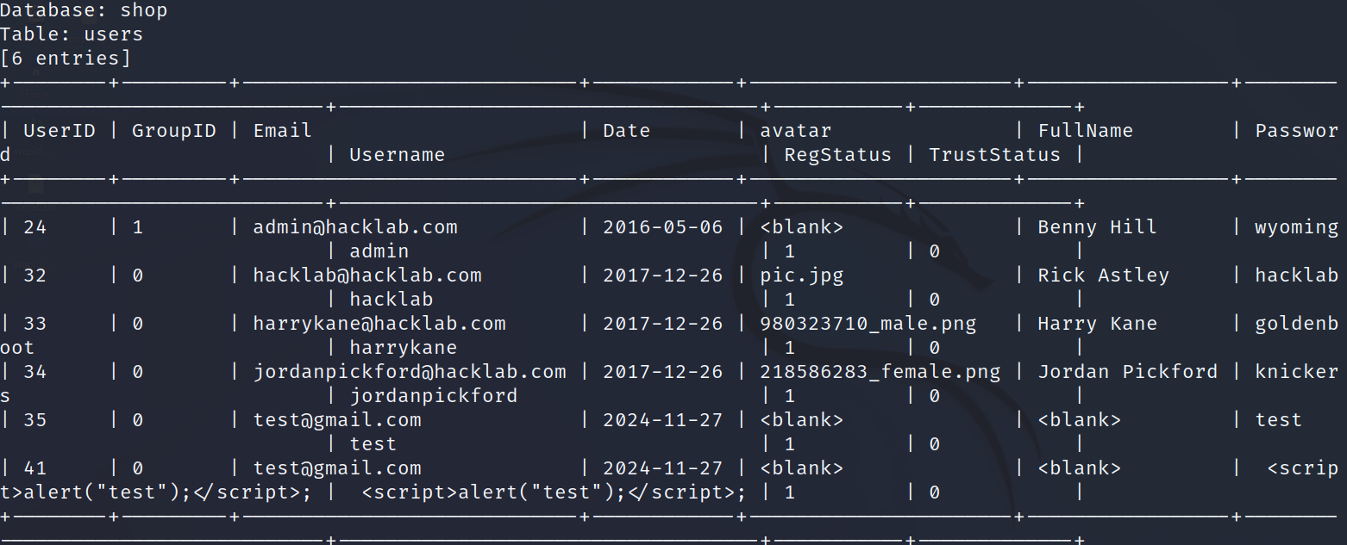Figure 30 – Admin table dumped using SQLmap

## Business Logic Testing

### Test Ability to Forge Requests

As can been seen in previous sections of this report , the target web application contains a multitude of vulnerabilities such as Cross Site Scripting , SQL Injection and session hijacking. This gave the tester access to information such as user data and the entirety of the admin functionality of the application.

### Test Integrity Checks

To test the integrity the tester intercepted traffic using a OWASP Zap and a web proxy and it was possible to edit non-editable from values before they were sent to the server as shown below in Figure 31. It was possible to edit the price of the phone, and it was accepted as shown below in Figure 31.1

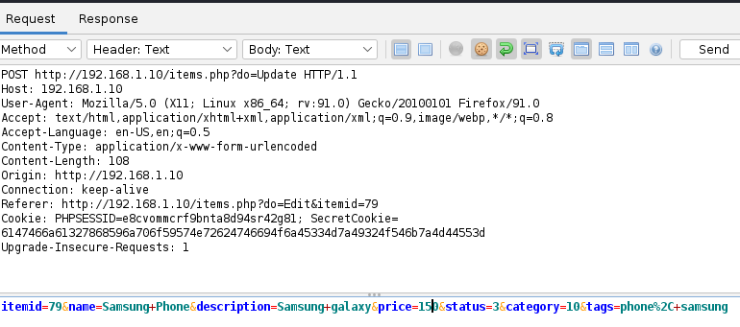 Figure 31 – POST request edited the price of the phone to 150 instead of 250

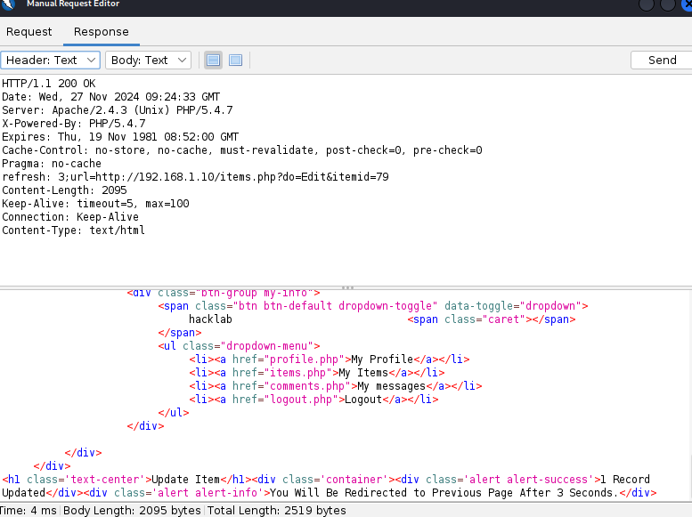 Figure 31.1 The response from the server to show the change has gone through

### Test number of Times a Function Can Be Used Limits

As was seen in section 2.4.3 this application does not have any lock out method which is used in nearly all applications to date as it is a defense mechanism against brute force attacks. These issues could result in an unauthorized user gaining access to a user account by repeatedly and systematically trying different credentials against the login page until one of them works.

### Test Defenses Against Application Misuse

To test for defenses against application misuse this entails observing the web application to see if it detects malicious activity and if the appropriate measures are in place, for example a lockout is taken to stop it.

During the testing process, the tester was able to see many actions that could be considered malicious were performed but nothing was observed. The only observation that was of notes was the error message which was returned uploading an unexpected file type when uploading an image into the items.

### Test Upload of an Unexpected File Types

When uploading a non-image file into the item’s description , the message was shown as can be seen in Figure 32 below.

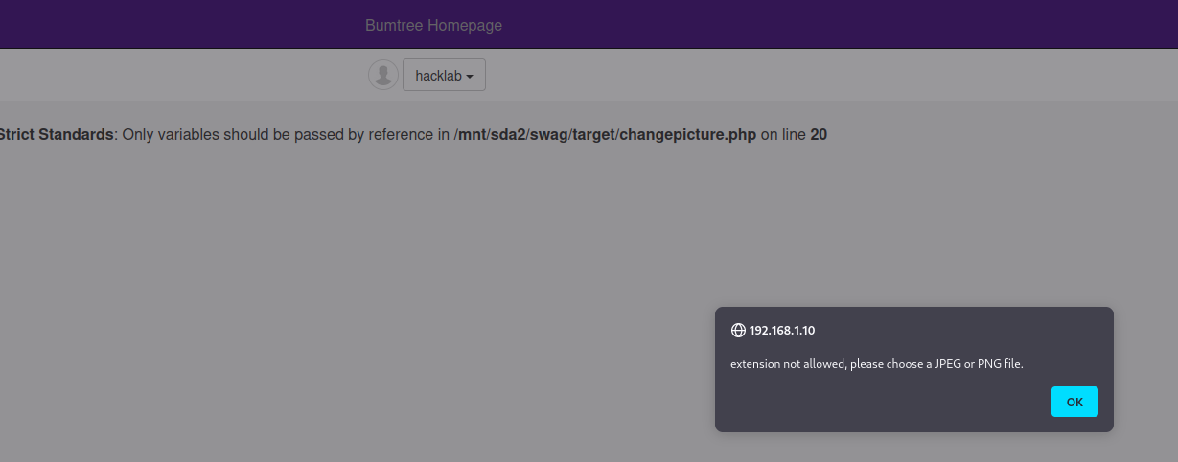Figure 32 – trying to upload a non-image file

There is a simple way to bypass this error by changing the file extension to .jpg instead of a .txt file which is shown below in Figures 32.1-32.2.

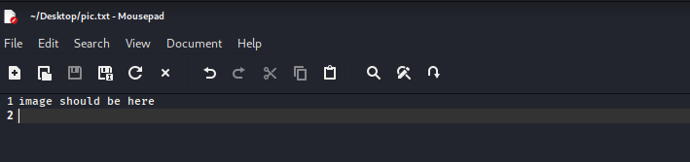Figure 32.1- info in the pic.txt file

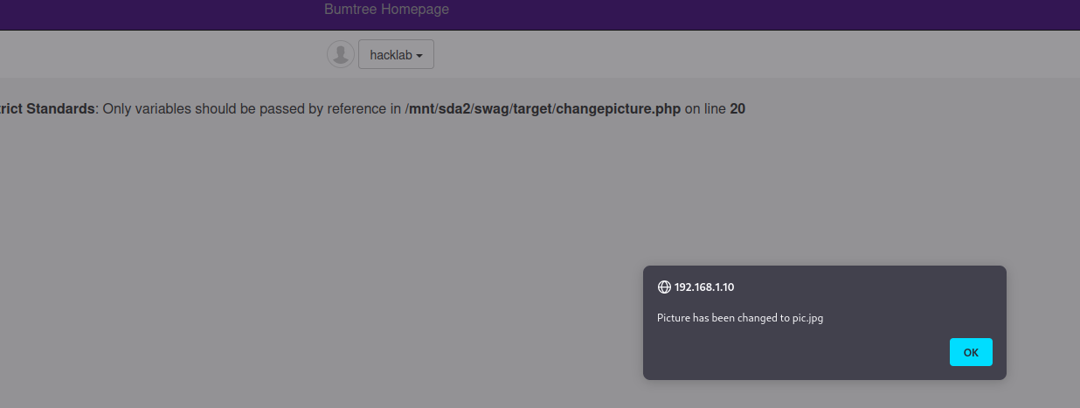 Figure 32.2 – allowing the jpg file , even though it contains text

The tester was then able to browse to the directory /uploads/images/pic.jpg and open the file , the information was not able to be seen as shown below in Figure 32.3

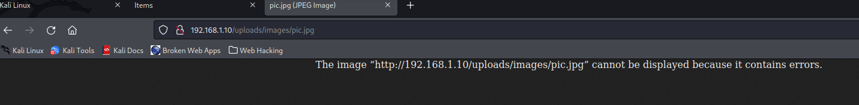Figure 32.3 – Image of the file

This could be used in the future to inject a script into the images area and have that executed when a user navigates to that item on the website.

# Discussion

## Vulnerability Disclosure and Countermeasures

### Robots.txt file Vulnerability

This isn’t a file that is vulnerable, however it is responsible for providing information for any web crawlers, spiders or robots regarding what directories and files on the target site should and should not be indexed which is usually done by search engines like Google or Bing.

The Robots.txt file can be used for many different and valid reasons such as search engine optimization but in this case the file is being used to hide the company accounts, a private internal directory that should not be made available publicly.

#### Mitigation

The best way to mitigate this is to not use robots.txt for sensitive information as it is always available to the public if it is being used. The quickest fix for this issue is to remove the company accounts directory from the robots.txt file completely which will disallow any hackers from learning about that file in the first place.

### Outdated Software and Service Versions

As was seen in section 2.2.1 – Fingerprint a web server, old technology is being used on this web application. The latest version of Apache is v2.4.62 and the latest version of PHP is 8.3.14 as of writing this but the versions of Apache are 2.4.3 and the version of PHP is 5.4.7.

Software that is outdated leaves the systems open to a great number of security risks as older software versions do not feature patches for more current and newly released vulnerabilities.

#### Mitigation

The best way to mitigate this issue is to update all outdated software to the latest and the most stable version that has been released.

### Information Leakage from phpinfo ()

Phpinfo.php and info.php are both publicly available on the website. There is lot of information in these files about the system such as the services used as well as their versions and the path to the webserver root.

#### Mitigation

The phpinfo function can be disabled in the php.ini (Enabling and disabling phpinfo() for security reasons, n.d.) with the command = disable_functions = phpinfo

There is a way to also to prevent these files from being accessible by editing Apache’s .htaccess file to contain the following directive for each chosen file:

<Files ~ “^\.htaccess”>  
Order allow,deny  
Deny from all  
</Files>

(How to deny access to files, folders through htaccess file, n.d.)

### Information Leakage in Code

When the tester was inspecting the code from the inspect feature in the browser as was shown in section 2.2.4 there were several pages with comments hinting at the existence of info.php which discussed in section 3.1.2 was observed. This file is available publicly and exposes information about the webserver configuration.

#### Mitigation

The best way to mitigate this is to remove the comments in the code hinting at their existence as well as making the file info.php and phpinfo not available to the public.

### Information Leakage from Listable Directories

There are several directories of this web application that are listable and can be accessed publicly without authentication , an example of this is the /uploads directory which stores profile images as well as item pictures as seen in section 2.3.1. Having listable directories can enable a threat actor to gain information about the structure of the web application and then access sensitive information.

#### Mitigation

With proper configuration directory listing can be avoided in the future. For Apache servers , it can be done by accessing the .htaccess file in the websites root directory and adding this line (Swisher, 2024): “Options -Indexes”

### Information Leakage Upon Incorrect Login

The message that is returned upon an incorrect login is different depending on an incorrect username or a correct username as shown in section 2.4.4 , this can allow for enumeration of usernames present in the database.

#### Mitigation

To be able to properly resolve this , is to have the same message returned which says, “The username/password is incorrect, please try again” , this can be edited into the code.

### Information Leakage from Error Messages

As was shown in section 2.9.1 accessing a non-existent resource on the website and the error displayed shows system information such as the Apache and PHP versions . If this is obtained by a threat actor , this information could help them in executing potential attacks specific to those versions.

#### Mitigation

This can be avoided; error messages should only display the error code and its meaning not any other information. Custom error messages can be added to Apache server by configuring the ErrorDocument directive. (Apache, n.d.)

### No Lockout Policy

When a user enters an incorrect password repeatedly there is no lockout on the site when trying to access a user profile. This lack of a lockout policy makes it easy for attackers to execute dictionary attacks on the website application which endangers the users on the site as their accounts could then be compromised when a password is obtained using this method.

#### Mitigation

The best way to resolve this is to implement a lockout policy on the web application. The National Cyber Security Centre recommend 5-10 login attempts before locking out on their password policy advice for system owner’s pdf. (Password Policy) With this approach it can enable an attacker to perform a DoS attack on the web application. To be able to counter this , is to use something called password throttling which is when delaying any subsequent login attempts after an incorrect login. This will limit the number of guesses used by an attacker and does not lock out any existing users.

### No/Weak Password Policy

There is a very weak password policy in place for registering users to the website. A password of 4 characters is the only limit that seems to be on registering users. The passwords are also case-insensitive as well as there is no input sanitation on passwords as seen in section 2.8.2 scripts can be used. A password policy should be in place as this will avoid user accounts being compromised by password guessing or dictionary attacks and will make the site more robust. This will also ensure that users choose stronger passwords.

#### Mitigation

The Canadian Centre for Cyber Security recommends using a minimum of 12 characters (Security, 2024) as well as passphrases which are easier to remember and the chance of them being in a wordlist for a dictionary attack is lower. Passwords should also be case-sensitive and implement the use of certain special characters/numbers.

### No Credential Encryption

There is no form of encryption for user passwords stored in the database which can be seen in the user table in section 2.10.3. This allows for an attacker to obtain user credentials in their plaintext format. Passwords should always be salted and hashed , which ensures they are stored following best practice measures.

#### Mitigation

To be able to mitigate this, it is possible to salt and hash passwords in php using the password_hash() function. There are several hashing algorithms that can be chosen from and specified in the parameters for this function. Using Bcrypt or Argon2 are very good choices as they will also salt as well. It also uses slow hashing, and the iteration count will increase over time , which makes it more resilient against brute force attacks. The hashes can be compared to the hash stored in the database with the password_verify() function to verify passwords when logging in.

### Reversible and Insecure Cookie

There is a SecretCookie which is generated upon login, and it is very insecure. In this web application , the cookie was able to be reversed and contained the username and password as well as a UNIX timestamp that correlated to their login time. This type of sensitive information should never be stored in a cookie, especially if it is easy to obtain.

#### Mitigation

There is a more secure way to manage authenticated users which is to use the PHP sessions, as their information will reside on the webserver and then can’t be accessed directly. By doing this only the PHPSESSID cookie would be used to generate session IDs and then check for any existing sessions. This ID should also only regenerate after the user authentication state changes using the session_renegrate_id() function to prevent session fixation.

### Missing Cookie Attributes

The cookies on this web application do not follow the best cookie configuration which is Set-Cookie:__Host-SID=<session token>;path=/; as defined by OWASP (OWASP). This can pose several security risks with cookies being transported over unencrypted channels with a lack of the secure attribute , and the HttpOnly not being present this means that the cookie can be accessed with scripts as well as session hijacking.

#### Mitigation

The best way to remediate this is for the cookies to have the above-mentioned attributes configured when they are set. Cookies should also not be transported over unencrypted channels or be able to be accessed by scripts , the path and SameSite attributes can then ensure that cookies are not being used outside of those directories and the sites they are needed on. This will reduce the risk of them being used in attacks.

### No Session Timeout

On this web application there is no session timeout , session timeouts are a good security measures to have in the case of the user leaving one session open , it will automatically be destroyed after a certain amount of time which makes it harder for a third party to access and continue using it.

#### Mitigation

The best way to fix this issue is to implement a session timeout , which needs to be at a defined interval on the server after which that session will be terminated. When a user has been idle for certain amount of time i.e., they have not performed any actions on the application for the duration of the defined interval. The sever will set their session as invalid and it will then be destroyed. The way to implement a session timeout can be done in the web deployment descriptor (web.xml) file or it can be programmed in the session object.

Idle time duration can be widely dependent on the intended purpose of the web application and the data it operates with. OWASP says that common idle timeouts are between 2 to 5 minutes for high value applications and 15-30 minutes for low-risk applications. (Session Management Cheat Sheet). It would be a good idea to determine how long a user would need to navigate the site , view items ,add items, view comments , message sellers and then set the timeout above the time required to complete these actions.

### Stored Cross Site Scripting

As was seen in section 2.8.2 stored cross site scripting was possible. This can also lead to an incubated vulnerability.

#### Mitigation

The way to mitigate this is to make sure that user input is being sanitized after it has been supplied. When user input is being accepted , it should only be in an accepted format. Named fields should not accept symbols like parentheses or angled brackets which could be part of a script for example. The way to sanitize user input is to use sanitize filters in PHP, Regex can also be used as well.

Another thing to do is to output encoding so that data is encoded to a different representation of the same symbols. This way the data can no longer be interpreted in a way that can lead to potentially dangerous script execution. In PHP htmlspecialchars() and htmlentities() are both functions that can be used to accomplish this.

### SQL Injection Vulnerability

As was shown in section 2.8.3 , this web application is vulnerable to SQL Injections. This was shown by the /tags.php?name=apple being vulnerable to being used by SQLMAP. By using this tool , it was possible to find the database used and the tables in that database were able to be dumped. An attacker can use this vulnerability to access sensitive information that is stored in the database that includes user information but is not limited to that.

#### Mitigation

To be able to avoid SQL injections , prepared statements should be used. To do this , the SQL query will first be defined and then the parameters are then passed to it later , this way any injected code cannot be executed and is handled like regular data.

### File Upload Vulnerability

In the edit profile area , there is a change picture option that is found to be vulnerable to code injections as seen in section 2.11.5.

The application in this area only allows specific file types to upload but by changing the file extension it is possible to upload a txt file as a png/jpeg file which could contain a shell script or other executable code.

#### Mitigation

The best way to resolve this is to use proper file upload validation, for images it is recommended to utilize image rewrite libraries to verify that the image is valid and to remove any unnecessary content.

For stored images the extension should be set to detect content type of the image, from any image processing rather than trusting the upload header.

### No Integrity Checks

By using OWASP Zap , a web proxy it was possible to edit the price of an item to less than it is or a negative value , its name , which are otherwise not able to able to be modified to a different value as well as editing an item that doesn’t exist . There is no backend check to verify these changes or that the item exists.

#### Mitigation

The best way to resolve this is to add in a backend check of the input values , compare them to values in the database to make sure that the item exists. This could be done by implementing an item ID so when the name and price of the item is retrieved from the databases they cannot be forged. If the ID doesn’t exist , then it shouldn’t go through. There should also be a system for email verification which would be beneficial to check that legitimate email accounts are being used.

### No Transport Layer Security/Secure Socket Layer and HTTPS

In Section 2.10.1 it was seen the web application does not have TLS/SSL enabled. This can be very dangerous not having TLS enabled and puts the users on the site at risk since the traffic is not being encrypted , which means that private information is visible and being transported to a third party. The website is also using HTTP instead of HTTPS which means it is being seen in plain text and is not secure.

#### Mitigation

To be able to configure TLS and HTTPS :

* Generate a public/private key pair
* Generate a certificate signing request (CSR) that embeds the public key
* Share the CSR with a Certificate Authority (CA) to be able to receive the final certificate
* Install the certificate in a place on the web server that is not accessible from the web.

Once the certificate is activated, the website will then be able to load over HTTPS instead of HTTP when the Apache virtual host configuration is changed to contain the information about the certificate and key locations. This file can also be used to configure the redirection from HTTP to HTTPS.

### Misconfigured Headers

On the web application there are missing security headers which can have several impacts. This was indicated in the Nikto scan which can be seen in Appendix E – Nikto Scan Outputs , the site was missing x-frame options, X-XSS-Protection and the X-Content-Type-Options headers. Also, the X-powered-by header was leaking information about the version of PHP that is being used. Furthermore , the HSTS header was not set as seen in section 2.3.4.

#### Mitigation

For the X-powered-by header to not reveal PHP information , expose_php should be set to off in the php.ini file on the webserver.

To be able to add the HSTS header , the virtual host section in the Apache config file needs to be edited to add the following line:

Header always set Strict-Transport-Security "max-age=31536000; includeSubdomains; preload"

The max age in the example is set to 1 year but can be edited when it is being configured.

For the 3 missing headers that were identified by Nikto , it is identified that XSS protection header is no longer required for newer browsers (for cross site scripting countermeasures see Section 3.1.14).The X-Frame-Options and X-Content-Type-Options headers can be configured in the Apache configuration file using the following lines :

Header set X-Content-Type-Options "nosniff" Header set X-Frame-Options: "SAMEORIGIN"

The X-Frame-Options header can also be changed to deny(DENY) everything or allow specific sites (ALLOW-FROM). This will help in avoiding clickjacking attacks , whereas the content type header will ensure that the browser does not perform any MIME-sniffing.

### Enable HTTP TRACE Method

As was seen in section 2.3.3, the HTTP TRACE method is enabled , the TRACE method returns the full HTTP request back to the requesting client.

#### Mitigation

The configuration file on the Apahce server can be edited to disable the TRACE method this can be done by editing the TraceEnable 0ff. The TRACE method returns the full HTTP request back to the requesting client. This should not be used outside of debugging and having it enabled for publicly accessible sites makes cross site tracing possible; this can lead to the disclosure of sensitive information such as internal authentication headers.

## Overall Discussion

The aim of this was to perform a comprehensive security evaluation on the web application Bumtree and to identify vulnerabilities and for their countermeasures to be outlined, that task has been done. A complete penetration test was executed in line with OWASP WSTGv4.0 methodology and has found Bumtree to be highly insecure. There are numerous high-risk vulnerabilities or missing security considerations identified.

These discovered vulnerabilities fall into categories such as information leakage, lack of input validation, lack of security considerations, this includes things like cookies that contain sensitive information, as well as them having no security attributes.

This report sets out the vulnerabilities and other miscellaneous security concerns that are present in the web application , why they are an issue and methods to mitigate them if possible.

## Future Work

The next step will be that the information that has been gathered during this assessment would be to establish the severity of each vulnerability to efficiently approach their solutions as laid out in section 3.1.

After the identified vulnerabilities have been fixed there should be another test following the same outline as the one documented in this report. This should aid in seeing if the fixes have corrected the issues and that they have been correctly implemented. This will also help in identifying any other vulnerabilities that were either missed or that have arisen from the changes made to the webserver configuration during this process.

Future work will be relating to the security of this host and organization would be testing the actual web server that is underlying.

Another test on the organization holistically may also be beneficial. A genuine attacker would not necessarily stop at just attacking the web application , they may also attempt to gain unauthorized access through an employee , a server or physically.

A second test done should include the site like this one has, as well as the organisation members (employees) submitting to social engineering attacks which could include email phishing or impersonating a third-party contractor etc. Doing a holistic test may also be able to test the web server which would bolster the security of the server from an attack.

# References

Apache. (n.d.). *Custom Error Response*. Retrieved from APACHE HTTP Server Project : https://httpd.apache.org/docs/current/custom-error.html

Cardillo, A. (2024, October 21). *How Many Websites Are On The Internet?* Retrieved from Exploding Topics: https://explodingtopics.com/blog/how-many-websites-on-the-internet

*Enabling and disabling phpinfo() for security reasons*. (n.d.). Retrieved from Drupal: https://www.drupal.org/node/243993

Haan, K. (2024, June 4). *Top Website Statistics For 2024*. Retrieved from Forbes Advisor: Top Website Statistics For 2024 – Forbes Advisor

*How to deny access to files, folders through htaccess file*. (n.d.). Retrieved from Filemanage: https://filemanagerpro.io/article/how-to-deny-access-to-files-folders-through-htaccess-file/

OWASP. (n.d.). *OWASP Top Ten*. Retrieved from OWASP Foundation, the Open Source Foundation for Application Security | OWASP Foundation: https://owasp.org/www-project-top-ten/

OWASP. (n.d.). *Testing for Cookies Attributes.* Retrieved from OWASP WSATG - Latest: https://owasp.org/www-project-web-security-testing-guide/latest/4-Web_Application_Security_Testing/06-Session_Management_Testing/02-Testing_for_Cookies_Attributes

*Password Policy.* (n.d.). Retrieved from National Cyber Security Centre : https://www.ncsc.gov.uk/files/password_policy_infographic.pdf

Security, C. C. (2024, 02). *Best practices for passphrases and passwords (ITSAP.30.032).* Retrieved from Canda.ca: https://www.cyber.gc.ca/en/guidance/best-practices-passphrases-and-passwords-itsap30032

*Session Management Cheat Sheet.* (n.d.). Retrieved from OWASP Cheat Sheet Series : https://cheatsheetseries.owasp.org/cheatsheets/Session_Management_Cheat_Sheet.html#session-expiration

Swisher, J. (2024, September 3). *Directory Indexing: What it is and Why You Need to Disable it*. Retrieved from JetPack: https://jetpack.com/blog/directory-indexing/#:~:text=To%20disable%20directory%20indexing%20in,server%20from%20listing%20directory%20contents.

# Appendices part 1

## Appendix A – Omitted Methodology

**1.Information Gathering**

Conduct Search Engine Discovery Reconnaissance for Information Leakage

Map Application Architecture

**2.Configuration Deployment Management Testing**

Test Network Infrastructure Configuration

Test File Extensions Handling for Sensitive Information

Review Old Backup and Unreferenced Files for Sensitive Information

Test RIA Cross Domain Policy

Test File Permission

Test for Subdomain Takeover

Test Cloud Storage

**3.Identity Management Testing**

Test Account Provisioning Process

**4.Authentication Testing**

Testing for bypassing authentication schema

Testing for vulnerable remember password

Testing for Browser cache weakness

Testing for weak security question answer

Testing for weak password change or reset functionalities

Testing for weaker authentication in alternative channel

**5.Authorisation Testing**

Testing for Bypassing Authorisation Schema

Testing for Privilege Escalation

**6.Session Management Testing**

Testing for exposed session variables

Testing for cross site request forgery

Testing for Logout Functionality

Testing for session puzzling

**7.Input Validation Testing**

Testing for HTTP Verb Tampering

Testing for HTTP Parameter Pollution

Testing for MySQL

Testing for SQL Server

Testing PostgreSQL:

Testing MS Access

Testing for NoSQL Injection

Testing for ORM Injection

Testing for Client-side

Testing for LDAP Injection

Testing for XML Injection

Testing for SSI Injection

Testing for XPath

Testing for Code Injection

Testing for Local File Inclusion

Testing for Remote File Inclusion

Testing for Command Injection

Testing Format String Injection

Testing for HTTP Splitting Smuggling

Testing for HTTP Incoming Requests

Testing for Host Header Injection

Testing for Server-side template Injection

Testing for Server-side Request Forgery

**8.Error Handling**

Testing for Stack Traces

**9.Cryptography**

Testing for Padding Oracle

**10.Business Logic Testing**

Test business logic data validation

Test for process timing

Testing for the circumvention of Work Flows

Test upload of Malicious files

**11.Client-Side Testing**

Testing for DOM-Based Cross Site Scripting

Testing for JavaScript Execution

Testing for HTML Injection

Testing for Client-side URL Redirect

Testing for CSS Injection

Testing for Client-side Resource Manipulation

Testing Cross origin Resource sharing

Testing for Cross site flashing

Testing for Clickjacking

Testing Websockets

Testing Web Messaging

Testing Browser Storage

Testing for Cross site script inclusion

**12.API Testing**

Testing GraphQL

## Appendix B – Finances Zip File Information

Account_statement.xls

|  |  |  |  |  |  |  |  |
| --- | --- | --- | --- | --- | --- | --- | --- |
| **Account Statement** | | | |  |    |  | | --- | |  | |  |
|  |  |  |  |  |  |  |
|  |  |  |  |  |  |  |
|  |  |  |  |  |  |  |
| **To:** | **Bon app'** |  |  |  |  |  |
|  | 12, rue des Bouchers | |  |  |  |  |
|  | Marseille, France | |  |  |  |  |
|  | 13008 |  |  |  |  |  |
|  |  |  |  |  |  |  |
|  | Below is a current statement of your account. The total amount due is £1,885.36 and is payable upon the indicated due date. If your payment is in the mail, thank you and please disregard this notice. | | | | | |
|  | If you should have any questions please call us at Phone: (86)-10-61234567 Fax: (86)-10-61234568 | | | | | |
|  | Sincerely, |  |  |  |  |  |
|  |  | Tom |  |  |  |  |
|  |  | CEO, XYZ Limited Co. | |  |  |  |
|  | **Statement of Account** | |  |  |  |  |
|  | **Invoice Date** | **Invoice #** | **Order #** | **Due Date** | **Amount** | **Freight** |
|  | 11/04/1995 | 10470 | 10470 | 11/05/1995 | $1,820.80 | $64.56 |
|  |  |  |  |  |  |  |
|  |  |  |  |  | **Total:** | $1,885.36 |
|  | **Remit Payment to:** | |  |  |  |  |
|  | XYZ Limited Co. |  |  |  |  |  |
|  | XYZ Building No.88 AAA Street BBB District | | |  |  |  |
|  | Beijing China, 100123 | |  |  |  |  |
|  |  |  |  |  |  |  |
| **To:** | **B's Beverages** | |  |  |  |  |
|  | Fauntleroy Circus | |  |  |  |  |
|  | London, UK |  |  |  |  |  |
|  | EC2 5NT |  |  |  |  |  |
|  |  |  |  |  |  |  |
|  | Below is a current statement of your account. The total amount due is £1,766.67 and is payable upon the indicated due date. If your payment is in the mail, thank you and please disregard this notice. | | | | | |
|  | If you should have any questions please call us at Phone: (86)-10-61234567 Fax: (86)-10-61234568 | | | | | |
|  | Sincerely, |  |  |  |  |  |
|  |  | Tom |  |  |  |  |
|  |  | CEO, XYZ Limited Co. | |  |  |  |
|  | **Statement of Account** | |  |  |  |  |
|  | **Invoice Date** | **Invoice #** | **Order #** | **Due Date** | **Amount** | **Freight** |
|  | 11/04/1995 | 10471 | 10471 | 11/05/1995 | $1,328.00 | $45.59 |
|  | 24/04/1995 | 10484 | 10484 | 24/05/1995 | $386.20 | $6.88 |
|  |  |  |  |  |  |  |
|  |  |  |  |  | **Total:** | $1,766.67 |
|  | **Remit Payment to:** | |  |  |  |  |
|  | XYZ Limited Co. |  |  |  |  |  |
|  | XYZ Building No.88 AAA Street BBB District | | |  |  |  |
|  | Beijing China, 100123 | |  |  |  |  |
|  |  |  |  |  |  |  |
| **To:** | **Folies gourmandes** | |  |  |  |  |
|  | 184, chaussée de Tournai | |  |  |  |  |
|  | Lille, France |  |  |  |  |  |
|  | 59000 |  |  |  |  |  |
|  |  |  |  |  |  |  |
|  | Below is a current statement of your account. The total amount due is £757.35 and is payable upon the indicated due date. If your payment is in the mail, thank you and please disregard this notice. | | | | | |
|  | If you should have any questions please call us at Phone: (86)-10-61234567 Fax: (86)-10-61234568 | | | | | |
|  | Sincerely, |  |  |  |  |  |
|  |  | Tom |  |  |  |  |
|  |  | CEO, XYZ Limited Co. | |  |  |  |
|  | **Statement of Account** | |  |  |  |  |
|  | **Invoice Date** | **Invoice #** | **Order #** | **Due Date** | **Amount** | **Freight** |
|  | 20/04/1995 | 10480 | 10480 | 20/05/1995 | $756.00 | $1.35 |
|  |  |  |  |  |  |  |
|  |  |  |  |  | **Total:** | $757.35 |
|  | **Remit Payment to:** | |  |  |  |  |
|  | XYZ Limited Co. |  |  |  |  |  |
|  | XYZ Building No.88 AAA Street BBB District | | |  |  |  |
|  | Beijing China, 100123 | |  |  |  |  |
|  |  |  |  |  |  |  |
| **To:** | **Frankenversand** | |  |  |  |  |
|  | Berliner Platz 43 | |  |  |  |  |
|  | München, Germany | |  |  |  |  |
|  | 80805 |  |  |  |  |  |
|  |  |  |  |  |  |  |
|  | Below is a current statement of your account. The total amount due is £1,516.93 and is payable upon the indicated due date. If your payment is in the mail, thank you and please disregard this notice. | | | | | |
|  | If you should have any questions please call us at Phone: (86)-10-61234567 Fax: (86)-10-61234568 | | | | | |
|  | Sincerely, |  |  |  |  |  |
|  |  | Tom |  |  |  |  |
|  |  | CEO, XYZ Limited Co. | |  |  |  |
|  | **Statement of Account** | |  |  |  |  |
|  | **Invoice Date** | **Invoice #** | **Order #** | **Due Date** | **Amount** | **Freight** |
|  | 27/04/1995 | 10488 | 10488 | 27/05/1995 | $1,512.00 | $4.93 |
|  |  |  |  |  |  |  |
|  |  |  |  |  | **Total:** | $1,516.93 |
|  | **Remit Payment to:** | |  |  |  |  |
|  | XYZ Limited Co. |  |  |  |  |  |
|  | XYZ Building No.88 AAA Street BBB District | | |  |  |  |
|  | Beijing China, 100123 | |  |  |  |  |
|  |  |  |  |  |  |  |
| **To:** | **HILARIÓN-Abastos** | |  |  |  |  |
|  | Carrera 22 con Ave. Carlos Soublette #8-35 | | | |  |  |
|  | San Cristóbal, Venezuela | |  |  |  |  |
|  | 5022 |  |  |  |  |  |
|  |  |  |  |  |  |  |
|  | Below is a current statement of your account. The total amount due is £4,860.81 and is payable upon the indicated due date. If your payment is in the mail, thank you and please disregard this notice. | | | | | |
|  | If you should have any questions please call us at Phone: (86)-10-61234567 Fax: (86)-10-61234568 | | | | | |
|  | Sincerely, |  |  |  |  |  |
|  |  | Tom |  |  |  |  |
|  |  | CEO, XYZ Limited Co. | |  |  |  |
|  | **Statement of Account** | |  |  |  |  |
|  | **Invoice Date** | **Invoice #** | **Order #** | **Due Date** | **Amount** | **Freight** |
|  | 17/04/1995 | 10476 | 10476 | 17/05/1995 | $180.48 | $4.41 |
|  | 26/04/1995 | 10486 | 10486 | 26/05/1995 | $1,272.00 | $30.53 |
|  | 01/05/1995 | 10490 | 10490 | 31/05/1995 | $3,163.20 | $210.19 |
|  |  |  |  |  |  |  |
|  |  |  |  |  | **Total:** | $4,860.81 |
|  | **Remit Payment to:** | |  |  |  |  |
|  | XYZ Limited Co. |  |  |  |  |  |
|  | XYZ Building No.88 AAA Street BBB District | | |  |  |  |
|  | Beijing China, 100123 | |  |  |  |  |
|  |  |  |  |  |  |  |
| **To:** | **Island Trading** | |  |  |  |  |
|  | Garden House Crowther Way | | |  |  |  |
|  | Cowes, UK |  |  |  |  |  |
|  | PO31 7PJ |  |  |  |  |  |
|  |  |  |  |  |  |  |
|  | Below is a current statement of your account. The total amount due is £246.77 and is payable upon the indicated due date. If your payment is in the mail, thank you and please disregard this notice. | | | | | |
|  | If you should have any questions please call us at Phone: (86)-10-61234567 Fax: (86)-10-61234568 | | | | | |
|  | Sincerely, |  |  |  |  |  |
|  |  | Tom |  |  |  |  |
|  |  | CEO, XYZ Limited Co. | |  |  |  |
|  | **Statement of Account** | |  |  |  |  |
|  | **Invoice Date** | **Invoice #** | **Order #** | **Due Date** | **Amount** | **Freight** |
|  | 13/04/1995 | 10473 | 10473 | 13/05/1995 | $230.40 | $16.37 |
|  |  |  |  |  |  |  |
|  |  |  |  |  | **Total:** | $246.77 |
|  | **Remit Payment to:** | |  |  |  |  |
|  | XYZ Limited Co. |  |  |  |  |  |
|  | XYZ Building No.88 AAA Street BBB District | | |  |  |  |
|  | Beijing China, 100123 | |  |  |  |  |
|  |  |  |  |  |  |  |
| **To:** | **Lazy K Kountry Store** | |  |  |  |  |
|  | 12 Orchestra Terrace | |  |  |  |  |
|  | Walla Walla, USA | |  |  |  |  |
|  | 99362 |  |  |  |  |  |
|  |  |  |  |  |  |  |
|  | Below is a current statement of your account. The total amount due is £154.48 and is payable upon the indicated due date. If your payment is in the mail, thank you and please disregard this notice. | | | | | |
|  | If you should have any questions please call us at Phone: (86)-10-61234567 Fax: (86)-10-61234568 | | | | | |
|  | Sincerely, |  |  |  |  |  |
|  |  | Tom |  |  |  |  |
|  |  | CEO, XYZ Limited Co. | |  |  |  |
|  | **Statement of Account** | |  |  |  |  |
|  | **Invoice Date** | **Invoice #** | **Order #** | **Due Date** | **Amount** | **Freight** |
|  | 21/04/1995 | 10482 | 10482 | 21/05/1995 | $147.00 | $7.48 |
|  |  |  |  |  |  |  |
|  |  |  |  |  | **Total:** | $154.48 |
|  | **Remit Payment to:** | |  |  |  |  |
|  | XYZ Limited Co. |  |  |  |  |  |
|  | XYZ Building No.88 AAA Street BBB District | | |  |  |  |
|  | Beijing China, 100123 | |  |  |  |  |
|  |  |  |  |  |  |  |
| **To:** | **LINO-Delicateses** | |  |  |  |  |
|  | Ave. 5 de Mayo Porlamar | |  |  |  |  |
|  | I. de Margarita, Venezuela | |  |  |  |  |
|  | 4980 |  |  |  |  |  |
|  |  |  |  |  |  |  |
|  | Below is a current statement of your account. The total amount due is £1,648.45 and is payable upon the indicated due date. If your payment is in the mail, thank you and please disregard this notice. | | | | | |
|  | If you should have any questions please call us at Phone: (86)-10-61234567 Fax: (86)-10-61234568 | | | | | |
|  | Sincerely, |  |  |  |  |  |
|  |  | Tom |  |  |  |  |
|  |  | CEO, XYZ Limited Co. | |  |  |  |
|  | **Statement of Account** | |  |  |  |  |
|  | **Invoice Date** | **Invoice #** | **Order #** | **Due Date** | **Amount** | **Freight** |
|  | 25/04/1995 | 10485 | 10485 | 25/05/1995 | $1,584.00 | $64.45 |
|  |  |  |  |  |  |  |
|  |  |  |  |  | **Total:** | $1,648.45 |
|  | **Remit Payment to:** | |  |  |  |  |
|  | XYZ Limited Co. |  |  |  |  |  |
|  | XYZ Building No.88 AAA Street BBB District | | |  |  |  |
|  | Beijing China, 100123 | |  |  |  |  |
|  |  |  |  |  |  |  |
| **To:** | **Pericles Comidas clásicas** | |  |  |  |  |
|  | Calle Dr. Jorge Cash 321 | |  |  |  |  |
|  | México D.F., Mexico | |  |  |  |  |
|  | 5033 |  |  |  |  |  |
|  |  |  |  |  |  |  |
|  | Below is a current statement of your account. The total amount due is £1,332.59 and is payable upon the indicated due date. If your payment is in the mail, thank you and please disregard this notice. | | | | | |
|  | If you should have any questions please call us at Phone: (86)-10-61234567 Fax: (86)-10-61234568 | | | | | |
|  | Sincerely, |  |  |  |  |  |
|  |  | Tom |  |  |  |  |
|  |  | CEO, XYZ Limited Co. | |  |  |  |
|  | **Statement of Account** | |  |  |  |  |
|  | **Invoice Date** | **Invoice #** | **Order #** | **Due Date** | **Amount** | **Freight** |
|  | 13/04/1995 | 10474 | 10474 | 13/05/1995 | $1,249.10 | $83.49 |
|  |  |  |  |  |  |  |
|  |  |  |  |  | **Total:** | $1,332.59 |
|  | **Remit Payment to:** | |  |  |  |  |
|  | XYZ Limited Co. |  |  |  |  |  |
|  | XYZ Building No.88 AAA Street BBB District | | |  |  |  |
|  | Beijing China, 100123 | |  |  |  |  |
|  |  |  |  |  |  |  |
| **To:** | **Piccolo und mehr** | |  |  |  |  |
|  | Geislweg 14 |  |  |  |  |  |
|  | Salzburg, Austria | |  |  |  |  |
|  | 5020 |  |  |  |  |  |
|  |  |  |  |  |  |  |
|  | Below is a current statement of your account. The total amount due is £444.49 and is payable upon the indicated due date. If your payment is in the mail, thank you and please disregard this notice. | | | | | |
|  | If you should have any questions please call us at Phone: (86)-10-61234567 Fax: (86)-10-61234568 | | | | | |
|  | Sincerely, |  |  |  |  |  |
|  |  | Tom |  |  |  |  |
|  |  | CEO, XYZ Limited Co. | |  |  |  |
|  | **Statement of Account** | |  |  |  |  |
|  | **Invoice Date** | **Invoice #** | **Order #** | **Due Date** | **Amount** | **Freight** |
|  | 28/04/1995 | 10489 | 10489 | 28/05/1995 | $439.20 | $5.29 |
|  |  |  |  |  |  |  |
|  |  |  |  |  | **Total:** | $444.49 |
|  | **Remit Payment to:** | |  |  |  |  |
|  | XYZ Limited Co. |  |  |  |  |  |
|  | XYZ Building No.88 AAA Street BBB District | | |  |  |  |
|  | Beijing China, 100123 | |  |  |  |  |
|  |  |  |  |  |  |  |
| **To:** | **Princesa Isabel Vinhos** | |  |  |  |  |
|  | Estrada da saúde n. 58 | |  |  |  |  |
|  | Lisboa, Portugal | |  |  |  |  |
|  | 1756 |  |  |  |  |  |
|  |  |  |  |  |  |  |
|  | Below is a current statement of your account. The total amount due is £571.02 and is payable upon the indicated due date. If your payment is in the mail, thank you and please disregard this notice. | | | | | |
|  | If you should have any questions please call us at Phone: (86)-10-61234567 Fax: (86)-10-61234568 | | | | | |
|  | Sincerely, |  |  |  |  |  |
|  |  | Tom |  |  |  |  |
|  |  | CEO, XYZ Limited Co. | |  |  |  |
|  | **Statement of Account** | |  |  |  |  |
|  | **Invoice Date** | **Invoice #** | **Order #** | **Due Date** | **Amount** | **Freight** |
|  | 17/04/1995 | 10477 | 10477 | 17/05/1995 | $558.00 | $13.02 |
|  |  |  |  |  |  |  |
|  |  |  |  |  | **Total:** | $571.02 |
|  | **Remit Payment to:** | |  |  |  |  |
|  | XYZ Limited Co. |  |  |  |  |  |
|  | XYZ Building No.88 AAA Street BBB District | | |  |  |  |
|  | Beijing China, 100123 | |  |  |  |  |
|  |  |  |  |  |  |  |
| **To:** | **Queen Cozinha** | |  |  |  |  |
|  | Alameda dos Canàrios, 891 | |  |  |  |  |
|  | São Paulo, Brazil | |  |  |  |  |
|  | 05487-020 |  |  |  |  |  |
|  |  |  |  |  |  |  |
|  | Below is a current statement of your account. The total amount due is £960.77 and is payable upon the indicated due date. If your payment is in the mail, thank you and please disregard this notice. | | | | | |
|  | If you should have any questions please call us at Phone: (86)-10-61234567 Fax: (86)-10-61234568 | | | | | |
|  | Sincerely, |  |  |  |  |  |
|  |  | Tom |  |  |  |  |
|  |  | CEO, XYZ Limited Co. | |  |  |  |
|  | **Statement of Account** | |  |  |  |  |
|  | **Invoice Date** | **Invoice #** | **Order #** | **Due Date** | **Amount** | **Freight** |
|  | 26/04/1995 | 10487 | 10487 | 26/05/1995 | $889.70 | $71.07 |
|  |  |  |  |  |  |  |
|  |  |  |  |  | **Total:** | $960.77 |
|  | **Remit Payment to:** | |  |  |  |  |
|  | XYZ Limited Co. |  |  |  |  |  |
|  | XYZ Building No.88 AAA Street BBB District | | |  |  |  |
|  | Beijing China, 100123 | |  |  |  |  |
|  |  |  |  |  |  |  |
| **To:** | **Rattlesnake Canyon Grocery** | | |  |  |  |
|  | 2817 Milton Dr. | |  |  |  |  |
|  | Albuquerque, USA | |  |  |  |  |
|  | 87110 |  |  |  |  |  |
|  |  |  |  |  |  |  |
|  | Below is a current statement of your account. The total amount due is £11,204.55 and is payable upon the indicated due date. If your payment is in the mail, thank you and please disregard this notice. | | | | | |
|  | If you should have any questions please call us at Phone: (86)-10-61234567 Fax: (86)-10-61234568 | | | | | |
|  | Sincerely, |  |  |  |  |  |
|  |  | Tom |  |  |  |  |
|  |  | CEO, XYZ Limited Co. | |  |  |  |
|  | **Statement of Account** | |  |  |  |  |
|  | **Invoice Date** | **Invoice #** | **Order #** | **Due Date** | **Amount** | **Freight** |
|  | 19/04/1995 | 10479 | 10479 | 19/05/1995 | $10,495.60 | $708.95 |
|  |  |  |  |  |  |  |
|  |  |  |  |  | **Total:** | $11,204.55 |
|  | **Remit Payment to:** | |  |  |  |  |
|  | XYZ Limited Co. |  |  |  |  |  |
|  | XYZ Building No.88 AAA Street BBB District | | |  |  |  |
|  | Beijing China, 100123 | |  |  |  |  |
|  |  |  |  |  |  |  |
| **To:** | **Ricardo Adocicados** | |  |  |  |  |
|  | Av. Copacabana, 267 | |  |  |  |  |
|  | Rio de Janeiro, Brazil | |  |  |  |  |
|  | 02389-890 |  |  |  |  |  |
|  |  |  |  |  |  |  |
|  | Below is a current statement of your account. The total amount due is £1,536.33 and is payable upon the indicated due date. If your payment is in the mail, thank you and please disregard this notice. | | | | | |
|  | If you should have any questions please call us at Phone: (86)-10-61234567 Fax: (86)-10-61234568 | | | | | |
|  | Sincerely, |  |  |  |  |  |
|  |  | Tom |  |  |  |  |
|  |  | CEO, XYZ Limited Co. | |  |  |  |
|  | **Statement of Account** | |  |  |  |  |
|  | **Invoice Date** | **Invoice #** | **Order #** | **Due Date** | **Amount** | **Freight** |
|  | 20/04/1995 | 10481 | 10481 | 20/05/1995 | $1,472.00 | $64.33 |
|  |  |  |  |  |  |  |
|  |  |  |  |  | **Total:** | $1,536.33 |
|  | **Remit Payment to:** | |  |  |  |  |
|  | XYZ Limited Co. |  |  |  |  |  |
|  | XYZ Building No.88 AAA Street BBB District | | |  |  |  |
|  | Beijing China, 100123 | |  |  |  |  |
|  |  |  |  |  |  |  |
| **To:** | **Seven Seas Imports** | |  |  |  |  |
|  | 90 Wadhurst Rd. | |  |  |  |  |
|  | London, UK |  |  |  |  |  |
|  | OX15 4NB |  |  |  |  |  |
|  |  |  |  |  |  |  |
|  | Below is a current statement of your account. The total amount due is £1,041.00 and is payable upon the indicated due date. If your payment is in the mail, thank you and please disregard this notice. | | | | | |
|  | If you should have any questions please call us at Phone: (86)-10-61234567 Fax: (86)-10-61234568 | | | | | |
|  | Sincerely, |  |  |  |  |  |
|  |  | Tom |  |  |  |  |
|  |  | CEO, XYZ Limited Co. | |  |  |  |
|  | **Statement of Account** | |  |  |  |  |
|  | **Invoice Date** | **Invoice #** | **Order #** | **Due Date** | **Amount** | **Freight** |
|  | 12/04/1995 | 10472 | 10472 | 12/05/1995 | $1,036.80 | $4.20 |
|  |  |  |  |  |  |  |
|  |  |  |  |  | **Total:** | $1,041.00 |
|  | **Remit Payment to:** | |  |  |  |  |
|  | XYZ Limited Co. |  |  |  |  |  |
|  | XYZ Building No.88 AAA Street BBB District | | |  |  |  |
|  | Beijing China, 100123 | |  |  |  |  |
|  |  |  |  |  |  |  |
| **To:** | **Suprêmes délices** | |  |  |  |  |
|  | Boulevard Tirou, 255 | |  |  |  |  |
|  | Charleroi, Belgium | |  |  |  |  |
|  | B-6000 |  |  |  |  |  |
|  |  |  |  |  |  |  |
|  | Below is a current statement of your account. The total amount due is £1,573.70 and is payable upon the indicated due date. If your payment is in the mail, thank you and please disregard this notice. | | | | | |
|  | If you should have any questions please call us at Phone: (86)-10-61234567 Fax: (86)-10-61234568 | | | | | |
|  | Sincerely, |  |  |  |  |  |
|  |  | Tom |  |  |  |  |
|  |  | CEO, XYZ Limited Co. | |  |  |  |
|  | **Statement of Account** | |  |  |  |  |
|  | **Invoice Date** | **Invoice #** | **Order #** | **Due Date** | **Amount** | **Freight** |
|  | 14/04/1995 | 10475 | 10475 | 14/05/1995 | $1,505.18 | $68.52 |
|  |  |  |  |  |  |  |
|  |  |  |  |  | **Total:** | $1,573.70 |
|  | **Remit Payment to:** | |  |  |  |  |
|  | XYZ Limited Co. |  |  |  |  |  |
|  | XYZ Building No.88 AAA Street BBB District | | |  |  |  |
|  | Beijing China, 100123 | |  |  |  |  |
|  |  |  |  |  |  |  |
| **To:** | **Victuailles en stock** | |  |  |  |  |
|  | 2, rue du Commerce | |  |  |  |  |
|  | Lyon, France |  |  |  |  |  |
|  | 69004 |  |  |  |  |  |
|  |  |  |  |  |  |  |
|  | Below is a current statement of your account. The total amount due is £476.01 and is payable upon the indicated due date. If your payment is in the mail, thank you and please disregard this notice. | | | | | |
|  | If you should have any questions please call us at Phone: (86)-10-61234567 Fax: (86)-10-61234568 | | | | | |
|  | Sincerely, |  |  |  |  |  |
|  |  | Tom |  |  |  |  |
|  |  | CEO, XYZ Limited Co. | |  |  |  |
|  | **Statement of Account** | |  |  |  |  |
|  | **Invoice Date** | **Invoice #** | **Order #** | **Due Date** | **Amount** | **Freight** |
|  | 18/04/1995 | 10478 | 10478 | 18/05/1995 | $471.20 | $4.81 |
|  |  |  |  |  |  |  |
|  |  |  |  |  | **Total:** | $476.01 |
|  | **Remit Payment to:** | |  |  |  |  |
|  | XYZ Limited Co. |  |  |  |  |  |
|  | XYZ Building No.88 AAA Street BBB District | | |  |  |  |
|  | Beijing China, 100123 | |  |  |  |  |
|  |  |  |  |  |  |  |
| **To:** | **White Clover Markets** | |  |  |  |  |
|  | 305 - 14th Ave. S. Suite 3B | |  |  |  |  |
|  | Seattle, USA |  |  |  |  |  |
|  | 98128 |  |  |  |  |  |
|  |  |  |  |  |  |  |
|  | Below is a current statement of your account. The total amount due is £684.08 and is payable upon the indicated due date. If your payment is in the mail, thank you and please disregard this notice. | | | | | |
|  | If you should have any questions please call us at Phone: (86)-10-61234567 Fax: (86)-10-61234568 | | | | | |
|  | Sincerely, |  |  |  |  |  |
|  |  | Tom |  |  |  |  |
|  |  | CEO, XYZ Limited Co. | |  |  |  |
|  | **Statement of Account** | |  |  |  |  |
|  | **Invoice Date** | **Invoice #** | **Order #** | **Due Date** | **Amount** | **Freight** |
|  | 24/04/1995 | 10483 | 10483 | 24/05/1995 | $668.80 | $15.28 |
|  |  |  |  |  |  |  |
|  |  |  |  |  | **Total:** | $684.08 |
|  | **Remit Payment to:** | |  |  |  |  |
|  | XYZ Limited Co. |  |  |  |  |  |
|  | XYZ Building No.88 AAA Street BBB District | | |  |  |  |
|  | Beijing China, 100123 | |  |  |  |  |
|  |  |  |  |  |  |  |
|  |  |  |  |  |  |  |
|  |  |  |  |  |  |  |

customer_list.xls

|  |  |  |  |  |
| --- | --- | --- | --- | --- |
| **Customer List** |  |  |    |  | | --- | |  | |
|  |  |  |  |
|  |  |  |  |
|  |  |  |  |
| **Customer Name** | **City** | **Country** | **Contact Name** |
| Alfreds Futterkiste | Berlin | Germany | Maria Anders |
| Ana Trujillo Emparedados y helados | México D.F. | Mexico | Ana Trujillo |
| Antonio Moreno Taquería | México D.F. | Mexico | Antonio Moreno |
| Around the Horn | London | UK | Thomas Hardy |
| Berglunds snabbköp | Luleå | Sweden | Christina Berglund |
| Blauer See Delikatessen | Mannheim | Germany | Hanna Moos |
| Blondel père et fils | Strasbourg | France | Frédérique Citeaux |
| Bólido Comidas preparadas | Madrid | Spain | Martín Sommer |
| Bon app' | Marseille | France | Laurence Lebihan |
| Bottom-Dollar Markets | Tsawassen | Canada | Elizabeth Lincoln |
| B's Beverages | London | UK | Victoria Ashworth |
| Cactus Comidas para llevar | Buenos Aires | Argentina | Patricio Simpson |
| Centro comercial Moctezuma | México D.F. | Mexico | Francisco Chang |
| Chop-suey Chinese | Bern | Switzerland | Yang Wang |
| Comércio Mineiro | São Paulo | Brazil | Pedro Afonso |
| Consolidated Holdings | London | UK | Elizabeth Brown |
| Die Wandernde Kuh | Stuttgart | Germany | Rita Müller |
| Drachenblut Delikatessen | Aachen | Germany | Sven Ottlieb |
| Du monde entier | Nantes | France | Janine Labrune |
| Eastern Connection | London | UK | Ann Devon |
| Ernst Handel | Graz | Austria | Roland Mendel |
| Familia Arquibaldo | São Paulo | Brazil | Aria Cruz |
| FISSA Fabrica Inter. Salchichas S.A. | Madrid | Spain | Diego Roel |
| Folies gourmandes | Lille | France | Martine Rancé |
| Folk och fä HB | Bräcke | Sweden | Maria Larsson |
| France restauration | Nantes | France | Carine Schmitt |
| Franchi S.p.A. | Torino | Italy | Paolo Accorti |
| Frankenversand | München | Germany | Peter Franken |
| Furia Bacalhau e Frutos do Mar | Lisboa | Portugal | Lino Rodriguez |
| Galería del gastrónomo | Barcelona | Spain | Eduardo Saavedra |
| Godos Cocina Típica | Sevilla | Spain | José Pedro Freyre |
| Gourmet Lanchonetes | Campinas | Brazil | André Fonseca |
| Great Lakes Food Market | Eugene | USA | Howard Snyder |
| GROSELLA-Restaurante | Caracas | Venezuela | Manuel Pereira |
| Hanari Carnes | Rio de Janeiro | Brazil | Mario Pontes |
| HILARIÓN-Abastos | San Cristóbal | Venezuela | Carlos Hernández |
| Hungry Coyote Import Store | Elgin | USA | Yoshi Latimer |
| Hungry Owl All-Night Grocers | Cork | Ireland | Patricia McKenna |
| Island Trading | Cowes | UK | Helen Bennett |
| Königlich Essen | Brandenburg | Germany | Philip Cramer |
| La corne d'abondance | Versailles | France | Daniel Tonini |
| La maison d'Asie | Toulouse | France | Annette Roulet |
| Laughing Bacchus Wine Cellars | Vancouver | Canada | Yoshi Tannamuri |
| Lazy K Kountry Store | Walla Walla | USA | John Steel |
| Lehmanns Marktstand | Frankfurt a.M. | Germany | Renate Messner |
| Let's Stop N Shop | San Francisco | USA | Jaime Yorres |
| LILA-Supermercado | Barquisimeto | Venezuela | Carlos González |
| LINO-Delicateses | I. de Margarita | Venezuela | Felipe Izquierdo |
| Lonesome Pine Restaurant | Portland | USA | Fran Wilson |
| Magazzini Alimentari Riuniti | Bergamo | Italy | Giovanni Rovelli |
| Maison Dewey | Bruxelles | Belgium | Catherine Dewey |
| Mère Paillarde | Montréal | Canada | Jean Fresnière |
| Morgenstern Gesundkost | Leipzig | Germany | Alexander Feuer |
| North/South | London | UK | Simon Crowther |
| Océano Atlántico Ltda. | Buenos Aires | Argentina | Yvonne Moncada |
| Old World Delicatessen | Anchorage | USA | Rene Phillips |
| Ottilies Käseladen | Köln | Germany | Henriette Pfalzheim |
| Paris spécialités | Paris | France | Marie Bertrand |
| Pericles Comidas clásicas | México D.F. | Mexico | Guillermo Fernández |
| Piccolo und mehr | Salzburg | Austria | Georg Pipps |
| Princesa Isabel Vinhos | Lisboa | Portugal | Isabel de Castro |
| Que Delícia | Rio de Janeiro | Brazil | Bernardo Batista |
| Queen Cozinha | São Paulo | Brazil | Lúcia Carvalho |
| QUICK-Stop | Cunewalde | Germany | Horst Kloss |
| Rancho grande | Buenos Aires | Argentina | Sergio Gutiérrez |
| Rattlesnake Canyon Grocery | Albuquerque | USA | Paula Wilson |
| Reggiani Caseifici | Reggio Emilia | Italy | Maurizio Moroni |
| Ricardo Adocicados | Rio de Janeiro | Brazil | Janete Limeira |
| Richter Supermarkt | Genève | Switzerland | Michael Holz |
| Romero y tomillo | Madrid | Spain | Alejandra Camino |
| Santé Gourmet | Stavern | Norway | Jonas Bergulfsen |
| Save-a-lot Markets | Boise | USA | Jose Pavarotti |
| Seven Seas Imports | London | UK | Hari Kumar |
| Simons bistro | København | Denmark | Jytte Petersen |
| Spécialités du monde | Paris | France | Dominique Perrier |
| Split Rail Beer & Ale | Lander | USA | Art Braunschweiger |
| Suprêmes délices | Charleroi | Belgium | Pascale Cartrain |
| The Big Cheese | Portland | USA | Liz Nixon |
| The Cracker Box | Butte | USA | Liu Wong |
| Toms Spezialitäten | Münster | Germany | Karin Josephs |
| Tortuga Restaurante | México D.F. | Mexico | Miguel Angel Paolino |
| Tradição Hipermercados | São Paulo | Brazil | Anabela Domingues |
| Trail's Head Gourmet Provisioners | Kirkland | USA | Helvetius Nagy |
| Vaffeljernet | Århus | Denmark | Palle Ibsen |
| Victuailles en stock | Lyon | France | Mary Saveley |
| Vins et alcools Chevalier | Reims | France | Paul Henriot |
| Wartian Herkku | Oulu | Finland | Pirkko Koskitalo |
| Wellington Importadora | Resende | Brazil | Paula Parente |
| White Clover Markets | Seattle | USA | Karl Jablonski |
| Wilman Kala | Helsinki | Finland | Matti Karttunen |
| Wolski Zajazd | Warszawa | Poland | Zbyszek Piestrzeniewicz |
|  |  |  |  |

|  |  |  |  |  |  |
| --- | --- | --- | --- | --- | --- |
| **Customer Profile** | |  |  |    |  | | --- | |  | |
|  |  |  |  |  |
|  |  |  |  |  |
|  |  |  |  |  |
|  | **Customer Name** | **Contact Name** | **Phone/Fax** | **Address** |
| **A** | |  |  |  |
|  | Alfreds Futterkiste | Maria Anders | Phone: 030-0074321 | Obere Str. 57 |
|  |  |  | Fax: 030-0076545 | Berlin, Germany |
|  |  |  |  | 12209 |
|  |  |  |  |  |
|  | Ana Trujillo Emparedados y helados | Ana Trujillo | Phone: (5) 555-4729 | Avda. de la Constitución 2222 |
|  |  |  | Fax: (5) 555-3745 | México D.F., Mexico |
|  |  |  |  | 5021 |
|  |  |  |  |  |
|  | Antonio Moreno Taquería | Antonio Moreno | Phone: (5) 555-3932 | Mataderos 2312 |
|  |  |  | Fax: | México D.F., Mexico |
|  |  |  |  | 5023 |
|  |  |  |  |  |
|  | Around the Horn | Thomas Hardy | Phone: (171) 555-7788 | 120 Hanover Sq. |
|  |  |  | Fax: (171) 555-6750 | London, UK |
|  |  |  |  | WA1 1DP |
| **B** | |  |  |  |
|  | Berglunds snabbköp | Christina Berglund | Phone: 0921-12 34 65 | Berguvsvägen 8 |
|  |  |  | Fax: 0921-12 34 67 | Luleå, Sweden |
|  |  |  |  | S-958 22 |
|  |  |  |  |  |
|  | Blauer See Delikatessen | Hanna Moos | Phone: 0621-08460 | Forsterstr. 57 |
|  |  |  | Fax: 0621-08924 | Mannheim, Germany |
|  |  |  |  | 68306 |
|  |  |  |  |  |
|  | Blondel père et fils | Frédérique Citeaux | Phone: 88.60.15.31 | 24, place Kléber |
|  |  |  | Fax: 88.60.15.32 | Strasbourg, France |
|  |  |  |  | 67000 |
|  |  |  |  |  |
|  | Bólido Comidas preparadas | Martín Sommer | Phone: (91) 555 22 82 | C/ Araquil, 67 |
|  |  |  | Fax: (91) 555 91 99 | Madrid, Spain |
|  |  |  |  | 28023 |
|  |  |  |  |  |
|  | Bon app' | Laurence Lebihan | Phone: 91.24.45.40 | 12, rue des Bouchers |
|  |  |  | Fax: 91.24.45.41 | Marseille, France |
|  |  |  |  | 13008 |
|  |  |  |  |  |
|  | Bottom-Dollar Markets | Elizabeth Lincoln | Phone: (604) 555-4729 | 23 Tsawassen Blvd. |
|  |  |  | Fax: (604) 555-3745 | Tsawassen, Canada |
|  |  |  |  | T2F 8M4 |
|  |  |  |  |  |
|  | B's Beverages | Victoria Ashworth | Phone: (171) 555-1212 | Fauntleroy Circus |
|  |  |  | Fax: | London, UK |
|  |  |  |  | EC2 5NT |
| **C** | |  |  |  |
|  | Cactus Comidas para llevar | Patricio Simpson | Phone: (1) 135-5555 | Cerrito 333 |
|  |  |  | Fax: (1) 135-4892 | Buenos Aires, Argentina |
|  |  |  |  | 1010 |
|  |  |  |  |  |
|  | Centro comercial Moctezuma | Francisco Chang | Phone: (5) 555-3392 | Sierras de Granada 9993 |
|  |  |  | Fax: (5) 555-7293 | México D.F., Mexico |
|  |  |  |  | 5022 |
|  |  |  |  |  |
|  | Chop-suey Chinese | Yang Wang | Phone: 0452-076545 | Hauptstr. 29 |
|  |  |  | Fax: | Bern, Switzerland |
|  |  |  |  | 3012 |
|  |  |  |  |  |
|  | Comércio Mineiro | Pedro Afonso | Phone: (11) 555-7647 | Av. dos Lusíadas, 23 |
|  |  |  | Fax: | São Paulo, Brazil |
|  |  |  |  | 05432-043 |
|  |  |  |  |  |
|  | Consolidated Holdings | Elizabeth Brown | Phone: (171) 555-2282 | Berkeley Gardens 12 Brewery |
|  |  |  | Fax: (171) 555-9199 | London, UK |
|  |  |  |  | WX1 6LT |
| **D** | |  |  |  |
|  | Die Wandernde Kuh | Rita Müller | Phone: 0711-020361 | Adenauerallee 900 |
|  |  |  | Fax: 0711-035428 | Stuttgart, Germany |
|  |  |  |  | 70563 |
|  |  |  |  |  |
|  | Drachenblut Delikatessen | Sven Ottlieb | Phone: 0241-039123 | Walserweg 21 |
|  |  |  | Fax: 0241-059428 | Aachen, Germany |
|  |  |  |  | 52066 |
|  |  |  |  |  |
|  | Du monde entier | Janine Labrune | Phone: 40.67.88.88 | 67, rue des Cinquante Otages |
|  |  |  | Fax: 40.67.89.89 | Nantes, France |
|  |  |  |  | 44000 |
| **E** | |  |  |  |
|  | Eastern Connection | Ann Devon | Phone: (171) 555-0297 | 35 King George |
|  |  |  | Fax: (171) 555-3373 | London, UK |
|  |  |  |  | WX3 6FW |
|  |  |  |  |  |
|  | Ernst Handel | Roland Mendel | Phone: 7675-3425 | Kirchgasse 6 |
|  |  |  | Fax: 7675-3426 | Graz, Austria |
|  |  |  |  | 8010 |
| **F** | |  |  |  |
|  | Familia Arquibaldo | Aria Cruz | Phone: (11) 555-9857 | Rua Orós, 92 |
|  |  |  | Fax: | São Paulo, Brazil |
|  |  |  |  | 05442-030 |
|  |  |  |  |  |
|  | FISSA Fabrica Inter. Salchichas S.A. | Diego Roel | Phone: (91) 555 94 44 | C/ Moralzarzal, 86 |
|  |  |  | Fax: (91) 555 55 93 | Madrid, Spain |
|  |  |  |  | 28034 |
|  |  |  |  |  |
|  | Folies gourmandes | Martine Rancé | Phone: 20.16.10.16 | 184, chaussée de Tournai |
|  |  |  | Fax: 20.16.10.17 | Lille, France |
|  |  |  |  | 59000 |
|  |  |  |  |  |
|  | Folk och fä HB | Maria Larsson | Phone: 0695-34 67 21 | Åkergatan 24 |
|  |  |  | Fax: | Bräcke, Sweden |
|  |  |  |  | S-844 67 |
|  |  |  |  |  |
|  | France restauration | Carine Schmitt | Phone: 40.32.21.21 | 54, rue Royale |
|  |  |  | Fax: 40.32.21.20 | Nantes, France |
|  |  |  |  | 44000 |
|  |  |  |  |  |
|  | Franchi S.p.A. | Paolo Accorti | Phone: 011-4988260 | Via Monte Bianco 34 |
|  |  |  | Fax: 011-4988261 | Torino, Italy |
|  |  |  |  | 10100 |
|  |  |  |  |  |
|  | Frankenversand | Peter Franken | Phone: 089-0877310 | Berliner Platz 43 |
|  |  |  | Fax: 089-0877451 | München, Germany |
|  |  |  |  | 80805 |
|  |  |  |  |  |
|  | Furia Bacalhau e Frutos do Mar | Lino Rodriguez | Phone: (1) 354-2534 | Jardim das rosas n. 32 |
|  |  |  | Fax: (1) 354-2535 | Lisboa, Portugal |
|  |  |  |  | 1675 |
| **G** | |  |  |  |
|  | Galería del gastrónomo | Eduardo Saavedra | Phone: (93) 203 4560 | Rambla de Cataluña, 23 |
|  |  |  | Fax: (93) 203 4561 | Barcelona, Spain |
|  |  |  |  | 8022 |
|  |  |  |  |  |
|  | Godos Cocina Típica | José Pedro Freyre | Phone: (95) 555 82 82 | C/ Romero, 33 |
|  |  |  | Fax: | Sevilla, Spain |
|  |  |  |  | 41101 |
|  |  |  |  |  |
|  | Gourmet Lanchonetes | André Fonseca | Phone: (11) 555-9482 | Av. Brasil, 442 |
|  |  |  | Fax: | Campinas, Brazil |
|  |  |  |  | 04876-786 |
|  |  |  |  |  |
|  | Great Lakes Food Market | Howard Snyder | Phone: (503) 555-7555 | 2732 Baker Blvd. |
|  |  |  | Fax: | Eugene, USA |
|  |  |  |  | 97403 |
|  |  |  |  |  |
|  | GROSELLA-Restaurante | Manuel Pereira | Phone: (2) 283-2951 | 5ª Ave. Los Palos Grandes |
|  |  |  | Fax: (2) 283-3397 | Caracas, Venezuela |
|  |  |  |  | 1081 |
| **H** | |  |  |  |
|  | Hanari Carnes | Mario Pontes | Phone: (21) 555-0091 | Rua do Paço, 67 |
|  |  |  | Fax: (21) 555-8765 | Rio de Janeiro, Brazil |
|  |  |  |  | 05454-876 |
|  |  |  |  |  |
|  | HILARIÓN-Abastos | Carlos Hernández | Phone: (5) 555-1340 | Carrera 22 con Ave. Carlos Soublette #8-35 |
|  |  |  | Fax: (5) 555-1948 | San Cristóbal, Venezuela |
|  |  |  |  | 5022 |
|  |  |  |  |  |
|  | Hungry Coyote Import Store | Yoshi Latimer | Phone: (503) 555-6874 | City Center Plaza 516 Main St. |
|  |  |  | Fax: (503) 555-2376 | Elgin, USA |
|  |  |  |  | 97827 |
|  |  |  |  |  |
|  | Hungry Owl All-Night Grocers | Patricia McKenna | Phone: 2967 542 | 8 Johnstown Road |
|  |  |  | Fax: 2967 3333 | Cork, Ireland |
|  |  |  |  |  |
| **I** |  |  |  |  |
|  | Island Trading | Helen Bennett | Phone: (198) 555-8888 | Garden House Crowther Way |
|  |  |  | Fax: | Cowes, UK |
|  |  |  |  | PO31 7PJ |
| **K** | |  |  |  |
|  | Königlich Essen | Philip Cramer | Phone: 0555-09876 | Maubelstr. 90 |
|  |  |  | Fax: | Brandenburg, Germany |
|  |  |  |  | 14776 |
| **L** | |  |  |  |
|  | La corne d'abondance | Daniel Tonini | Phone: 30.59.84.10 | 67, avenue de l'Europe |
|  |  |  | Fax: 30.59.85.11 | Versailles, France |
|  |  |  |  | 78000 |
|  |  |  |  |  |
|  | La maison d'Asie | Annette Roulet | Phone: 61.77.61.10 | 1 rue Alsace-Lorraine |
|  |  |  | Fax: 61.77.61.11 | Toulouse, France |
|  |  |  |  | 31000 |
|  |  |  |  |  |
|  | Laughing Bacchus Wine Cellars | Yoshi Tannamuri | Phone: (604) 555-3392 | 1900 Oak St. |
|  |  |  | Fax: (604) 555-7293 | Vancouver, Canada |
|  |  |  |  | V3F 2K1 |
|  |  |  |  |  |
|  | Lazy K Kountry Store | John Steel | Phone: (509) 555-7969 | 12 Orchestra Terrace |
|  |  |  | Fax: (509) 555-6221 | Walla Walla, USA |
|  |  |  |  | 99362 |
|  |  |  |  |  |
|  | Lehmanns Marktstand | Renate Messner | Phone: 069-0245984 | Magazinweg 7 |
|  |  |  | Fax: 069-0245874 | Frankfurt a.M. , Germany |
|  |  |  |  | 60528 |
|  |  |  |  |  |
|  | Let's Stop N Shop | Jaime Yorres | Phone: (415) 555-5938 | 87 Polk St. Suite 5 |
|  |  |  | Fax: | San Francisco, USA |
|  |  |  |  | 94117 |
|  |  |  |  |  |
|  | LILA-Supermercado | Carlos González | Phone: (9) 331-6954 | Carrera 52 con Ave. Bolívar #65-98 Llano Largo |
|  |  |  | Fax: (9) 331-7256 | Barquisimeto, Venezuela |
|  |  |  |  | 3508 |
|  |  |  |  |  |
|  | LINO-Delicateses | Felipe Izquierdo | Phone: (8) 34-56-12 | Ave. 5 de Mayo Porlamar |
|  |  |  | Fax: (8) 34-93-93 | I. de Margarita, Venezuela |
|  |  |  |  | 4980 |
|  |  |  |  |  |
|  | Lonesome Pine Restaurant | Fran Wilson | Phone: (503) 555-9573 | 89 Chiaroscuro Rd. |
|  |  |  | Fax: (503) 555-9646 | Portland, USA |
|  |  |  |  | 97219 |
| **M** | |  |  |  |
|  | Magazzini Alimentari Riuniti | Giovanni Rovelli | Phone: 035-640230 | Via Ludovico il Moro 22 |
|  |  |  | Fax: 035-640231 | Bergamo, Italy |
|  |  |  |  | 24100 |
|  |  |  |  |  |
|  | Maison Dewey | Catherine Dewey | Phone: (02) 201 24 67 | Rue Joseph-Bens 532 |
|  |  |  | Fax: (02) 201 24 68 | Bruxelles, Belgium |
|  |  |  |  | B-1180 |
|  |  |  |  |  |
|  | Mère Paillarde | Jean Fresnière | Phone: (514) 555-8054 | 43 rue St. Laurent |
|  |  |  | Fax: (514) 555-8055 | Montréal, Canada |
|  |  |  |  | H1J 1C3 |
|  |  |  |  |  |
|  | Morgenstern Gesundkost | Alexander Feuer | Phone: 0342-023176 | Heerstr. 22 |
|  |  |  | Fax: | Leipzig, Germany |
|  |  |  |  | 4179 |
| **N** | |  |  |  |
|  | North/South | Simon Crowther | Phone: (171) 555-7733 | South House 300 Queensbridge |
|  |  |  | Fax: (171) 555-2530 | London, UK |
|  |  |  |  | SW7 1RZ |
| **O** | |  |  |  |
|  | Océano Atlántico Ltda. | Yvonne Moncada | Phone: (1) 135-5333 | Ing. Gustavo Moncada 8585 Piso 20-A |
|  |  |  | Fax: (1) 135-5535 | Buenos Aires, Argentina |
|  |  |  |  | 1010 |
|  |  |  |  |  |
|  | Old World Delicatessen | Rene Phillips | Phone: (907) 555-7584 | 2743 Bering St. |
|  |  |  | Fax: (907) 555-2880 | Anchorage, USA |
|  |  |  |  | 99508 |
|  |  |  |  |  |
|  | Ottilies Käseladen | Henriette Pfalzheim | Phone: 0221-0644327 | Mehrheimerstr. 369 |
|  |  |  | Fax: 0221-0765721 | Köln, Germany |
|  |  |  |  | 50739 |
| **P** | |  |  |  |
|  | Paris spécialités | Marie Bertrand | Phone: (1) 42.34.22.66 | 265, boulevard Charonne |
|  |  |  | Fax: (1) 42.34.22.77 | Paris, France |
|  |  |  |  | 75012 |
|  |  |  |  |  |
|  | Pericles Comidas clásicas | Guillermo Fernández | Phone: (5) 552-3745 | Calle Dr. Jorge Cash 321 |
|  |  |  | Fax: (5) 545-3745 | México D.F., Mexico |
|  |  |  |  | 5033 |
|  |  |  |  |  |
|  | Piccolo und mehr | Georg Pipps | Phone: 6562-9722 | Geislweg 14 |
|  |  |  | Fax: 6562-9723 | Salzburg, Austria |
|  |  |  |  | 5020 |
|  |  |  |  |  |
|  | Princesa Isabel Vinhos | Isabel de Castro | Phone: (1) 356-5634 | Estrada da saúde n. 58 |
|  |  |  | Fax: | Lisboa, Portugal |
|  |  |  |  | 1756 |
| **Q** | |  |  |  |
|  | Que Delícia | Bernardo Batista | Phone: (21) 555-4252 | Rua da Panificadora, 12 |
|  |  |  | Fax: (21) 555-4545 | Rio de Janeiro, Brazil |
|  |  |  |  | 02389-673 |
|  |  |  |  |  |
|  | Queen Cozinha | Lúcia Carvalho | Phone: (11) 555-1189 | Alameda dos Canàrios, 891 |
|  |  |  | Fax: | São Paulo, Brazil |
|  |  |  |  | 05487-020 |
|  |  |  |  |  |
|  | QUICK-Stop | Horst Kloss | Phone: 0372-035188 | Taucherstraße 10 |
|  |  |  | Fax: | Cunewalde, Germany |
|  |  |  |  | 1307 |
| **R** | |  |  |  |
|  | Rancho grande | Sergio Gutiérrez | Phone: (1) 123-5555 | Av. del Libertador 900 |
|  |  |  | Fax: (1) 123-5556 | Buenos Aires, Argentina |
|  |  |  |  | 1010 |
|  |  |  |  |  |
|  | Rattlesnake Canyon Grocery | Paula Wilson | Phone: (505) 555-5939 | 2817 Milton Dr. |
|  |  |  | Fax: (505) 555-3620 | Albuquerque, USA |
|  |  |  |  | 87110 |
|  |  |  |  |  |
|  | Reggiani Caseifici | Maurizio Moroni | Phone: 0522-556721 | Strada Provinciale 124 |
|  |  |  | Fax: 0522-556722 | Reggio Emilia, Italy |
|  |  |  |  | 42100 |
|  |  |  |  |  |
|  | Ricardo Adocicados | Janete Limeira | Phone: (21) 555-3412 | Av. Copacabana, 267 |
|  |  |  | Fax: | Rio de Janeiro, Brazil |
|  |  |  |  | 02389-890 |
|  |  |  |  |  |
|  | Richter Supermarkt | Michael Holz | Phone: 0897-034214 | Grenzacherweg 237 |
|  |  |  | Fax: | Genève, Switzerland |
|  |  |  |  | 1203 |
|  |  |  |  |  |
|  | Romero y tomillo | Alejandra Camino | Phone: (91) 745 6200 | Gran Vía, 1 |
|  |  |  | Fax: (91) 745 6210 | Madrid, Spain |
|  |  |  |  | 28001 |
| **S** | |  |  |  |
|  | Santé Gourmet | Jonas Bergulfsen | Phone: 07-98 92 35 | Erling Skakkes gate 78 |
|  |  |  | Fax: 07-98 92 47 | Stavern, Norway |
|  |  |  |  | 4110 |
|  |  |  |  |  |
|  | Save-a-lot Markets | Jose Pavarotti | Phone: (208) 555-8097 | 187 Suffolk Ln. |
|  |  |  | Fax: | Boise, USA |
|  |  |  |  | 83720 |
|  |  |  |  |  |
|  | Seven Seas Imports | Hari Kumar | Phone: (171) 555-1717 | 90 Wadhurst Rd. |
|  |  |  | Fax: (171) 555-5646 | London, UK |
|  |  |  |  | OX15 4NB |
|  |  |  |  |  |
|  | Simons bistro | Jytte Petersen | Phone: 31 12 34 56 | Vinbæltet 34 |
|  |  |  | Fax: 31 13 35 57 | København, Denmark |
|  |  |  |  | 1734 |
|  |  |  |  |  |
|  | Spécialités du monde | Dominique Perrier | Phone: (1) 47.55.60.10 | 25, rue Lauriston |
|  |  |  | Fax: (1) 47.55.60.20 | Paris, France |
|  |  |  |  | 75016 |
|  |  |  |  |  |
|  | Split Rail Beer & Ale | Art Braunschweiger | Phone: (307) 555-4680 | P.O. Box 555 |
|  |  |  | Fax: (307) 555-6525 | Lander, USA |
|  |  |  |  | 82520 |
|  |  |  |  |  |
|  | Suprêmes délices | Pascale Cartrain | Phone: (071) 23 67 22 20 | Boulevard Tirou, 255 |
|  |  |  | Fax: (071) 23 67 22 21 | Charleroi, Belgium |
|  |  |  |  | B-6000 |
| **T** | |  |  |  |
|  | The Big Cheese | Liz Nixon | Phone: (503) 555-3612 | 89 Jefferson Way Suite 2 |
|  |  |  | Fax: | Portland, USA |
|  |  |  |  | 97201 |
|  |  |  |  |  |
|  | The Cracker Box | Liu Wong | Phone: (406) 555-5834 | 55 Grizzly Peak Rd. |
|  |  |  | Fax: (406) 555-8083 | Butte, USA |
|  |  |  |  | 59801 |
|  |  |  |  |  |
|  | Toms Spezialitäten | Karin Josephs | Phone: 0251-031259 | Luisenstr. 48 |
|  |  |  | Fax: 0251-035695 | Münster, Germany |
|  |  |  |  | 44087 |
|  |  |  |  |  |
|  | Tortuga Restaurante | Miguel Angel Paolino | Phone: (5) 555-2933 | Avda. Azteca 123 |
|  |  |  | Fax: | México D.F., Mexico |
|  |  |  |  | 5033 |
|  |  |  |  |  |
|  | Tradição Hipermercados | Anabela Domingues | Phone: (11) 555-2167 | Av. Inês de Castro, 414 |
|  |  |  | Fax: (11) 555-2168 | São Paulo, Brazil |
|  |  |  |  | 05634-030 |
|  |  |  |  |  |
|  | Trail's Head Gourmet Provisioners | Helvetius Nagy | Phone: (206) 555-8257 | 722 DaVinci Blvd. |
|  |  |  | Fax: (206) 555-2174 | Kirkland, USA |
|  |  |  |  | 98034 |
| **V** | |  |  |  |
|  | Vaffeljernet | Palle Ibsen | Phone: 86 21 32 43 | Smagsløget 45 |
|  |  |  | Fax: 86 22 33 44 | Århus, Denmark |
|  |  |  |  | 8200 |
|  |  |  |  |  |
|  | Victuailles en stock | Mary Saveley | Phone: 78.32.54.86 | 2, rue du Commerce |
|  |  |  | Fax: 78.32.54.87 | Lyon, France |
|  |  |  |  | 69004 |
|  |  |  |  |  |
|  | Vins et alcools Chevalier | Paul Henriot | Phone: 26.47.15.10 | 59 rue de l'Abbaye |
|  |  |  | Fax: 26.47.15.11 | Reims, France |
|  |  |  |  | 51100 |
| **W** | |  |  |  |
|  | Wartian Herkku | Pirkko Koskitalo | Phone: 981-443655 | Torikatu 38 |
|  |  |  | Fax: 981-443655 | Oulu, Finland |
|  |  |  |  | 90110 |
|  |  |  |  |  |
|  | Wellington Importadora | Paula Parente | Phone: (14) 555-8122 | Rua do Mercado, 12 |
|  |  |  | Fax: | Resende, Brazil |
|  |  |  |  | 08737-363 |
|  |  |  |  |  |
|  | White Clover Markets | Karl Jablonski | Phone: (206) 555-4112 | 305 - 14th Ave. S. Suite 3B |
|  |  |  | Fax: (206) 555-4115 | Seattle, USA |
|  |  |  |  | 98128 |
|  |  |  |  |  |
|  | Wilman Kala | Matti Karttunen | Phone: 90-224 8858 | Keskuskatu 45 |
|  |  |  | Fax: 90-224 8858 | Helsinki, Finland |
|  |  |  |  | 21240 |
|  |  |  |  |  |
|  | Wolski Zajazd | Zbyszek Piestrzeniewicz | Phone: (26) 642-7012 | ul. Filtrowa 68 |
|  |  |  | Fax: (26) 642-7012 | Warszawa, Poland |
|  |  |  |  | 01-012 |
|  |  |  |  |  |

|  |  |  |  |  |
| --- | --- | --- | --- | --- |
| **Customer Profile** | |  |  |  |
|  |  |  |  |  |
|  |  |  |  |  |
|  |  |  |  |  |
|  | **Customer Name** | **Contact Name** | **Phone/Fax** | **Address** |
| **A** |  |  |  |  |
|  | Alfreds Futterkiste | Maria Anders | Phone: 030-0074321 | Obere Str. 57 |
|  |  |  | Fax: 030-0076545 | Berlin, Germany |
|  |  |  |  | 12209 |
|  |  |  |  |  |
|  | Ana Trujillo Emparedados y helados | Ana Trujillo | Phone: (5) 555-4729 | Avda. de la Constitución 2222 |
|  |  |  | Fax: (5) 555-3745 | México D.F., Mexico |
|  |  |  |  | 5021 |
|  |  |  |  |  |
|  | Antonio Moreno Taquería | Antonio Moreno | Phone: (5) 555-3932 | Mataderos 2312 |
|  |  |  | Fax: | México D.F., Mexico |
|  |  |  |  | 5023 |
|  |  |  |  |  |
|  | Around the Horn | Thomas Hardy | Phone: (171) 555-7788 | 120 Hanover Sq. |
|  |  |  | Fax: (171) 555-6750 | London, UK |
|  |  |  |  | WA1 1DP |
| **B** |  |  |  |  |
|  | Berglunds snabbköp | Christina Berglund | Phone: 0921-12 34 65 | Berguvsvägen 8 |
|  |  |  | Fax: 0921-12 34 67 | Luleå, Sweden |
|  |  |  |  | S-958 22 |
|  |  |  |  |  |
|  | Blauer See Delikatessen | Hanna Moos | Phone: 0621-08460 | Forsterstr. 57 |
|  |  |  | Fax: 0621-08924 | Mannheim, Germany |
|  |  |  |  | 68306 |
|  |  |  |  |  |
|  | Blondel père et fils | Frédérique Citeaux | Phone: 88.60.15.31 | 24, place Kléber |
|  |  |  | Fax: 88.60.15.32 | Strasbourg, France |
|  |  |  |  | 67000 |
|  |  |  |  |  |
|  | Bólido Comidas preparadas | Martín Sommer | Phone: (91) 555 22 82 | C/ Araquil, 67 |
|  |  |  | Fax: (91) 555 91 99 | Madrid, Spain |
|  |  |  |  | 28023 |
|  |  |  |  |  |
|  | Bon app' | Laurence Lebihan | Phone: 91.24.45.40 | 12, rue des Bouchers |
|  |  |  | Fax: 91.24.45.41 | Marseille, France |
|  |  |  |  | 13008 |
|  |  |  |  |  |
|  | Bottom-Dollar Markets | Elizabeth Lincoln | Phone: (604) 555-4729 | 23 Tsawassen Blvd. |
|  |  |  | Fax: (604) 555-3745 | Tsawassen, Canada |
|  |  |  |  | T2F 8M4 |
|  |  |  |  |  |
|  | B's Beverages | Victoria Ashworth | Phone: (171) 555-1212 | Fauntleroy Circus |
|  |  |  | Fax: | London, UK |
|  |  |  |  | EC2 5NT |
| **C** |  |  |  |  |
|  | Cactus Comidas para llevar | Patricio Simpson | Phone: (1) 135-5555 | Cerrito 333 |
|  |  |  | Fax: (1) 135-4892 | Buenos Aires, Argentina |
|  |  |  |  | 1010 |
|  |  |  |  |  |
|  | Centro comercial Moctezuma | Francisco Chang | Phone: (5) 555-3392 | Sierras de Granada 9993 |
|  |  |  | Fax: (5) 555-7293 | México D.F., Mexico |
|  |  |  |  | 5022 |
|  |  |  |  |  |
|  | Chop-suey Chinese | Yang Wang | Phone: 0452-076545 | Hauptstr. 29 |
|  |  |  | Fax: | Bern, Switzerland |
|  |  |  |  | 3012 |
|  |  |  |  |  |
|  | Comércio Mineiro | Pedro Afonso | Phone: (11) 555-7647 | Av. dos Lusíadas, 23 |
|  |  |  | Fax: | São Paulo, Brazil |
|  |  |  |  | 05432-043 |
|  |  |  |  |  |
|  | Consolidated Holdings | Elizabeth Brown | Phone: (171) 555-2282 | Berkeley Gardens 12 Brewery |
|  |  |  | Fax: (171) 555-9199 | London, UK |
|  |  |  |  | WX1 6LT |
| **D** |  |  |  |  |
|  | Die Wandernde Kuh | Rita Müller | Phone: 0711-020361 | Adenauerallee 900 |
|  |  |  | Fax: 0711-035428 | Stuttgart, Germany |
|  |  |  |  | 70563 |
|  |  |  |  |  |
|  | Drachenblut Delikatessen | Sven Ottlieb | Phone: 0241-039123 | Walserweg 21 |
|  |  |  | Fax: 0241-059428 | Aachen, Germany |
|  |  |  |  | 52066 |
|  |  |  |  |  |
|  | Du monde entier | Janine Labrune | Phone: 40.67.88.88 | 67, rue des Cinquante Otages |
|  |  |  | Fax: 40.67.89.89 | Nantes, France |
|  |  |  |  | 44000 |
| **E** |  |  |  |  |
|  | Eastern Connection | Ann Devon | Phone: (171) 555-0297 | 35 King George |
|  |  |  | Fax: (171) 555-3373 | London, UK |
|  |  |  |  | WX3 6FW |
|  |  |  |  |  |
|  | Ernst Handel | Roland Mendel | Phone: 7675-3425 | Kirchgasse 6 |
|  |  |  | Fax: 7675-3426 | Graz, Austria |
|  |  |  |  | 8010 |
| **F** |  |  |  |  |
|  | Familia Arquibaldo | Aria Cruz | Phone: (11) 555-9857 | Rua Orós, 92 |
|  |  |  | Fax: | São Paulo, Brazil |
|  |  |  |  | 05442-030 |
|  |  |  |  |  |
|  | FISSA Fabrica Inter. Salchichas S.A. | Diego Roel | Phone: (91) 555 94 44 | C/ Moralzarzal, 86 |
|  |  |  | Fax: (91) 555 55 93 | Madrid, Spain |
|  |  |  |  | 28034 |
|  |  |  |  |  |
|  | Folies gourmandes | Martine Rancé | Phone: 20.16.10.16 | 184, chaussée de Tournai |
|  |  |  | Fax: 20.16.10.17 | Lille, France |
|  |  |  |  | 59000 |
|  |  |  |  |  |
|  | Folk och fä HB | Maria Larsson | Phone: 0695-34 67 21 | Åkergatan 24 |
|  |  |  | Fax: | Bräcke, Sweden |
|  |  |  |  | S-844 67 |
|  |  |  |  |  |
|  | France restauration | Carine Schmitt | Phone: 40.32.21.21 | 54, rue Royale |
|  |  |  | Fax: 40.32.21.20 | Nantes, France |
|  |  |  |  | 44000 |
|  |  |  |  |  |
|  | Franchi S.p.A. | Paolo Accorti | Phone: 011-4988260 | Via Monte Bianco 34 |
|  |  |  | Fax: 011-4988261 | Torino, Italy |
|  |  |  |  | 10100 |
|  |  |  |  |  |
|  | Frankenversand | Peter Franken | Phone: 089-0877310 | Berliner Platz 43 |
|  |  |  | Fax: 089-0877451 | München, Germany |
|  |  |  |  | 80805 |
|  |  |  |  |  |
|  | Furia Bacalhau e Frutos do Mar | Lino Rodriguez | Phone: (1) 354-2534 | Jardim das rosas n. 32 |
|  |  |  | Fax: (1) 354-2535 | Lisboa, Portugal |
|  |  |  |  | 1675 |
| **G** |  |  |  |  |
|  | Galería del gastrónomo | Eduardo Saavedra | Phone: (93) 203 4560 | Rambla de Cataluña, 23 |
|  |  |  | Fax: (93) 203 4561 | Barcelona, Spain |
|  |  |  |  | 8022 |
|  |  |  |  |  |
|  | Godos Cocina Típica | José Pedro Freyre | Phone: (95) 555 82 82 | C/ Romero, 33 |
|  |  |  | Fax: | Sevilla, Spain |
|  |  |  |  | 41101 |
|  |  |  |  |  |
|  | Gourmet Lanchonetes | André Fonseca | Phone: (11) 555-9482 | Av. Brasil, 442 |
|  |  |  | Fax: | Campinas, Brazil |
|  |  |  |  | 04876-786 |
|  |  |  |  |  |
|  | Great Lakes Food Market | Howard Snyder | Phone: (503) 555-7555 | 2732 Baker Blvd. |
|  |  |  | Fax: | Eugene, USA |
|  |  |  |  | 97403 |
|  |  |  |  |  |
|  | GROSELLA-Restaurante | Manuel Pereira | Phone: (2) 283-2951 | 5ª Ave. Los Palos Grandes |
|  |  |  | Fax: (2) 283-3397 | Caracas, Venezuela |
|  |  |  |  | 1081 |
| **H** |  |  |  |  |
|  | Hanari Carnes | Mario Pontes | Phone: (21) 555-0091 | Rua do Paço, 67 |
|  |  |  | Fax: (21) 555-8765 | Rio de Janeiro, Brazil |
|  |  |  |  | 05454-876 |
|  |  |  |  |  |
|  | HILARIÓN-Abastos | Carlos Hernández | Phone: (5) 555-1340 | Carrera 22 con Ave. Carlos Soublette #8-35 |
|  |  |  | Fax: (5) 555-1948 | San Cristóbal, Venezuela |
|  |  |  |  | 5022 |
|  |  |  |  |  |
|  | Hungry Coyote Import Store | Yoshi Latimer | Phone: (503) 555-6874 | City Center Plaza 516 Main St. |
|  |  |  | Fax: (503) 555-2376 | Elgin, USA |
|  |  |  |  | 97827 |
|  |  |  |  |  |
|  | Hungry Owl All-Night Grocers | Patricia McKenna | Phone: 2967 542 | 8 Johnstown Road |
|  |  |  | Fax: 2967 3333 | Cork, Ireland |
|  |  |  |  |  |
| **I** |  |  |  |  |
|  | Island Trading | Helen Bennett | Phone: (198) 555-8888 | Garden House Crowther Way |
|  |  |  | Fax: | Cowes, UK |
|  |  |  |  | PO31 7PJ |
| **K** |  |  |  |  |
|  | Königlich Essen | Philip Cramer | Phone: 0555-09876 | Maubelstr. 90 |
|  |  |  | Fax: | Brandenburg, Germany |
|  |  |  |  | 14776 |
| **L** |  |  |  |  |
|  | La corne d'abondance | Daniel Tonini | Phone: 30.59.84.10 | 67, avenue de l'Europe |
|  |  |  | Fax: 30.59.85.11 | Versailles, France |
|  |  |  |  | 78000 |
|  |  |  |  |  |
|  | La maison d'Asie | Annette Roulet | Phone: 61.77.61.10 | 1 rue Alsace-Lorraine |
|  |  |  | Fax: 61.77.61.11 | Toulouse, France |
|  |  |  |  | 31000 |
|  |  |  |  |  |
|  | Laughing Bacchus Wine Cellars | Yoshi Tannamuri | Phone: (604) 555-3392 | 1900 Oak St. |
|  |  |  | Fax: (604) 555-7293 | Vancouver, Canada |
|  |  |  |  | V3F 2K1 |
|  |  |  |  |  |
|  | Lazy K Kountry Store | John Steel | Phone: (509) 555-7969 | 12 Orchestra Terrace |
|  |  |  | Fax: (509) 555-6221 | Walla Walla, USA |
|  |  |  |  | 99362 |
|  |  |  |  |  |
|  | Lehmanns Marktstand | Renate Messner | Phone: 069-0245984 | Magazinweg 7 |
|  |  |  | Fax: 069-0245874 | Frankfurt a.M. , Germany |
|  |  |  |  | 60528 |
|  |  |  |  |  |
|  | Let's Stop N Shop | Jaime Yorres | Phone: (415) 555-5938 | 87 Polk St. Suite 5 |
|  |  |  | Fax: | San Francisco, USA |
|  |  |  |  | 94117 |
|  |  |  |  |  |
|  | LILA-Supermercado | Carlos González | Phone: (9) 331-6954 | Carrera 52 con Ave. Bolívar #65-98 Llano Largo |
|  |  |  | Fax: (9) 331-7256 | Barquisimeto, Venezuela |
|  |  |  |  | 3508 |
|  |  |  |  |  |
|  | LINO-Delicateses | Felipe Izquierdo | Phone: (8) 34-56-12 | Ave. 5 de Mayo Porlamar |
|  |  |  | Fax: (8) 34-93-93 | I. de Margarita, Venezuela |
|  |  |  |  | 4980 |
|  |  |  |  |  |
|  | Lonesome Pine Restaurant | Fran Wilson | Phone: (503) 555-9573 | 89 Chiaroscuro Rd. |
|  |  |  | Fax: (503) 555-9646 | Portland, USA |
|  |  |  |  | 97219 |
| **M** |  |  |  |  |
|  | Magazzini Alimentari Riuniti | Giovanni Rovelli | Phone: 035-640230 | Via Ludovico il Moro 22 |
|  |  |  | Fax: 035-640231 | Bergamo, Italy |
|  |  |  |  | 24100 |
|  |  |  |  |  |
|  | Maison Dewey | Catherine Dewey | Phone: (02) 201 24 67 | Rue Joseph-Bens 532 |
|  |  |  | Fax: (02) 201 24 68 | Bruxelles, Belgium |
|  |  |  |  | B-1180 |
|  |  |  |  |  |
|  | Mère Paillarde | Jean Fresnière | Phone: (514) 555-8054 | 43 rue St. Laurent |
|  |  |  | Fax: (514) 555-8055 | Montréal, Canada |
|  |  |  |  | H1J 1C3 |
|  |  |  |  |  |
|  | Morgenstern Gesundkost | Alexander Feuer | Phone: 0342-023176 | Heerstr. 22 |
|  |  |  | Fax: | Leipzig, Germany |
|  |  |  |  | 4179 |
| **N** |  |  |  |  |
|  | North/South | Simon Crowther | Phone: (171) 555-7733 | South House 300 Queensbridge |
|  |  |  | Fax: (171) 555-2530 | London, UK |
|  |  |  |  | SW7 1RZ |
| **O** |  |  |  |  |
|  | Océano Atlántico Ltda. | Yvonne Moncada | Phone: (1) 135-5333 | Ing. Gustavo Moncada 8585 Piso 20-A |
|  |  |  | Fax: (1) 135-5535 | Buenos Aires, Argentina |
|  |  |  |  | 1010 |
|  |  |  |  |  |
|  | Old World Delicatessen | Rene Phillips | Phone: (907) 555-7584 | 2743 Bering St. |
|  |  |  | Fax: (907) 555-2880 | Anchorage, USA |
|  |  |  |  | 99508 |
|  |  |  |  |  |
|  | Ottilies Käseladen | Henriette Pfalzheim | Phone: 0221-0644327 | Mehrheimerstr. 369 |
|  |  |  | Fax: 0221-0765721 | Köln, Germany |
|  |  |  |  | 50739 |
| **P** |  |  |  |  |
|  | Paris spécialités | Marie Bertrand | Phone: (1) 42.34.22.66 | 265, boulevard Charonne |
|  |  |  | Fax: (1) 42.34.22.77 | Paris, France |
|  |  |  |  | 75012 |
|  |  |  |  |  |
|  | Pericles Comidas clásicas | Guillermo Fernández | Phone: (5) 552-3745 | Calle Dr. Jorge Cash 321 |
|  |  |  | Fax: (5) 545-3745 | México D.F., Mexico |
|  |  |  |  | 5033 |
|  |  |  |  |  |
|  | Piccolo und mehr | Georg Pipps | Phone: 6562-9722 | Geislweg 14 |
|  |  |  | Fax: 6562-9723 | Salzburg, Austria |
|  |  |  |  | 5020 |
|  |  |  |  |  |
|  | Princesa Isabel Vinhos | Isabel de Castro | Phone: (1) 356-5634 | Estrada da saúde n. 58 |
|  |  |  | Fax: | Lisboa, Portugal |
|  |  |  |  | 1756 |
| **Q** |  |  |  |  |
|  | Que Delícia | Bernardo Batista | Phone: (21) 555-4252 | Rua da Panificadora, 12 |
|  |  |  | Fax: (21) 555-4545 | Rio de Janeiro, Brazil |
|  |  |  |  | 02389-673 |
|  |  |  |  |  |
|  | Queen Cozinha | Lúcia Carvalho | Phone: (11) 555-1189 | Alameda dos Canàrios, 891 |
|  |  |  | Fax: | São Paulo, Brazil |
|  |  |  |  | 05487-020 |
|  |  |  |  |  |
|  | QUICK-Stop | Horst Kloss | Phone: 0372-035188 | Taucherstraße 10 |
|  |  |  | Fax: | Cunewalde, Germany |
|  |  |  |  | 1307 |
| **R** |  |  |  |  |
|  | Rancho grande | Sergio Gutiérrez | Phone: (1) 123-5555 | Av. del Libertador 900 |
|  |  |  | Fax: (1) 123-5556 | Buenos Aires, Argentina |
|  |  |  |  | 1010 |
|  |  |  |  |  |
|  | Rattlesnake Canyon Grocery | Paula Wilson | Phone: (505) 555-5939 | 2817 Milton Dr. |
|  |  |  | Fax: (505) 555-3620 | Albuquerque, USA |
|  |  |  |  | 87110 |
|  |  |  |  |  |
|  | Reggiani Caseifici | Maurizio Moroni | Phone: 0522-556721 | Strada Provinciale 124 |
|  |  |  | Fax: 0522-556722 | Reggio Emilia, Italy |
|  |  |  |  | 42100 |
|  |  |  |  |  |
|  | Ricardo Adocicados | Janete Limeira | Phone: (21) 555-3412 | Av. Copacabana, 267 |
|  |  |  | Fax: | Rio de Janeiro, Brazil |
|  |  |  |  | 02389-890 |
|  |  |  |  |  |
|  | Richter Supermarkt | Michael Holz | Phone: 0897-034214 | Grenzacherweg 237 |
|  |  |  | Fax: | Genève, Switzerland |
|  |  |  |  | 1203 |
|  |  |  |  |  |
|  | Romero y tomillo | Alejandra Camino | Phone: (91) 745 6200 | Gran Vía, 1 |
|  |  |  | Fax: (91) 745 6210 | Madrid, Spain |
|  |  |  |  | 28001 |
| **S** |  |  |  |  |
|  | Santé Gourmet | Jonas Bergulfsen | Phone: 07-98 92 35 | Erling Skakkes gate 78 |
|  |  |  | Fax: 07-98 92 47 | Stavern, Norway |
|  |  |  |  | 4110 |
|  |  |  |  |  |
|  | Save-a-lot Markets | Jose Pavarotti | Phone: (208) 555-8097 | 187 Suffolk Ln. |
|  |  |  | Fax: | Boise, USA |
|  |  |  |  | 83720 |
|  |  |  |  |  |
|  | Seven Seas Imports | Hari Kumar | Phone: (171) 555-1717 | 90 Wadhurst Rd. |
|  |  |  | Fax: (171) 555-5646 | London, UK |
|  |  |  |  | OX15 4NB |
|  |  |  |  |  |
|  | Simons bistro | Jytte Petersen | Phone: 31 12 34 56 | Vinbæltet 34 |
|  |  |  | Fax: 31 13 35 57 | København, Denmark |
|  |  |  |  | 1734 |
|  |  |  |  |  |
|  | Spécialités du monde | Dominique Perrier | Phone: (1) 47.55.60.10 | 25, rue Lauriston |
|  |  |  | Fax: (1) 47.55.60.20 | Paris, France |
|  |  |  |  | 75016 |
|  |  |  |  |  |
|  | Split Rail Beer & Ale | Art Braunschweiger | Phone: (307) 555-4680 | P.O. Box 555 |
|  |  |  | Fax: (307) 555-6525 | Lander, USA |
|  |  |  |  | 82520 |
|  |  |  |  |  |
|  | Suprêmes délices | Pascale Cartrain | Phone: (071) 23 67 22 20 | Boulevard Tirou, 255 |
|  |  |  | Fax: (071) 23 67 22 21 | Charleroi, Belgium |
|  |  |  |  | B-6000 |
| **T** |  |  |  |  |
|  | The Big Cheese | Liz Nixon | Phone: (503) 555-3612 | 89 Jefferson Way Suite 2 |
|  |  |  | Fax: | Portland, USA |
|  |  |  |  | 97201 |
|  |  |  |  |  |
|  | The Cracker Box | Liu Wong | Phone: (406) 555-5834 | 55 Grizzly Peak Rd. |
|  |  |  | Fax: (406) 555-8083 | Butte, USA |
|  |  |  |  | 59801 |
|  |  |  |  |  |
|  | Toms Spezialitäten | Karin Josephs | Phone: 0251-031259 | Luisenstr. 48 |
|  |  |  | Fax: 0251-035695 | Münster, Germany |
|  |  |  |  | 44087 |
|  |  |  |  |  |
|  | Tortuga Restaurante | Miguel Angel Paolino | Phone: (5) 555-2933 | Avda. Azteca 123 |
|  |  |  | Fax: | México D.F., Mexico |
|  |  |  |  | 5033 |
|  |  |  |  |  |
|  | Tradição Hipermercados | Anabela Domingues | Phone: (11) 555-2167 | Av. Inês de Castro, 414 |
|  |  |  | Fax: (11) 555-2168 | São Paulo, Brazil |
|  |  |  |  | 05634-030 |
|  |  |  |  |  |
|  | Trail's Head Gourmet Provisioners | Helvetius Nagy | Phone: (206) 555-8257 | 722 DaVinci Blvd. |
|  |  |  | Fax: (206) 555-2174 | Kirkland, USA |
|  |  |  |  | 98034 |
| **V** |  |  |  |  |
|  | Vaffeljernet | Palle Ibsen | Phone: 86 21 32 43 | Smagsløget 45 |
|  |  |  | Fax: 86 22 33 44 | Århus, Denmark |
|  |  |  |  | 8200 |
|  |  |  |  |  |
|  | Victuailles en stock | Mary Saveley | Phone: 78.32.54.86 | 2, rue du Commerce |
|  |  |  | Fax: 78.32.54.87 | Lyon, France |
|  |  |  |  | 69004 |
|  |  |  |  |  |
|  | Vins et alcools Chevalier | Paul Henriot | Phone: 26.47.15.10 | 59 rue de l'Abbaye |
|  |  |  | Fax: 26.47.15.11 | Reims, France |
|  |  |  |  | 51100 |
| **W** | |  |  |  |
|  | Wartian Herkku | Pirkko Koskitalo | Phone: 981-443655 | Torikatu 38 |
|  |  |  | Fax: 981-443655 | Oulu, Finland |
|  |  |  |  | 90110 |
|  |  |  |  |  |
|  | Wellington Importadora | Paula Parente | Phone: (14) 555-8122 | Rua do Mercado, 12 |
|  |  |  | Fax: | Resende, Brazil |
|  |  |  |  | 08737-363 |
|  |  |  |  |  |
|  | White Clover Markets | Karl Jablonski | Phone: (206) 555-4112 | 305 - 14th Ave. S. Suite 3B |
|  |  |  | Fax: (206) 555-4115 | Seattle, USA |
|  |  |  |  | 98128 |
|  |  |  |  |  |
|  | Wilman Kala | Matti Karttunen | Phone: 90-224 8858 | Keskuskatu 45 |
|  |  |  | Fax: 90-224 8858 | Helsinki, Finland |
|  |  |  |  | 21240 |
|  |  |  |  |  |
|  | Wolski Zajazd | Zbyszek Piestrzeniewicz | Phone: (26) 642-7012 | ul. Filtrowa 68 |
|  |  |  | Fax: (26) 642-7012 | Warszawa, Poland |
|  |  |  |  | 01-012 |

Customer_profile.xls

Employee_profile.xls

|  |  |  |  |  |  |  |  |
| --- | --- | --- | --- | --- | --- | --- | --- |
| **Employee Profile** | | | |  |    |  | | --- | |  | |  |
|  |  |  |  |  |  |  |
|  |  |  |  |  |  |  |
|  |  |  |  |  |  |  |
|  | **Buchanan,Steven** | |  |  |  |  |
|  |  |  |  |  |  |  |
|  | **Name** |  | Steven Buchanan |  |    |  | | --- | |  | | |  |
|  |  |  |  |  |  |
|  | **Title** |  | Sales Manager |  |  |
|  |  |  |  |  |  |
|  | **Birth Date** |  | 04/03/1955 |  |  |
|  |  |  |  |  |  |
|  | **Hire Date** |  | 17/10/1993 |  |  |
|  |  |  |  |  |  |
|  | **Home Phone** |  | (71) 555-4848 |  |  |
|  |  |  |  |  |  |
|  | **Extension** |  | 3453 |  |  |
|  |  |  |  |  |  |  |
|  | **Home Address** |  | 14 Garrett Hill London, UK, SW1 8JR |  |  |  |
|  |  |  |  |  |  |
|  |  |  |  |  |  |  |
|  |  |  |  |  |  |  |
|  | **Notes** |  |  |  |  |  |
|  | Steven Buchanan graduated from St. Andrews University, Scotland, with a BSC degree in 1976. Upon joining the company as a sales representative in 1992, he spent 6 months in an orientation program at the Seattle office and then returned to his permanent post in London. He was promoted to sales manager in March 1993. Mr. Buchanan has completed the courses "Successful Telemarketing" and "International Sales Management." He is fluent in French. | | | | |  |
|  |  |  |  |  |  |  |
|  |  |  |  |  |  |  |
|  | **Callahan,Laura** |  |  |  |  |  |
|  |  |  |  |  |  |  |
|  | **Name** |  | Laura Callahan |  |    |  | | --- | |  | | |  |
|  |  |  |  |  |  |
|  | **Title** |  | Inside Sales Coordinator |  |  |
|  |  |  |  |  |  |
|  | **Birth Date** |  | 09/01/1958 |  |  |
|  |  |  |  |  |  |
|  | **Hire Date** |  | 05/03/1994 |  |  |
|  |  |  |  |  |  |
|  | **Home Phone** |  | (206) 555-1189 |  |  |
|  |  |  |  |  |  |
|  | **Extension** |  | 2344 |  |  |
|  |  |  |  |  |  |  |
|  | **Home Address** |  | 4726 - 11th Ave. N.E. Seattle, USA, 98105 |  |  |  |
|  |  |  |  |  |  |
|  |  |  |  |  |  |  |
|  |  |  |  |  |  |  |
|  | **Notes** |  |  |  |  |  |
|  | Laura received a BA in psychology from the University of Washington. She has also completed a course in business French. She reads and writes French. | | | | |  |
|  |  |  |  |  |  |  |
|  |  |  |  |  |  |  |
|  | **Davolio,Nancy** |  |  |  |  |  |
|  |  |  |  |  |  |  |
|  | **Name** |  | Nancy Davolio |  |    |  | | --- | |  | | |  |
|  |  |  |  |  |  |
|  | **Title** |  | Sales Representative |  |  |
|  |  |  |  |  |  |
|  | **Birth Date** |  | 08/12/1948 |  |  |
|  |  |  |  |  |  |
|  | **Hire Date** |  | 01/05/1992 |  |  |
|  |  |  |  |  |  |
|  | **Home Phone** |  | (206) 555-9857 |  |  |
|  |  |  |  |  |  |
|  | **Extension** |  | 5467 |  |  |
|  |  |  |  |  |  |  |
|  | **Home Address** |  | 507 - 20th Ave. E. Apt. 2A Seattle, USA, 98122 |  |  |  |
|  |  |  |  |  |  |
|  |  |  |  |  |  |  |
|  |  |  |  |  |  |  |
|  | **Notes** |  |  |  |  |  |
|  | Education includes a BA in psychology from Colorado State University in 1970. She also completed "The Art of the Cold Call." Nancy is a member of Toastmasters International. | | | | |  |
|  |  |  |  |  |  |  |
|  |  |  |  |  |  |  |
|  | **Dodsworth,Anne** | |  |  |  |  |
|  |  |  |  |  |  |  |
|  | **Name** |  | Anne Dodsworth |  |    |  | | --- | |  | | |  |
|  |  |  |  |  |  |
|  | **Title** |  | Sales Representative |  |  |
|  |  |  |  |  |  |
|  | **Birth Date** |  | 27/01/1966 |  |  |
|  |  |  |  |  |  |
|  | **Hire Date** |  | 15/11/1994 |  |  |
|  |  |  |  |  |  |
|  | **Home Phone** |  | (71) 555-4444 |  |  |
|  |  |  |  |  |  |
|  | **Extension** |  | 452 |  |  |
|  |  |  |  |  |  |  |
|  | **Home Address** |  | 7 Houndstooth Rd. London, UK, WG2 7LT |  |  |  |
|  |  |  |  |  |  |
|  |  |  |  |  |  |  |
|  |  |  |  |  |  |  |
|  | **Notes** |  |  |  |  |  |
|  | Anne has a BA degree in English from St. Lawrence College. She is fluent in French and German. | | | | |  |
|  |  |  |  |  |  |  |
|  |  |  |  |  |  |  |
|  | **Fuller,Andrew** |  |  |  |  |  |
|  |  |  |  |  |  |  |
|  | **Name** |  | Andrew Fuller |  |    |  | | --- | |  | | |  |
|  |  |  |  |  |  |
|  | **Title** |  | Vice President, Sales |  |  |
|  |  |  |  |  |  |
|  | **Birth Date** |  | 19/02/1952 |  |  |
|  |  |  |  |  |  |
|  | **Hire Date** |  | 14/08/1992 |  |  |
|  |  |  |  |  |  |
|  | **Home Phone** |  | (206) 555-9482 |  |  |
|  |  |  |  |  |  |
|  | **Extension** |  | 3457 |  |  |
|  |  |  |  |  |  |  |
|  | **Home Address** |  | 908 W. Capital Way Tacoma, USA, 98401 |  |  |  |
|  |  |  |  |  |  |
|  |  |  |  |  |  |  |
|  |  |  |  |  |  |  |
|  | **Notes** |  |  |  |  |  |
|  | Andrew received his BTS commercial in 1974 and a Ph.D. in international marketing from the University of Dallas in 1981. He is fluent in French and Italian and reads German. He joined the company as a sales representative, was promoted to sales manager in January 1992 and to vice president of sales in March 1993. Andrew is a member of the Sales Management Roundtable, the Seattle Chamber of Commerce, and the Pacific Rim Importers Association. | | | | |  |
|  |  |  |  |  |  |  |
|  |  |  |  |  |  |  |
|  | **King,Robert** |  |  |  |  |  |
|  |  |  |  |  |  |  |
|  | **Name** |  | Robert King |  |    |  | | --- | |  | | |  |
|  |  |  |  |  |  |
|  | **Title** |  | Sales Representative |  |  |
|  |  |  |  |  |  |
|  | **Birth Date** |  | 29/05/1960 |  |  |
|  |  |  |  |  |  |
|  | **Hire Date** |  | 02/01/1994 |  |  |
|  |  |  |  |  |  |
|  | **Home Phone** |  | (71) 555-5598 |  |  |
|  |  |  |  |  |  |
|  | **Extension** |  | 465 |  |  |
|  |  |  |  |  |  |  |
|  | **Home Address** |  | Edgeham Hollow Winchester Way London, UK, RG1 9SP |  |  |  |
|  |  |  |  |  |  |
|  |  |  |  |  |  |  |
|  |  |  |  |  |  |  |
|  | **Notes** |  |  |  |  |  |
|  | Robert King served in the Peace Corps and traveled extensively before completing his degree in English at the University of Michigan in 1992, the year he joined the company. After completing a course entitled "Selling in Europe," he was transferred to the London office in March 1993. | | | | |  |
|  |  |  |  |  |  |  |
|  |  |  |  |  |  |  |
|  | **Leverling,Janet** |  |  |  |  |  |
|  |  |  |  |  |  |  |
|  | **Name** |  | Janet Leverling |  |    |  | | --- | |  | | |  |
|  |  |  |  |  |  |
|  | **Title** |  | Sales Representative |  |  |
|  |  |  |  |  |  |
|  | **Birth Date** |  | 30/08/1963 |  |  |
|  |  |  |  |  |  |
|  | **Hire Date** |  | 01/04/1992 |  |  |
|  |  |  |  |  |  |
|  | **Home Phone** |  | (206) 555-3412 |  |  |
|  |  |  |  |  |  |
|  | **Extension** |  | 3355 |  |  |
|  |  |  |  |  |  |  |
|  | **Home Address** |  | 722 Moss Bay Blvd. Kirkland, USA, 98033 |  |  |  |
|  |  |  |  |  |  |
|  |  |  |  |  |  |  |
|  |  |  |  |  |  |  |
|  | **Notes** |  |  |  |  |  |
|  | Janet has a BS degree in chemistry from Boston College (1984). She has also completed a certificate program in food retailing management. Janet was hired as a sales associate in 1991 and promoted to sales representative in February 1992. | | | | |  |
|  |  |  |  |  |  |  |
|  |  |  |  |  |  |  |
|  | **Peacock,Margaret** | |  |  |  |  |
|  |  |  |  |  |  |  |
|  | **Name** |  | Margaret Peacock |  |    |  | | --- | |  | | |  |
|  |  |  |  |  |  |
|  | **Title** |  | Sales Representative |  |  |
|  |  |  |  |  |  |
|  | **Birth Date** |  | 19/09/1937 |  |  |
|  |  |  |  |  |  |
|  | **Hire Date** |  | 03/05/1993 |  |  |
|  |  |  |  |  |  |
|  | **Home Phone** |  | (206) 555-8122 |  |  |
|  |  |  |  |  |  |
|  | **Extension** |  | 5176 |  |  |
|  |  |  |  |  |  |  |
|  | **Home Address** |  | 4110 Old Redmond Rd. Redmond, USA, 98052 |  |  |  |
|  |  |  |  |  |  |
|  |  |  |  |  |  |  |
|  |  |  |  |  |  |  |
|  | **Notes** |  |  |  |  |  |
|  | Margaret holds a BA in English literature from Concordia College (1958) and an MA from the American Institute of Culinary Arts (1966). She was assigned to the London office temporarily from July through November 1992. | | | | |  |
|  |  |  |  |  |  |  |
|  |  |  |  |  |  |  |
|  | **Suyama,Michael** | |  |  |  |  |
|  |  |  |  |  |  |  |
|  | **Name** |  | Michael Suyama |  |    |  | | --- | |  | | |  |
|  |  |  |  |  |  |
|  | **Title** |  | Sales Representative |  |  |
|  |  |  |  |  |  |
|  | **Birth Date** |  | 02/07/1963 |  |  |
|  |  |  |  |  |  |
|  | **Hire Date** |  | 17/10/1993 |  |  |
|  |  |  |  |  |  |
|  | **Home Phone** |  | (71) 555-7773 |  |  |
|  |  |  |  |  |  |
|  | **Extension** |  | 428 |  |  |
|  |  |  |  |  |  |  |
|  | **Home Address** |  | Coventry House Miner Rd. London, UK, EC2 7JR |  |  |  |
|  |  |  |  |  |  |
|  |  |  |  |  |  |  |
|  |  |  |  |  |  |  |
|  | **Notes** |  |  |  |  |  |
|  | Michael is a graduate of Sussex University (MA, economics, 1983) and the University of California at Los Angeles (MBA, marketing, 1986). He has also taken the courses "Multi-Cultural Selling" and "Time Management for the Sales Professional." He is fluent in Japanese and can read and write French, Portuguese, and Spanish. | | | | |  |
|  |  |  |  |  |  |  |
|  |  |  |  |  |  |  |

Invoice.xls

|  |  |  |  |  |  |  |  |
| --- | --- | --- | --- | --- | --- | --- | --- |
| **Invoice** | |  |  |  |    |  | | --- | |  | |  |
|  |  |  |  |  |  |  |
| XYZ Limited Co. | |  |  |  |  |  |
| XYZ Building No.88 AAA Street BBB District Beijing China, 100123 | | | |  |  |  |
| Phone: (86)-10-61234567 Fax: (86)-10-61234568 | | |  |  |  |  |
|  |  |  |  |  |  |  |
| **Ship to:** | Folies gourmandes | | **Bill to:** | Folies gourmandes | |  |
|  | 184, chaussée de Tournai | |  | 184, chaussée de Tournai | | |
|  | Lille, France |  |  | Lille, France | |  |
|  | 59000 |  |  | 59000 |  |  |
|  |  |  |  |  |  |  |
| **OrderID** | **Customer ID** | **Salespersion** | **Order Date** | **Req Date** | **Ship Date** | **Ship Via** |
| 10480 | FOLIG | Michael Suyama | 20/04/1995 | 18/05/1995 | 24/04/1995 | United Package |
|  |  |  |  |  |  |  |
| **ProductID** | **Product Name** | | **Quantity** | **Unit Price** | **Discount** | **Price** |
| 47 | Zaanse koeken | | 30 | $7.60 | 0% | $228.00 |
| 59 | Raclette Courdavault | | 12 | $44.00 | 0% | $528.00 |
|  |  |  |  |  |  |  |
|  |  |  |  |  | **Subtotal:** | $756.00 |
|  |  |  |  |  | **Freight:** | $1.35 |
|  |  |  |  |  | **Total:** | $757.35 |
|  |  |  |  |  |  |  |
| **Ship to:** | Ricardo Adocicados | | **Bill to:** | Ricardo Adocicados | |  |
|  | Av. Copacabana, 267 | |  | Av. Copacabana, 267 | | |
|  | Rio de Janeiro, Brazil | |  | Rio de Janeiro, Brazil | |  |
|  | 02389-890 |  |  | 02389-890 |  |  |
|  |  |  |  |  |  |  |
| **OrderID** | **Customer ID** | **Salespersion** | **Order Date** | **Req Date** | **Ship Date** | **Ship Via** |
| 10481 | RICAR | Laura Callahan | 20/04/1995 | 18/05/1995 | 25/04/1995 | United Package |
|  |  |  |  |  |  |  |
| **ProductID** | **Product Name** | | **Quantity** | **Unit Price** | **Discount** | **Price** |
| 49 | Maxilaku |  | 24 | $16.00 | 0% | $384.00 |
| 60 | Camembert Pierrot | | 40 | $27.20 | 0% | $1,088.00 |
|  |  |  |  |  |  |  |
|  |  |  |  |  | **Subtotal:** | $1,472.00 |
|  |  |  |  |  | **Freight:** | $64.33 |
|  |  |  |  |  | **Total:** | $1,536.33 |
|  |  |  |  |  |  |  |
| **Ship to:** | Lazy K Kountry Store | | **Bill to:** | Lazy K Kountry Store | |  |
|  | 12 Orchestra Terrace | |  | 12 Orchestra Terrace | | |
|  | Walla Walla, USA | |  | Walla Walla, USA | |  |
|  | 99362 |  |  | 99362 |  |  |
|  |  |  |  |  |  |  |
| **OrderID** | **Customer ID** | **Salespersion** | **Order Date** | **Req Date** | **Ship Date** | **Ship Via** |
| 10482 | LAZYK | Nancy Davolio | 21/04/1995 | 19/05/1995 | 11/05/1995 | Federal Shipping |
|  |  |  |  |  |  |  |
| **ProductID** | **Product Name** | | **Quantity** | **Unit Price** | **Discount** | **Price** |
| 40 | Boston Crab Meat | | 10 | $14.70 | 0% | $147.00 |
|  |  |  |  |  |  |  |
|  |  |  |  |  | **Subtotal:** | $147.00 |
|  |  |  |  |  | **Freight:** | $7.48 |
|  |  |  |  |  | **Total:** | $154.48 |
|  |  |  |  |  |  |  |
| **Ship to:** | White Clover Markets | | **Bill to:** | White Clover Markets | |  |
|  | 1029 - 12th Ave. S. | |  | 305 - 14th Ave. S. Suite 3B | | |
|  | Seattle, USA |  |  | Seattle, USA | |  |
|  | 98124 |  |  | 98128 |  |  |
|  |  |  |  |  |  |  |
| **OrderID** | **Customer ID** | **Salespersion** | **Order Date** | **Req Date** | **Ship Date** | **Ship Via** |
| 10483 | WHITC | Robert King | 24/04/1995 | 22/05/1995 | 26/05/1995 | United Package |
|  |  |  |  |  |  |  |
| **ProductID** | **Product Name** | | **Quantity** | **Unit Price** | **Discount** | **Price** |
| 34 | Sasquatch Ale | | 35 | $11.20 | 5% | $372.40 |
| 77 | Original Frankfurter grüne Soße | | 30 | $10.40 | 5% | $296.40 |
|  |  |  |  |  |  |  |
|  |  |  |  |  | **Subtotal:** | $668.80 |
|  |  |  |  |  | **Freight:** | $15.28 |
|  |  |  |  |  | **Total:** | $684.08 |
|  |  |  |  |  |  |  |
| **Ship to:** | B's Beverages | | **Bill to:** | B's Beverages | |  |
|  | Fauntleroy Circus | |  | Fauntleroy Circus | | |
|  | London, UK |  |  | London, UK |  |  |
|  | EC2 5NT |  |  | EC2 5NT |  |  |
|  |  |  |  |  |  |  |
| **OrderID** | **Customer ID** | **Salespersion** | **Order Date** | **Req Date** | **Ship Date** | **Ship Via** |
| 10484 | BSBEV | Janet Leverling | 24/04/1995 | 22/05/1995 | 02/05/1995 | Federal Shipping |
|  |  |  |  |  |  |  |
| **ProductID** | **Product Name** | | **Quantity** | **Unit Price** | **Discount** | **Price** |
| 21 | Sir Rodney's Scones | | 14 | $8.00 | 0% | $112.00 |
| 40 | Boston Crab Meat | | 10 | $14.70 | 0% | $147.00 |
| 51 | Manjimup Dried Apples | | 3 | $42.40 | 0% | $127.20 |
|  |  |  |  |  |  |  |
|  |  |  |  |  | **Subtotal:** | $386.20 |
|  |  |  |  |  | **Freight:** | $6.88 |
|  |  |  |  |  | **Total:** | $393.08 |
|  |  |  |  |  |  |  |
| **Ship to:** | LINO-Delicateses | | **Bill to:** | LINO-Delicateses | |  |
|  | Ave. 5 de Mayo Porlamar | |  | Ave. 5 de Mayo Porlamar | | |
|  | I. de Margarita, Venezuela | |  | I. de Margarita, Venezuela | | |
|  | 4980 |  |  | 4980 |  |  |
|  |  |  |  |  |  |  |
| **OrderID** | **Customer ID** | **Salespersion** | **Order Date** | **Req Date** | **Ship Date** | **Ship Via** |
| 10485 | LINOD | Margaret Peacock | 25/04/1995 | 09/05/1995 | 01/05/1995 | United Package |
|  |  |  |  |  |  |  |
| **ProductID** | **Product Name** | | **Quantity** | **Unit Price** | **Discount** | **Price** |
| 2 | Chang |  | 20 | $15.20 | 10% | $273.60 |
| 3 | Aniseed Syrup | | 20 | $8.00 | 10% | $144.00 |
| 55 | Pâté chinois |  | 30 | $19.20 | 10% | $518.40 |
| 70 | Outback Lager | | 60 | $12.00 | 10% | $648.00 |
|  |  |  |  |  |  |  |
|  |  |  |  |  | **Subtotal:** | $1,584.00 |
|  |  |  |  |  | **Freight:** | $64.45 |
|  |  |  |  |  | **Total:** | $1,648.45 |
|  |  |  |  |  |  |  |
| **Ship to:** | HILARIÓN-Abastos | | **Bill to:** | HILARIÓN-Abastos | |  |
|  | Carrera 22 con Ave. Carlos Soublette #8-35 | |  | Carrera 22 con Ave. Carlos Soublette #8-35 | | |
|  | San Cristóbal, Venezuela | |  | San Cristóbal, Venezuela | | |
|  | 5022 |  |  | 5022 |  |  |
|  |  |  |  |  |  |  |
| **OrderID** | **Customer ID** | **Salespersion** | **Order Date** | **Req Date** | **Ship Date** | **Ship Via** |
| 10486 | HILAA | Nancy Davolio | 26/04/1995 | 24/05/1995 | 03/05/1995 | United Package |
|  |  |  |  |  |  |  |
| **ProductID** | **Product Name** | | **Quantity** | **Unit Price** | **Discount** | **Price** |
| 11 | Queso Cabrales | | 5 | $16.80 | 0% | $84.00 |
| 51 | Manjimup Dried Apples | | 25 | $42.40 | 0% | $1,060.00 |
| 74 | Longlife Tofu |  | 16 | $8.00 | 0% | $128.00 |
|  |  |  |  |  |  |  |
|  |  |  |  |  | **Subtotal:** | $1,272.00 |
|  |  |  |  |  | **Freight:** | $30.53 |
|  |  |  |  |  | **Total:** | $1,302.53 |
|  |  |  |  |  |  |  |
| **Ship to:** | Queen Cozinha | | **Bill to:** | Queen Cozinha | |  |
|  | Alameda dos Canàrios, 891 | |  | Alameda dos Canàrios, 891 | | |
|  | São Paulo, Brazil | |  | São Paulo, Brazil | |  |
|  | 05487-020 |  |  | 05487-020 |  |  |
|  |  |  |  |  |  |  |
| **OrderID** | **Customer ID** | **Salespersion** | **Order Date** | **Req Date** | **Ship Date** | **Ship Via** |
| 10487 | QUEEN | Andrew Fuller | 26/04/1995 | 24/05/1995 | 28/04/1995 | United Package |
|  |  |  |  |  |  |  |
| **ProductID** | **Product Name** | | **Quantity** | **Unit Price** | **Discount** | **Price** |
| 19 | Teatime Chocolate Biscuits | | 5 | $7.30 | 0% | $36.50 |
| 26 | Gumbär Gummibärchen | | 30 | $24.90 | 0% | $747.00 |
| 54 | Tourtière |  | 24 | $5.90 | 25% | $106.20 |
|  |  |  |  |  |  |  |
|  |  |  |  |  | **Subtotal:** | $889.70 |
|  |  |  |  |  | **Freight:** | $71.07 |
|  |  |  |  |  | **Total:** | $960.77 |
|  |  |  |  |  |  |  |
| **Ship to:** | Frankenversand | | **Bill to:** | Frankenversand | |  |
|  | Berliner Platz 43 | |  | Berliner Platz 43 | | |
|  | München, Germany | |  | München, Germany | |  |
|  | 80805 |  |  | 80805 |  |  |
|  |  |  |  |  |  |  |
| **OrderID** | **Customer ID** | **Salespersion** | **Order Date** | **Req Date** | **Ship Date** | **Ship Via** |
| 10488 | FRANK | Laura Callahan | 27/04/1995 | 25/05/1995 | 03/05/1995 | United Package |
|  |  |  |  |  |  |  |
| **ProductID** | **Product Name** | | **Quantity** | **Unit Price** | **Discount** | **Price** |
| 59 | Raclette Courdavault | | 30 | $44.00 | 0% | $1,320.00 |
| 73 | Röd Kaviar |  | 20 | $12.00 | 20% | $192.00 |
|  |  |  |  |  |  |  |
|  |  |  |  |  | **Subtotal:** | $1,512.00 |
|  |  |  |  |  | **Freight:** | $4.93 |
|  |  |  |  |  | **Total:** | $1,516.93 |
|  |  |  |  |  |  |  |
| **Ship to:** | Piccolo und mehr | | **Bill to:** | Piccolo und mehr | |  |
|  | Geislweg 14 | |  | Geislweg 14 | | |
|  | Salzburg, Austria | |  | Salzburg, Austria | |  |
|  | 5020 |  |  | 5020 |  |  |
|  |  |  |  |  |  |  |
| **OrderID** | **Customer ID** | **Salespersion** | **Order Date** | **Req Date** | **Ship Date** | **Ship Via** |
| 10489 | PICCO | Michael Suyama | 28/04/1995 | 26/05/1995 | 10/05/1995 | United Package |
|  |  |  |  |  |  |  |
| **ProductID** | **Product Name** | | **Quantity** | **Unit Price** | **Discount** | **Price** |
| 11 | Queso Cabrales | | 15 | $16.80 | 25% | $189.00 |
| 16 | Pavlova |  | 18 | $13.90 | 0% | $250.20 |
|  |  |  |  |  |  |  |
|  |  |  |  |  | **Subtotal:** | $439.20 |
|  |  |  |  |  | **Freight:** | $5.29 |
|  |  |  |  |  | **Total:** | $444.49 |
|  |  |  |  |  |  |  |
| **Ship to:** | HILARIÓN-Abastos | | **Bill to:** | HILARIÓN-Abastos | |  |
|  | Carrera 22 con Ave. Carlos Soublette #8-35 | |  | Carrera 22 con Ave. Carlos Soublette #8-35 | | |
|  | San Cristóbal, Venezuela | |  | San Cristóbal, Venezuela | | |
|  | 5022 |  |  | 5022 |  |  |
|  |  |  |  |  |  |  |
| **OrderID** | **Customer ID** | **Salespersion** | **Order Date** | **Req Date** | **Ship Date** | **Ship Via** |
| 10490 | HILAA | Robert King | 01/05/1995 | 29/05/1995 | 04/05/1995 | United Package |
|  |  |  |  |  |  |  |
| **ProductID** | **Product Name** | | **Quantity** | **Unit Price** | **Discount** | **Price** |
| 59 | Raclette Courdavault | | 60 | $44.00 | 0% | $2,640.00 |
| 68 | Scottish Longbreads | | 30 | $10.00 | 0% | $300.00 |
| 75 | Rhönbräu Klosterbier | | 36 | $6.20 | 0% | $223.20 |
|  |  |  |  |  |  |  |
|  |  |  |  |  | **Subtotal:** | $3,163.20 |
|  |  |  |  |  | **Freight:** | $210.19 |
|  |  |  |  |  | **Total:** | $3,373.39 |
|  |  |  |  |  |  |  |
| **Ship to:** | Furia Bacalhau e Frutos do Mar | | **Bill to:** | Furia Bacalhau e Frutos do Mar | | |
|  | Jardim das rosas n. 32 | |  | Jardim das rosas n. 32 | | |
|  | Lisboa, Portugal | |  | Lisboa, Portugal | |  |
|  | 1675 |  |  | 1675 |  |  |
|  |  |  |  |  |  |  |
| **OrderID** | **Customer ID** | **Salespersion** | **Order Date** | **Req Date** | **Ship Date** | **Ship Via** |
| 10491 | FURIB | Laura Callahan | 01/05/1995 | 29/05/1995 | 09/05/1995 | Federal Shipping |
|  |  |  |  |  |  |  |
| **ProductID** | **Product Name** | | **Quantity** | **Unit Price** | **Discount** | **Price** |
| 44 | Gula Malacca |  | 15 | $15.50 | 15% | $197.62 |
| 77 | Original Frankfurter grüne Soße | | 7 | $10.40 | 15% | $61.88 |
|  |  |  |  |  |  |  |
|  |  |  |  |  | **Subtotal:** | $259.50 |
|  |  |  |  |  | **Freight:** | $16.96 |
|  |  |  |  |  | **Total:** | $276.46 |
|  |  |  |  |  |  |  |
| **Ship to:** | Bottom-Dollar Markets | | **Bill to:** | Bottom-Dollar Markets | |  |
|  | 23 Tsawassen Blvd. | |  | 23 Tsawassen Blvd. | | |
|  | Tsawassen, Canada | |  | Tsawassen, Canada | |  |
|  | T2F 8M4 |  |  | T2F 8M4 |  |  |
|  |  |  |  |  |  |  |
| **OrderID** | **Customer ID** | **Salespersion** | **Order Date** | **Req Date** | **Ship Date** | **Ship Via** |
| 10492 | BOTTM | Janet Leverling | 02/05/1995 | 30/05/1995 | 12/05/1995 | Speedy Express |
|  |  |  |  |  |  |  |
| **ProductID** | **Product Name** | | **Quantity** | **Unit Price** | **Discount** | **Price** |
| 25 | NuNuCa Nuß-Nougat-Creme | | 60 | $11.20 | 5% | $638.40 |
| 42 | Singaporean Hokkien Fried Mee | | 20 | $11.20 | 5% | $212.80 |
|  |  |  |  |  |  |  |
|  |  |  |  |  | **Subtotal:** | $851.20 |
|  |  |  |  |  | **Freight:** | $62.89 |
|  |  |  |  |  | **Total:** | $914.09 |
|  |  |  |  |  |  |  |
| **Ship to:** | La maison d'Asie | | **Bill to:** | La maison d'Asie | |  |
|  | 1 rue Alsace-Lorraine | |  | 1 rue Alsace-Lorraine | | |
|  | Toulouse, France | |  | Toulouse, France | |  |
|  | 31000 |  |  | 31000 |  |  |
|  |  |  |  |  |  |  |
| **OrderID** | **Customer ID** | **Salespersion** | **Order Date** | **Req Date** | **Ship Date** | **Ship Via** |
| 10493 | LAMAI | Margaret Peacock | 03/05/1995 | 31/05/1995 | 11/05/1995 | Federal Shipping |
|  |  |  |  |  |  |  |
| **ProductID** | **Product Name** | | **Quantity** | **Unit Price** | **Discount** | **Price** |
| 65 | Louisiana Fiery Hot Pepper Sauce | | 15 | $16.80 | 10% | $226.80 |
| 66 | Louisiana Hot Spiced Okra | | 10 | $13.60 | 10% | $122.40 |
| 69 | Gudbrandsdalsost | | 10 | $28.80 | 10% | $259.20 |
|  |  |  |  |  |  |  |
|  |  |  |  |  | **Subtotal:** | $608.40 |
|  |  |  |  |  | **Freight:** | $10.64 |
|  |  |  |  |  | **Total:** | $619.04 |
|  |  |  |  |  |  |  |
| **Ship to:** | Comércio Mineiro | | **Bill to:** | Comércio Mineiro | |  |
|  | Av. dos Lusíadas, 23 | |  | Av. dos Lusíadas, 23 | | |
|  | São Paulo, Brazil | |  | São Paulo, Brazil | |  |
|  | 05432-043 |  |  | 05432-043 |  |  |
|  |  |  |  |  |  |  |
| **OrderID** | **Customer ID** | **Salespersion** | **Order Date** | **Req Date** | **Ship Date** | **Ship Via** |
| 10494 | COMMI | Margaret Peacock | 03/05/1995 | 31/05/1995 | 10/05/1995 | United Package |
|  |  |  |  |  |  |  |
| **ProductID** | **Product Name** | | **Quantity** | **Unit Price** | **Discount** | **Price** |
| 56 | Gnocchi di nonna Alice | | 30 | $30.40 | 0% | $912.00 |
|  |  |  |  |  |  |  |
|  |  |  |  |  | **Subtotal:** | $912.00 |
|  |  |  |  |  | **Freight:** | $65.99 |
|  |  |  |  |  | **Total:** | $977.99 |
|  |  |  |  |  |  |  |

Mail_label.xls

|  |  |  |
| --- | --- | --- |
|  |  |  |
|  | XYZ Limited Co. |  |
|  | XYZ Building No.88 AAA Street BBB District |
|  | Beijing China, 100123 |
|  |  |
| **To:** |  |  |
|  | **Alfreds Futterkiste** |  |
|  | Obere Str. 57 |  |
|  | Berlin, Germany |  |
|  | 12209 |  |
|  |  |  |
|  |  |  |
|  | XYZ Limited Co. |  |
|  | XYZ Building No.88 AAA Street BBB District |
|  | Beijing China, 100123 |
|  |  |
| **To:** |  |  |
|  | **Ana Trujillo Emparedados y helados** |  |
|  | Avda. de la Constitución 2222 |  |
|  | México D.F., Mexico |  |
|  | 5021 |  |
|  |  |  |
|  |  |  |
|  | XYZ Limited Co. |  |
|  | XYZ Building No.88 AAA Street BBB District |
|  | Beijing China, 100123 |
|  |  |
| **To:** |  |  |
|  | **Antonio Moreno Taquería** |  |
|  | Mataderos 2312 |  |
|  | México D.F., Mexico |  |
|  | 5023 |  |
|  |  |  |
|  |  |  |
|  | XYZ Limited Co. |  |
|  | XYZ Building No.88 AAA Street BBB District |
|  | Beijing China, 100123 |
|  |  |
| **To:** |  |  |
|  | **Around the Horn** |  |
|  | 120 Hanover Sq. |  |
|  | London, UK |  |
|  | WA1 1DP |  |
|  |  |  |
|  |  |  |
|  | XYZ Limited Co. |  |
|  | XYZ Building No.88 AAA Street BBB District |
|  | Beijing China, 100123 |
|  |  |
| **To:** |  |  |
|  | **Berglunds snabbköp** |  |
|  | Berguvsvägen 8 |  |
|  | Luleå, Sweden |  |
|  | S-958 22 |  |
|  |  |  |
|  |  |  |
|  | XYZ Limited Co. |  |
|  | XYZ Building No.88 AAA Street BBB District |
|  | Beijing China, 100123 |
|  |  |
| **To:** |  |  |
|  | **Blauer See Delikatessen** |  |
|  | Forsterstr. 57 |  |
|  | Mannheim, Germany |  |
|  | 68306 |  |
|  |  |  |
|  |  |  |
|  | XYZ Limited Co. |  |
|  | XYZ Building No.88 AAA Street BBB District |
|  | Beijing China, 100123 |
|  |  |
| **To:** |  |  |
|  | **Blondel père et fils** |  |
|  | 24, place Kléber |  |
|  | Strasbourg, France |  |
|  | 67000 |  |
|  |  |  |
|  |  |  |
|  | XYZ Limited Co. |  |
|  | XYZ Building No.88 AAA Street BBB District |
|  | Beijing China, 100123 |
|  |  |
| **To:** |  |  |
|  | **Bólido Comidas preparadas** |  |
|  | C/ Araquil, 67 |  |
|  | Madrid, Spain |  |
|  | 28023 |  |
|  |  |  |
|  |  |  |
|  | XYZ Limited Co. |  |
|  | XYZ Building No.88 AAA Street BBB District |
|  | Beijing China, 100123 |
|  |  |
| **To:** |  |  |
|  | **Bon app'** |  |
|  | 12, rue des Bouchers |  |
|  | Marseille, France |  |
|  | 13008 |  |
|  |  |  |
|  |  |  |
|  | XYZ Limited Co. |  |
|  | XYZ Building No.88 AAA Street BBB District |
|  | Beijing China, 100123 |
|  |  |
| **To:** |  |  |
|  | **Bottom-Dollar Markets** |  |
|  | 23 Tsawassen Blvd. |  |
|  | Tsawassen, Canada |  |
|  | T2F 8M4 |  |
|  |  |  |
|  |  |  |
|  | XYZ Limited Co. |  |
|  | XYZ Building No.88 AAA Street BBB District |
|  | Beijing China, 100123 |
|  |  |
| **To:** |  |  |
|  | **B's Beverages** |  |
|  | Fauntleroy Circus |  |
|  | London, UK |  |
|  | EC2 5NT |  |
|  |  |  |
|  |  |  |
|  | XYZ Limited Co. |  |
|  | XYZ Building No.88 AAA Street BBB District |
|  | Beijing China, 100123 |
|  |  |
| **To:** |  |  |
|  | **Cactus Comidas para llevar** |  |
|  | Cerrito 333 |  |
|  | Buenos Aires, Argentina |  |
|  | 1010 |  |
|  |  |  |
|  |  |  |
|  | XYZ Limited Co. |  |
|  | XYZ Building No.88 AAA Street BBB District |
|  | Beijing China, 100123 |
|  |  |
| **To:** |  |  |
|  | **Centro comercial Moctezuma** |  |
|  | Sierras de Granada 9993 |  |
|  | México D.F., Mexico |  |
|  | 5022 |  |
|  |  |  |
|  |  |  |
|  | XYZ Limited Co. |  |
|  | XYZ Building No.88 AAA Street BBB District |
|  | Beijing China, 100123 |
|  |  |
| **To:** |  |  |
|  | **Chop-suey Chinese** |  |
|  | Hauptstr. 29 |  |
|  | Bern, Switzerland |  |
|  | 3012 |  |
|  |  |  |
|  |  |  |
|  | XYZ Limited Co. |  |
|  | XYZ Building No.88 AAA Street BBB District |
|  | Beijing China, 100123 |
|  |  |
| **To:** |  |  |
|  | **Comércio Mineiro** |  |
|  | Av. dos Lusíadas, 23 |  |
|  | São Paulo, Brazil |  |
|  | 05432-043 |  |
|  |  |  |
|  |  |  |
|  | XYZ Limited Co. |  |
|  | XYZ Building No.88 AAA Street BBB District |
|  | Beijing China, 100123 |
|  |  |
| **To:** |  |  |
|  | **Consolidated Holdings** |  |
|  | Berkeley Gardens 12 Brewery |  |
|  | London, UK |  |
|  | WX1 6LT |  |
|  |  |  |
|  |  |  |
|  | XYZ Limited Co. |  |
|  | XYZ Building No.88 AAA Street BBB District |
|  | Beijing China, 100123 |
|  |  |
| **To:** |  |  |
|  | **Die Wandernde Kuh** |  |
|  | Adenauerallee 900 |  |
|  | Stuttgart, Germany |  |
|  | 70563 |  |
|  |  |  |
|  |  |  |
|  | XYZ Limited Co. |  |
|  | XYZ Building No.88 AAA Street BBB District |
|  | Beijing China, 100123 |
|  |  |
| **To:** |  |  |
|  | **Drachenblut Delikatessen** |  |
|  | Walserweg 21 |  |
|  | Aachen, Germany |  |
|  | 52066 |  |
|  |  |  |
|  |  |  |
|  | XYZ Limited Co. |  |
|  | XYZ Building No.88 AAA Street BBB District |
|  | Beijing China, 100123 |
|  |  |
| **To:** |  |  |
|  | **Du monde entier** |  |
|  | 67, rue des Cinquante Otages |  |
|  | Nantes, France |  |
|  | 44000 |  |
|  |  |  |
|  |  |  |
|  | XYZ Limited Co. |  |
|  | XYZ Building No.88 AAA Street BBB District |
|  | Beijing China, 100123 |
|  |  |
| **To:** |  |  |
|  | **Eastern Connection** |  |
|  | 35 King George |  |
|  | London, UK |  |
|  | WX3 6FW |  |
|  |  |  |
|  |  |  |
|  | XYZ Limited Co. |  |
|  | XYZ Building No.88 AAA Street BBB District |
|  | Beijing China, 100123 |
|  |  |
| **To:** |  |  |
|  | **Ernst Handel** |  |
|  | Kirchgasse 6 |  |
|  | Graz, Austria |  |
|  | 8010 |  |
|  |  |  |
|  |  |  |
|  | XYZ Limited Co. |  |
|  | XYZ Building No.88 AAA Street BBB District |
|  | Beijing China, 100123 |
|  |  |
| **To:** |  |  |
|  | **Familia Arquibaldo** |  |
|  | Rua Orós, 92 |  |
|  | São Paulo, Brazil |  |
|  | 05442-030 |  |
|  |  |  |
|  |  |  |
|  | XYZ Limited Co. |  |
|  | XYZ Building No.88 AAA Street BBB District |
|  | Beijing China, 100123 |
|  |  |
| **To:** |  |  |
|  | **FISSA Fabrica Inter. Salchichas S.A.** |  |
|  | C/ Moralzarzal, 86 |  |
|  | Madrid, Spain |  |
|  | 28034 |  |
|  |  |  |
|  |  |  |
|  | XYZ Limited Co. |  |
|  | XYZ Building No.88 AAA Street BBB District |
|  | Beijing China, 100123 |
|  |  |
| **To:** |  |  |
|  | **Folies gourmandes** |  |
|  | 184, chaussée de Tournai |  |
|  | Lille, France |  |
|  | 59000 |  |
|  |  |  |
|  |  |  |
|  | XYZ Limited Co. |  |
|  | XYZ Building No.88 AAA Street BBB District |
|  | Beijing China, 100123 |
|  |  |
| **To:** |  |  |
|  | **Folk och fä HB** |  |
|  | Åkergatan 24 |  |
|  | Bräcke, Sweden |  |
|  | S-844 67 |  |
|  |  |  |
|  |  |  |
|  | XYZ Limited Co. |  |
|  | XYZ Building No.88 AAA Street BBB District |
|  | Beijing China, 100123 |
|  |  |
| **To:** |  |  |
|  | **France restauration** |  |
|  | 54, rue Royale |  |
|  | Nantes, France |  |
|  | 44000 |  |
|  |  |  |
|  |  |  |
|  | XYZ Limited Co. |  |
|  | XYZ Building No.88 AAA Street BBB District |
|  | Beijing China, 100123 |
|  |  |
| **To:** |  |  |
|  | **Franchi S.p.A.** |  |
|  | Via Monte Bianco 34 |  |
|  | Torino, Italy |  |
|  | 10100 |  |
|  |  |  |
|  |  |  |
|  | XYZ Limited Co. |  |
|  | XYZ Building No.88 AAA Street BBB District |
|  | Beijing China, 100123 |
|  |  |
| **To:** |  |  |
|  | **Frankenversand** |  |
|  | Berliner Platz 43 |  |
|  | München, Germany |  |
|  | 80805 |  |
|  |  |  |
|  |  |  |
|  | XYZ Limited Co. |  |
|  | XYZ Building No.88 AAA Street BBB District |
|  | Beijing China, 100123 |
|  |  |
| **To:** |  |  |
|  | **Furia Bacalhau e Frutos do Mar** |  |
|  | Jardim das rosas n. 32 |  |
|  | Lisboa, Portugal |  |
|  | 1675 |  |
|  |  |  |
|  |  |  |
|  | XYZ Limited Co. |  |
|  | XYZ Building No.88 AAA Street BBB District |
|  | Beijing China, 100123 |
|  |  |
| **To:** |  |  |
|  | **Galería del gastrónomo** |  |
|  | Rambla de Cataluña, 23 |  |
|  | Barcelona, Spain |  |
|  | 8022 |  |
|  |  |  |
|  |  |  |
|  | XYZ Limited Co. |  |
|  | XYZ Building No.88 AAA Street BBB District |
|  | Beijing China, 100123 |
|  |  |
| **To:** |  |  |
|  | **Godos Cocina Típica** |  |
|  | C/ Romero, 33 |  |
|  | Sevilla, Spain |  |
|  | 41101 |  |
|  |  |  |
|  |  |  |
|  | XYZ Limited Co. |  |
|  | XYZ Building No.88 AAA Street BBB District |
|  | Beijing China, 100123 |
|  |  |
| **To:** |  |  |
|  | **Gourmet Lanchonetes** |  |
|  | Av. Brasil, 442 |  |
|  | Campinas, Brazil |  |
|  | 04876-786 |  |
|  |  |  |
|  |  |  |
|  | XYZ Limited Co. |  |
|  | XYZ Building No.88 AAA Street BBB District |
|  | Beijing China, 100123 |
|  |  |
| **To:** |  |  |
|  | **Great Lakes Food Market** |  |
|  | 2732 Baker Blvd. |  |
|  | Eugene, USA |  |
|  | 97403 |  |
|  |  |  |
|  |  |  |
|  | XYZ Limited Co. |  |
|  | XYZ Building No.88 AAA Street BBB District |
|  | Beijing China, 100123 |
|  |  |
| **To:** |  |  |
|  | **GROSELLA-Restaurante** |  |
|  | 5ª Ave. Los Palos Grandes |  |
|  | Caracas, Venezuela |  |
|  | 1081 |  |
|  |  |  |
|  |  |  |
|  | XYZ Limited Co. |  |
|  | XYZ Building No.88 AAA Street BBB District |
|  | Beijing China, 100123 |
|  |  |
| **To:** |  |  |
|  | **Hanari Carnes** |  |
|  | Rua do Paço, 67 |  |
|  | Rio de Janeiro, Brazil |  |
|  | 05454-876 |  |
|  |  |  |
|  |  |  |
|  | XYZ Limited Co. |  |
|  | XYZ Building No.88 AAA Street BBB District |
|  | Beijing China, 100123 |
|  |  |
| **To:** |  |  |
|  | **HILARIÓN-Abastos** |  |
|  | Carrera 22 con Ave. Carlos Soublette #8-35 | |
|  | San Cristóbal, Venezuela |  |
|  | 5022 |  |
|  |  |  |
|  |  |  |
|  | XYZ Limited Co. |  |
|  | XYZ Building No.88 AAA Street BBB District |
|  | Beijing China, 100123 |
|  |  |
| **To:** |  |  |
|  | **Hungry Coyote Import Store** |  |
|  | City Center Plaza 516 Main St. |  |
|  | Elgin, USA |  |
|  | 97827 |  |
|  |  |  |
|  |  |  |
|  | XYZ Limited Co. |  |
|  | XYZ Building No.88 AAA Street BBB District |
|  | Beijing China, 100123 |
|  |  |
| **To:** |  |  |
|  | **Hungry Owl All-Night Grocers** |  |
|  | 8 Johnstown Road |  |
|  | Cork, Ireland |  |
|  |  |  |
|  |  |  |
|  |  |  |
|  | XYZ Limited Co. |  |
|  | XYZ Building No.88 AAA Street BBB District |
|  | Beijing China, 100123 |
|  |  |
| **To:** |  |  |
|  | **Island Trading** |  |
|  | Garden House Crowther Way |  |
|  | Cowes, UK |  |
|  | PO31 7PJ |  |
|  |  |  |
|  |  |  |
|  | XYZ Limited Co. |  |
|  | XYZ Building No.88 AAA Street BBB District |
|  | Beijing China, 100123 |
|  |  |
| **To:** |  |  |
|  | **Königlich Essen** |  |
|  | Maubelstr. 90 |  |
|  | Brandenburg, Germany |  |
|  | 14776 |  |
|  |  |  |
|  |  |  |
|  | XYZ Limited Co. |  |
|  | XYZ Building No.88 AAA Street BBB District |
|  | Beijing China, 100123 |
|  |  |
| **To:** |  |  |
|  | **La corne d'abondance** |  |
|  | 67, avenue de l'Europe |  |
|  | Versailles, France |  |
|  | 78000 |  |
|  |  |  |
|  |  |  |
|  | XYZ Limited Co. |  |
|  | XYZ Building No.88 AAA Street BBB District |
|  | Beijing China, 100123 |
|  |  |
| **To:** |  |  |
|  | **La maison d'Asie** |  |
|  | 1 rue Alsace-Lorraine |  |
|  | Toulouse, France |  |
|  | 31000 |  |
|  |  |  |
|  |  |  |
|  | XYZ Limited Co. |  |
|  | XYZ Building No.88 AAA Street BBB District |
|  | Beijing China, 100123 |
|  |  |
| **To:** |  |  |
|  | **Laughing Bacchus Wine Cellars** |  |
|  | 1900 Oak St. |  |
|  | Vancouver, Canada |  |
|  | V3F 2K1 |  |
|  |  |  |
|  |  |  |
|  | XYZ Limited Co. |  |
|  | XYZ Building No.88 AAA Street BBB District |
|  | Beijing China, 100123 |
|  |  |
| **To:** |  |  |
|  | **Lazy K Kountry Store** |  |
|  | 12 Orchestra Terrace |  |
|  | Walla Walla, USA |  |
|  | 99362 |  |
|  |  |  |
|  |  |  |
|  | XYZ Limited Co. |  |
|  | XYZ Building No.88 AAA Street BBB District |
|  | Beijing China, 100123 |
|  |  |
| **To:** |  |  |
|  | **Lehmanns Marktstand** |  |
|  | Magazinweg 7 |  |
|  | Frankfurt a.M. , Germany |  |
|  | 60528 |  |
|  |  |  |
|  |  |  |
|  | XYZ Limited Co. |  |
|  | XYZ Building No.88 AAA Street BBB District |
|  | Beijing China, 100123 |
|  |  |
| **To:** |  |  |
|  | **Let's Stop N Shop** |  |
|  | 87 Polk St. Suite 5 |  |
|  | San Francisco, USA |  |
|  | 94117 |  |
|  |  |  |
|  |  |  |
|  | XYZ Limited Co. |  |
|  | XYZ Building No.88 AAA Street BBB District |
|  | Beijing China, 100123 |
|  |  |
| **To:** |  |  |
|  | **LILA-Supermercado** |  |
|  | Carrera 52 con Ave. Bolívar #65-98 Llano Largo | |
|  | Barquisimeto, Venezuela |  |
|  | 3508 |  |
|  |  |  |
|  |  |  |
|  | XYZ Limited Co. |  |
|  | XYZ Building No.88 AAA Street BBB District |
|  | Beijing China, 100123 |
|  |  |
| **To:** |  |  |
|  | **LINO-Delicateses** |  |
|  | Ave. 5 de Mayo Porlamar |  |
|  | I. de Margarita, Venezuela |  |
|  | 4980 |  |
|  |  |  |
|  |  |  |
|  | XYZ Limited Co. |  |
|  | XYZ Building No.88 AAA Street BBB District |
|  | Beijing China, 100123 |
|  |  |
| **To:** |  |  |
|  | **Lonesome Pine Restaurant** |  |
|  | 89 Chiaroscuro Rd. |  |
|  | Portland, USA |  |
|  | 97219 |  |
|  |  |  |
|  |  |  |
|  | XYZ Limited Co. |  |
|  | XYZ Building No.88 AAA Street BBB District |
|  | Beijing China, 100123 |
|  |  |
| **To:** |  |  |
|  | **Magazzini Alimentari Riuniti** |  |
|  | Via Ludovico il Moro 22 |  |
|  | Bergamo, Italy |  |
|  | 24100 |  |
|  |  |  |
|  |  |  |
|  | XYZ Limited Co. |  |
|  | XYZ Building No.88 AAA Street BBB District |
|  | Beijing China, 100123 |
|  |  |
| **To:** |  |  |
|  | **Maison Dewey** |  |
|  | Rue Joseph-Bens 532 |  |
|  | Bruxelles, Belgium |  |
|  | B-1180 |  |
|  |  |  |
|  |  |  |
|  | XYZ Limited Co. |  |
|  | XYZ Building No.88 AAA Street BBB District |
|  | Beijing China, 100123 |
|  |  |
| **To:** |  |  |
|  | **Mère Paillarde** |  |
|  | 43 rue St. Laurent |  |
|  | Montréal, Canada |  |
|  | H1J 1C3 |  |
|  |  |  |
|  |  |  |
|  | XYZ Limited Co. |  |
|  | XYZ Building No.88 AAA Street BBB District |
|  | Beijing China, 100123 |
|  |  |
| **To:** |  |  |
|  | **Morgenstern Gesundkost** |  |
|  | Heerstr. 22 |  |
|  | Leipzig, Germany |  |
|  | 4179 |  |
|  |  |  |
|  |  |  |
|  | XYZ Limited Co. |  |
|  | XYZ Building No.88 AAA Street BBB District |
|  | Beijing China, 100123 |
|  |  |
| **To:** |  |  |
|  | **North/South** |  |
|  | South House 300 Queensbridge |  |
|  | London, UK |  |
|  | SW7 1RZ |  |
|  |  |  |
|  |  |  |
|  | XYZ Limited Co. |  |
|  | XYZ Building No.88 AAA Street BBB District |
|  | Beijing China, 100123 |
|  |  |
| **To:** |  |  |
|  | **Océano Atlántico Ltda.** |  |
|  | Ing. Gustavo Moncada 8585 Piso 20-A |  |
|  | Buenos Aires, Argentina |  |
|  | 1010 |  |
|  |  |  |
|  |  |  |
|  | XYZ Limited Co. |  |
|  | XYZ Building No.88 AAA Street BBB District |
|  | Beijing China, 100123 |
|  |  |
| **To:** |  |  |
|  | **Old World Delicatessen** |  |
|  | 2743 Bering St. |  |
|  | Anchorage, USA |  |
|  | 99508 |  |
|  |  |  |
|  |  |  |
|  | XYZ Limited Co. |  |
|  | XYZ Building No.88 AAA Street BBB District |
|  | Beijing China, 100123 |
|  |  |
| **To:** |  |  |
|  | **Ottilies Käseladen** |  |
|  | Mehrheimerstr. 369 |  |
|  | Köln, Germany |  |
|  | 50739 |  |
|  |  |  |
|  |  |  |
|  | XYZ Limited Co. |  |
|  | XYZ Building No.88 AAA Street BBB District |
|  | Beijing China, 100123 |
|  |  |
| **To:** |  |  |
|  | **Paris spécialités** |  |
|  | 265, boulevard Charonne |  |
|  | Paris, France |  |
|  | 75012 |  |
|  |  |  |
|  |  |  |
|  | XYZ Limited Co. |  |
|  | XYZ Building No.88 AAA Street BBB District |
|  | Beijing China, 100123 |
|  |  |
| **To:** |  |  |
|  | **Pericles Comidas clásicas** |  |
|  | Calle Dr. Jorge Cash 321 |  |
|  | México D.F., Mexico |  |
|  | 5033 |  |
|  |  |  |
|  |  |  |
|  | XYZ Limited Co. |  |
|  | XYZ Building No.88 AAA Street BBB District |
|  | Beijing China, 100123 |
|  |  |
| **To:** |  |  |
|  | **Piccolo und mehr** |  |
|  | Geislweg 14 |  |
|  | Salzburg, Austria |  |
|  | 5020 |  |
|  |  |  |
|  |  |  |
|  | XYZ Limited Co. |  |
|  | XYZ Building No.88 AAA Street BBB District |
|  | Beijing China, 100123 |
|  |  |
| **To:** |  |  |
|  | **Princesa Isabel Vinhos** |  |
|  | Estrada da saúde n. 58 |  |
|  | Lisboa, Portugal |  |
|  | 1756 |  |
|  |  |  |
|  |  |  |
|  | XYZ Limited Co. |  |
|  | XYZ Building No.88 AAA Street BBB District |
|  | Beijing China, 100123 |
|  |  |
| **To:** |  |  |
|  | **Que Delícia** |  |
|  | Rua da Panificadora, 12 |  |
|  | Rio de Janeiro, Brazil |  |
|  | 02389-673 |  |
|  |  |  |
|  |  |  |
|  | XYZ Limited Co. |  |
|  | XYZ Building No.88 AAA Street BBB District |
|  | Beijing China, 100123 |
|  |  |
| **To:** |  |  |
|  | **Queen Cozinha** |  |
|  | Alameda dos Canàrios, 891 |  |
|  | São Paulo, Brazil |  |
|  | 05487-020 |  |
|  |  |  |
|  |  |  |
|  | XYZ Limited Co. |  |
|  | XYZ Building No.88 AAA Street BBB District |
|  | Beijing China, 100123 |
|  |  |
| **To:** |  |  |
|  | **QUICK-Stop** |  |
|  | Taucherstraße 10 |  |
|  | Cunewalde, Germany |  |
|  | 1307 |  |
|  |  |  |
|  |  |  |
|  | XYZ Limited Co. |  |
|  | XYZ Building No.88 AAA Street BBB District |
|  | Beijing China, 100123 |
|  |  |
| **To:** |  |  |
|  | **Rancho grande** |  |
|  | Av. del Libertador 900 |  |
|  | Buenos Aires, Argentina |  |
|  | 1010 |  |
|  |  |  |
|  |  |  |
|  | XYZ Limited Co. |  |
|  | XYZ Building No.88 AAA Street BBB District |
|  | Beijing China, 100123 |
|  |  |
| **To:** |  |  |
|  | **Rattlesnake Canyon Grocery** |  |
|  | 2817 Milton Dr. |  |
|  | Albuquerque, USA |  |
|  | 87110 |  |
|  |  |  |
|  |  |  |
|  | XYZ Limited Co. |  |
|  | XYZ Building No.88 AAA Street BBB District |
|  | Beijing China, 100123 |
|  |  |
| **To:** |  |  |
|  | **Reggiani Caseifici** |  |
|  | Strada Provinciale 124 |  |
|  | Reggio Emilia, Italy |  |
|  | 42100 |  |
|  |  |  |
|  |  |  |
|  | XYZ Limited Co. |  |
|  | XYZ Building No.88 AAA Street BBB District |
|  | Beijing China, 100123 |
|  |  |
| **To:** |  |  |
|  | **Ricardo Adocicados** |  |
|  | Av. Copacabana, 267 |  |
|  | Rio de Janeiro, Brazil |  |
|  | 02389-890 |  |
|  |  |  |
|  |  |  |
|  | XYZ Limited Co. |  |
|  | XYZ Building No.88 AAA Street BBB District |
|  | Beijing China, 100123 |
|  |  |
| **To:** |  |  |
|  | **Richter Supermarkt** |  |
|  | Grenzacherweg 237 |  |
|  | Genève, Switzerland |  |
|  | 1203 |  |
|  |  |  |
|  |  |  |
|  | XYZ Limited Co. |  |
|  | XYZ Building No.88 AAA Street BBB District |
|  | Beijing China, 100123 |
|  |  |
| **To:** |  |  |
|  | **Romero y tomillo** |  |
|  | Gran Vía, 1 |  |
|  | Madrid, Spain |  |
|  | 28001 |  |
|  |  |  |
|  |  |  |
|  | XYZ Limited Co. |  |
|  | XYZ Building No.88 AAA Street BBB District |
|  | Beijing China, 100123 |
|  |  |
| **To:** |  |  |
|  | **Santé Gourmet** |  |
|  | Erling Skakkes gate 78 |  |
|  | Stavern, Norway |  |
|  | 4110 |  |
|  |  |  |
|  |  |  |
|  | XYZ Limited Co. |  |
|  | XYZ Building No.88 AAA Street BBB District |
|  | Beijing China, 100123 |
|  |  |
| **To:** |  |  |
|  | **Save-a-lot Markets** |  |
|  | 187 Suffolk Ln. |  |
|  | Boise, USA |  |
|  | 83720 |  |
|  |  |  |
|  |  |  |
|  | XYZ Limited Co. |  |
|  | XYZ Building No.88 AAA Street BBB District |
|  | Beijing China, 100123 |
|  |  |
| **To:** |  |  |
|  | **Seven Seas Imports** |  |
|  | 90 Wadhurst Rd. |  |
|  | London, UK |  |
|  | OX15 4NB |  |
|  |  |  |
|  |  |  |
|  | XYZ Limited Co. |  |
|  | XYZ Building No.88 AAA Street BBB District |
|  | Beijing China, 100123 |
|  |  |
| **To:** |  |  |
|  | **Simons bistro** |  |
|  | Vinbæltet 34 |  |
|  | København, Denmark |  |
|  | 1734 |  |
|  |  |  |
|  |  |  |
|  | XYZ Limited Co. |  |
|  | XYZ Building No.88 AAA Street BBB District |
|  | Beijing China, 100123 |
|  |  |
| **To:** |  |  |
|  | **Spécialités du monde** |  |
|  | 25, rue Lauriston |  |
|  | Paris, France |  |
|  | 75016 |  |
|  |  |  |
|  |  |  |
|  | XYZ Limited Co. |  |
|  | XYZ Building No.88 AAA Street BBB District |
|  | Beijing China, 100123 |
|  |  |
| **To:** |  |  |
|  | **Split Rail Beer & Ale** |  |
|  | P.O. Box 555 |  |
|  | Lander, USA |  |
|  | 82520 |  |
|  |  |  |
|  |  |  |
|  | XYZ Limited Co. |  |
|  | XYZ Building No.88 AAA Street BBB District |
|  | Beijing China, 100123 |
|  |  |
| **To:** |  |  |
|  | **Suprêmes délices** |  |
|  | Boulevard Tirou, 255 |  |
|  | Charleroi, Belgium |  |
|  | B-6000 |  |
|  |  |  |
|  |  |  |
|  | XYZ Limited Co. |  |
|  | XYZ Building No.88 AAA Street BBB District |
|  | Beijing China, 100123 |
|  |  |
| **To:** |  |  |
|  | **The Big Cheese** |  |
|  | 89 Jefferson Way Suite 2 |  |
|  | Portland, USA |  |
|  | 97201 |  |
|  |  |  |
|  |  |  |
|  | XYZ Limited Co. |  |
|  | XYZ Building No.88 AAA Street BBB District |
|  | Beijing China, 100123 |
|  |  |
| **To:** |  |  |
|  | **The Cracker Box** |  |
|  | 55 Grizzly Peak Rd. |  |
|  | Butte, USA |  |
|  | 59801 |  |
|  |  |  |
|  |  |  |
|  | XYZ Limited Co. |  |
|  | XYZ Building No.88 AAA Street BBB District |
|  | Beijing China, 100123 |
|  |  |
| **To:** |  |  |
|  | **Toms Spezialitäten** |  |
|  | Luisenstr. 48 |  |
|  | Münster, Germany |  |
|  | 44087 |  |
|  |  |  |
|  |  |  |
|  | XYZ Limited Co. |  |
|  | XYZ Building No.88 AAA Street BBB District |
|  | Beijing China, 100123 |
|  |  |
| **To:** |  |  |
|  | **Tortuga Restaurante** |  |
|  | Avda. Azteca 123 |  |
|  | México D.F., Mexico |  |
|  | 5033 |  |
|  |  |  |
|  |  |  |
|  | XYZ Limited Co. |  |
|  | XYZ Building No.88 AAA Street BBB District |
|  | Beijing China, 100123 |
|  |  |
| **To:** |  |  |
|  | **Tradição Hipermercados** |  |
|  | Av. Inês de Castro, 414 |  |
|  | São Paulo, Brazil |  |
|  | 05634-030 |  |
|  |  |  |
|  |  |  |
|  | XYZ Limited Co. |  |
|  | XYZ Building No.88 AAA Street BBB District |
|  | Beijing China, 100123 |
|  |  |
| **To:** |  |  |
|  | **Trail's Head Gourmet Provisioners** |  |
|  | 722 DaVinci Blvd. |  |
|  | Kirkland, USA |  |
|  | 98034 |  |
|  |  |  |
|  |  |  |
|  | XYZ Limited Co. |  |
|  | XYZ Building No.88 AAA Street BBB District |
|  | Beijing China, 100123 |
|  |  |
| **To:** |  |  |
|  | **Vaffeljernet** |  |
|  | Smagsløget 45 |  |
|  | Århus, Denmark |  |
|  | 8200 |  |
|  |  |  |
|  |  |  |
|  | XYZ Limited Co. |  |
|  | XYZ Building No.88 AAA Street BBB District |
|  | Beijing China, 100123 |
|  |  |
| **To:** |  |  |
|  | **Victuailles en stock** |  |
|  | 2, rue du Commerce |  |
|  | Lyon, France |  |
|  | 69004 |  |
|  |  |  |
|  |  |  |
|  | XYZ Limited Co. |  |
|  | XYZ Building No.88 AAA Street BBB District |
|  | Beijing China, 100123 |
|  |  |
| **To:** |  |  |
|  | **Vins et alcools Chevalier** |  |
|  | 59 rue de l'Abbaye |  |
|  | Reims, France |  |
|  | 51100 |  |
|  |  |  |
|  |  |  |
|  | XYZ Limited Co. |  |
|  | XYZ Building No.88 AAA Street BBB District |
|  | Beijing China, 100123 |
|  |  |
| **To:** |  |  |
|  | **Wartian Herkku** |  |
|  | Torikatu 38 |  |
|  | Oulu, Finland |  |
|  | 90110 |  |
|  |  |  |
|  |  |  |
|  | XYZ Limited Co. |  |
|  | XYZ Building No.88 AAA Street BBB District |
|  | Beijing China, 100123 |
|  |  |
| **To:** |  |  |
|  | **Wellington Importadora** |  |
|  | Rua do Mercado, 12 |  |
|  | Resende, Brazil |  |
|  | 08737-363 |  |
|  |  |  |
|  |  |  |
|  | XYZ Limited Co. |  |
|  | XYZ Building No.88 AAA Street BBB District |
|  | Beijing China, 100123 |
|  |  |
| **To:** |  |  |
|  | **White Clover Markets** |  |
|  | 305 - 14th Ave. S. Suite 3B |  |
|  | Seattle, USA |  |
|  | 98128 |  |
|  |  |  |
|  |  |  |
|  | XYZ Limited Co. |  |
|  | XYZ Building No.88 AAA Street BBB District |
|  | Beijing China, 100123 |
|  |  |
| **To:** |  |  |
|  | **Wilman Kala** |  |
|  | Keskuskatu 45 |  |
|  | Helsinki, Finland |  |
|  | 21240 |  |
|  |  |  |
|  |  |  |
|  | XYZ Limited Co. |  |
|  | XYZ Building No.88 AAA Street BBB District |
|  | Beijing China, 100123 |
|  |  |
| **To:** |  |  |
|  | **Wolski Zajazd** |  |
|  | ul. Filtrowa 68 |  |
|  | Warszawa, Poland |  |
|  | 01-012 |  |
|  |  |  |

Monthly_sales.xls

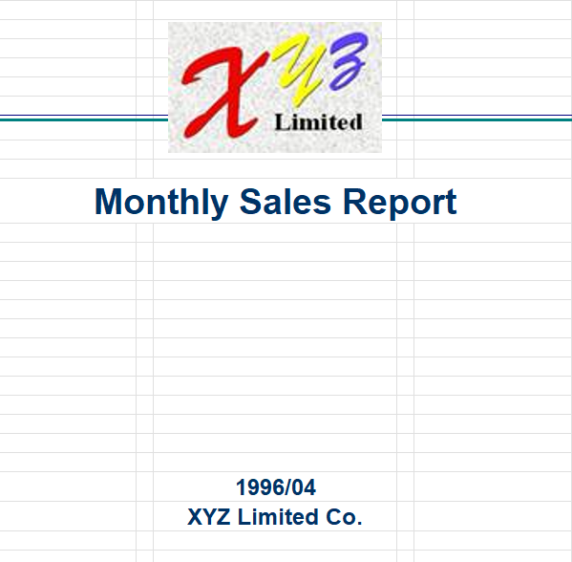

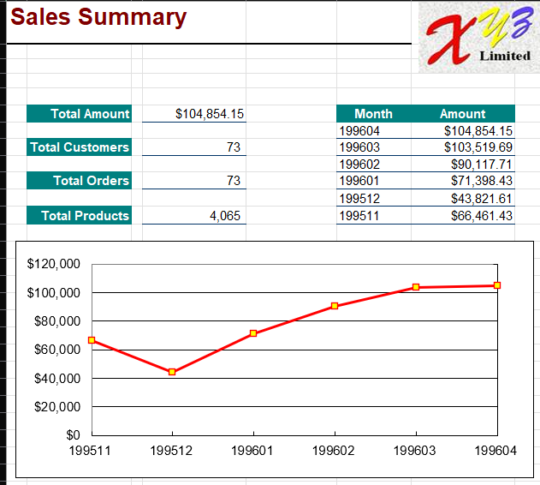

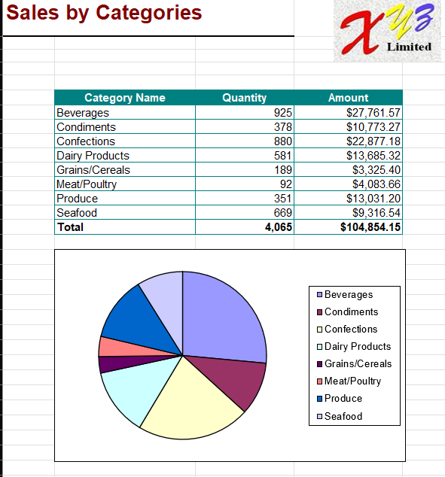

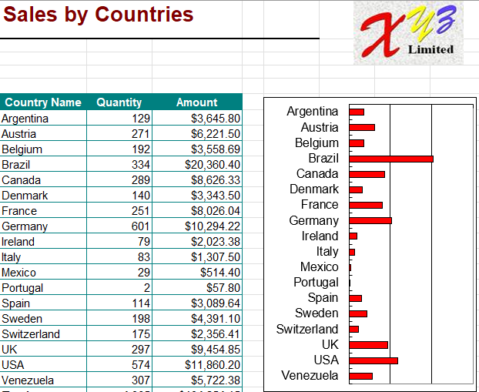

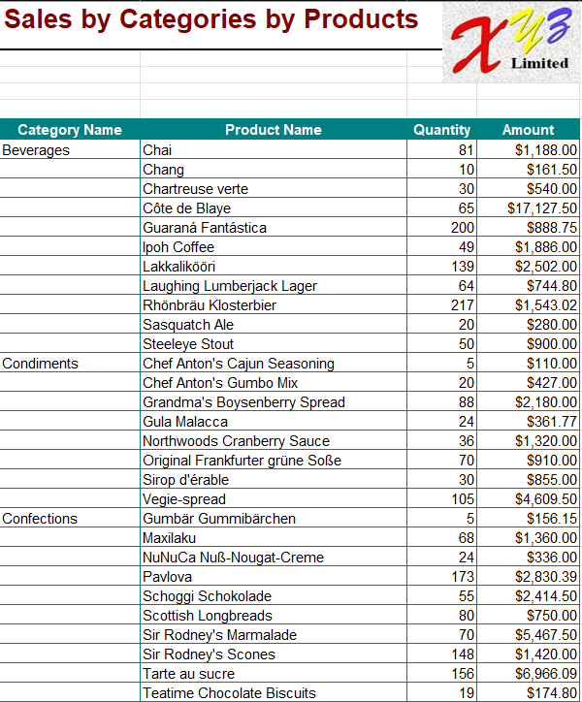

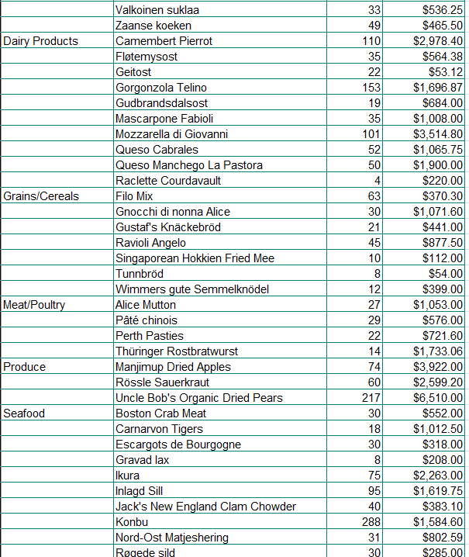



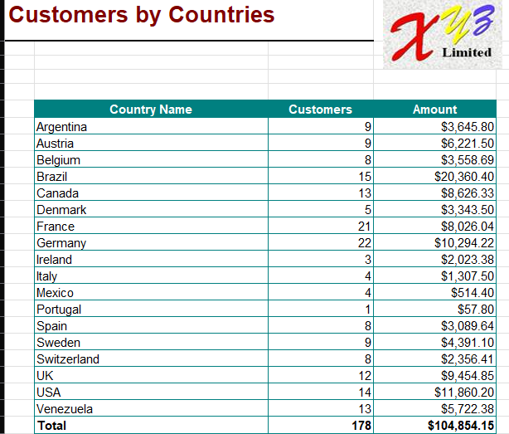

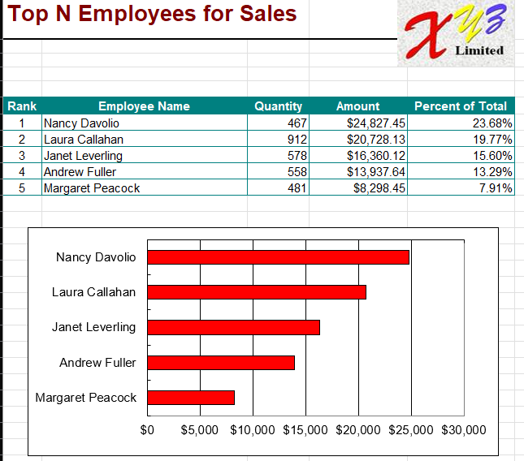

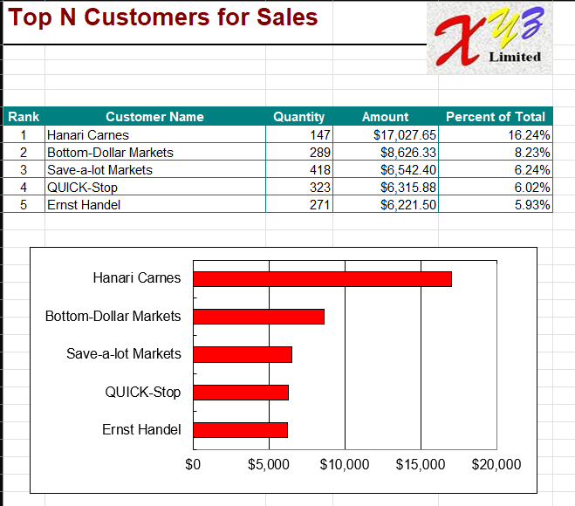

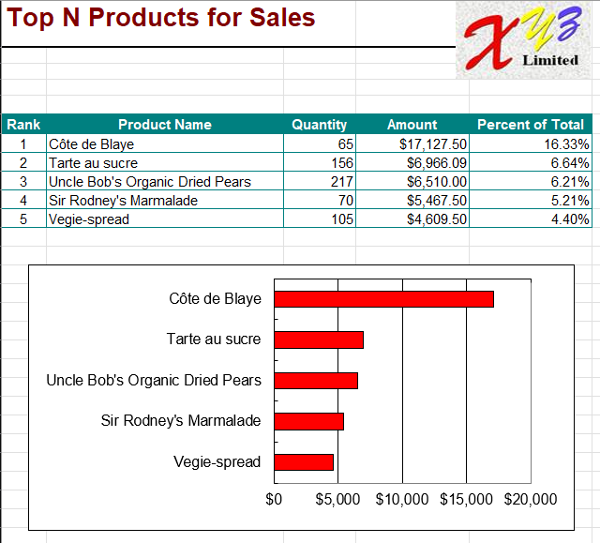

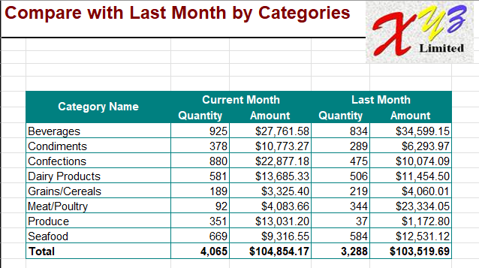

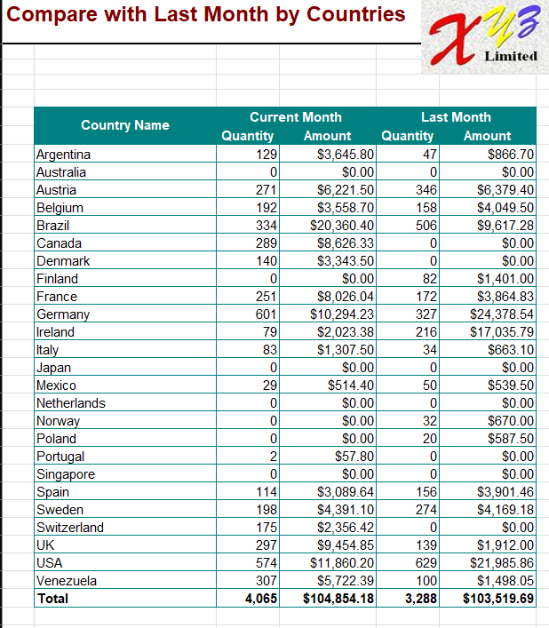

Product_catalog.xls

|  |  |  |  |  |  |
| --- | --- | --- | --- | --- | --- |
| **Product Catalog** |  |    |  | | --- | |  | |  |  |
|  |  |  |  |  |
|  |  |  |  |  |
|  |  |  |  |  |
| **Beverages** |  |  |  |  |
|    |  | | --- | |  | | Soft drinks, coffees, teas, beers, and ales | | |  |
|  |  |  |  |  |
| **Product Name** | **Product ID** | **Quantity Per Unit** | **Unit Price** |  |
| **Chai** | 1 | 10 boxes x 20 bags | $18.00 |  |
| **Chang** | 2 | 24 - 12 oz bottles | $19.00 |  |
| **Chartreuse verte** | 39 | 750 cc per bottle | $18.00 |  |
| **Côte de Blaye** | 38 | 12 - 75 cl bottles | $263.50 |  |
| **Guaraná Fantástica** | 24 | 12 - 355 ml cans | $4.50 |  |
| **Ipoh Coffee** | 43 | 16 - 500 g tins | $46.00 |  |
| **Lakkalikööri** | 76 | 500 ml | $18.00 |  |
| **Laughing Lumberjack Lager** | 67 | 24 - 12 oz bottles | $14.00 |  |
| **Outback Lager** | 70 | 24 - 355 ml bottles | $15.00 |  |
| **Rhönbräu Klosterbier** | 75 | 24 - 0.5 l bottles | $7.75 |  |
| **Sasquatch Ale** | 34 | 24 - 12 oz bottles | $14.00 |  |
| **Steeleye Stout** | 35 | 24 - 12 oz bottles | $18.00 |  |
|  |  |  |  |  |
| **Condiments** |  |  |  |  |
|    |  | | --- | |  | | Sweet and savory sauces, relishes, spreads, and seasonings | | |  |
|  |  |  |  |  |
| **Product Name** | **Product ID** | **Quantity Per Unit** | **Unit Price** |  |
| **Aniseed Syrup** | 3 | 12 - 550 ml bottles | $10.00 |  |
| **Chef Anton's Cajun Seasoning** | 4 | 48 - 6 oz jars | $22.00 |  |
| **Chef Anton's Gumbo Mix** | 5 | 36 boxes | $21.35 |  |
| **Genen Shouyu** | 15 | 24 - 250 ml bottles | $15.50 |  |
| **Grandma's Boysenberry Spread** | 6 | 12 - 8 oz jars | $25.00 |  |
| **Gula Malacca** | 44 | 20 - 2 kg bags | $19.45 |  |
| **Louisiana Fiery Hot Pepper Sauce** | 65 | 32 - 8 oz bottles | $21.05 |  |
| **Louisiana Hot Spiced Okra** | 66 | 24 - 8 oz jars | $17.00 |  |
| **Northwoods Cranberry Sauce** | 8 | 12 - 12 oz jars | $40.00 |  |
| **Original Frankfurter grüne Soße** | 77 | 12 boxes | $13.00 |  |
| **Sirop d'érable** | 61 | 24 - 500 ml bottles | $28.50 |  |
| **Vegie-spread** | 63 | 15 - 625 g jars | $43.90 |  |
|  |  |  |  |  |
| **Confections** |  |  |  |  |
|    |  | | --- | |  | | Desserts, candies, and sweet breads | | |  |
|  |  |  |  |  |
| **Product Name** | **Product ID** | **Quantity Per Unit** | **Unit Price** |  |
| **Chocolade** | 48 | 10 pkgs. | $12.75 |  |
| **Gumbär Gummibärchen** | 26 | 100 - 250 g bags | $31.23 |  |
| **Maxilaku** | 49 | 24 - 50 g pkgs. | $20.00 |  |
| **NuNuCa Nuß-Nougat-Creme** | 25 | 20 - 450 g glasses | $14.00 |  |
| **Pavlova** | 16 | 32 - 500 g boxes | $17.45 |  |
| **Schoggi Schokolade** | 27 | 100 - 100 g pieces | $43.90 |  |
| **Scottish Longbreads** | 68 | 10 boxes x 8 pieces | $12.50 |  |
| **Sir Rodney's Marmalade** | 20 | 30 gift boxes | $81.00 |  |
| **Sir Rodney's Scones** | 21 | 24 pkgs. x 4 pieces | $10.00 |  |
| **Tarte au sucre** | 62 | 48 pies | $49.30 |  |
| **Teatime Chocolate Biscuits** | 19 | 10 boxes x 12 pieces | $9.20 |  |
| **Valkoinen suklaa** | 50 | 12 - 100 g bars | $16.25 |  |
| **Zaanse koeken** | 47 | 10 - 4 oz boxes | $9.50 |  |
|  |  |  |  |  |
| **Dairy Products** |  |  |  |  |
|    |  | | --- | |  | | Cheeses | | |  |
|  |  |  |  |  |
| **Product Name** | **Product ID** | **Quantity Per Unit** | **Unit Price** |  |
| **Camembert Pierrot** | 60 | 15 - 300 g rounds | $34.00 |  |
| **Fløtemysost** | 71 | 10 - 500 g pkgs. | $21.50 |  |
| **Geitost** | 33 | 500 g | $2.50 |  |
| **Gorgonzola Telino** | 31 | 12 - 100 g pkgs | $12.50 |  |
| **Gudbrandsdalsost** | 69 | 10 kg pkg. | $36.00 |  |
| **Mascarpone Fabioli** | 32 | 24 - 200 g pkgs. | $32.00 |  |
| **Mozzarella di Giovanni** | 72 | 24 - 200 g pkgs. | $34.80 |  |
| **Queso Cabrales** | 11 | 1 kg pkg. | $21.00 |  |
| **Queso Manchego La Pastora** | 12 | 10 - 500 g pkgs. | $38.00 |  |
| **Raclette Courdavault** | 59 | 5 kg pkg. | $55.00 |  |
|  |  |  |  |  |
| **Grains/Cereals** |  |  |  |  |
|    |  | | --- | |  | | Breads, crackers, pasta, and cereal | | |  |
|  |  |  |  |  |
| **Product Name** | **Product ID** | **Quantity Per Unit** | **Unit Price** |  |
| **Filo Mix** | 52 | 16 - 2 kg boxes | $7.00 |  |
| **Gnocchi di nonna Alice** | 56 | 24 - 250 g pkgs. | $38.00 |  |
| **Gustaf's Knäckebröd** | 22 | 24 - 500 g pkgs. | $21.00 |  |
| **Ravioli Angelo** | 57 | 24 - 250 g pkgs. | $19.50 |  |
| **Singaporean Hokkien Fried Mee** | 42 | 32 - 1 kg pkgs. | $14.00 |  |
| **Tunnbröd** | 23 | 12 - 250 g pkgs. | $9.00 |  |
| **Wimmers gute Semmelknödel** | 64 | 20 bags x 4 pieces | $33.25 |  |
|  |  |  |  |  |
| **Meat/Poultry** |  |  |  |  |
|    |  | | --- | |  | | Prepared meats | | |  |
|  |  |  |  |  |
| **Product Name** | **Product ID** | **Quantity Per Unit** | **Unit Price** |  |
| **Alice Mutton** | 17 | 20 - 1 kg tins | $39.00 |  |
| **Mishi Kobe Niku** | 9 | 18 - 500 g pkgs. | $97.00 |  |
| **Pâté chinois** | 55 | 24 boxes x 2 pies | $24.00 |  |
| **Perth Pasties** | 53 | 48 pieces | $32.80 |  |
| **Thüringer Rostbratwurst** | 29 | 50 bags x 30 sausgs. | $123.79 |  |
| **Tourtière** | 54 | 16 pies | $7.45 |  |
|  |  |  |  |  |
| **Produce** |  |  |  |  |
|    |  | | --- | |  | | Dried fruit and bean curd | | |  |
|  |  |  |  |  |
| **Product Name** | **Product ID** | **Quantity Per Unit** | **Unit Price** |  |
| **Longlife Tofu** | 74 | 5 kg pkg. | $10.00 |  |
| **Manjimup Dried Apples** | 51 | 50 - 300 g pkgs. | $53.00 |  |
| **Rössle Sauerkraut** | 28 | 25 - 825 g cans | $45.60 |  |
| **Tofu** | 14 | 40 - 100 g pkgs. | $23.25 |  |
| **Uncle Bob's Organic Dried Pears** | 7 | 12 - 1 lb pkgs. | $30.00 |  |
|  |  |  |  |  |
| **Seafood** |  |  |  |  |
|    |  | | --- | |  | | Seaweed and fish | | |  |
|  |  |  |  |  |
| **Product Name** | **Product ID** | **Quantity Per Unit** | **Unit Price** |  |
| **Boston Crab Meat** | 40 | 24 - 4 oz tins | $18.40 |  |
| **Carnarvon Tigers** | 18 | 16 kg pkg. | $62.50 |  |
| **Escargots de Bourgogne** | 58 | 24 pieces | $13.25 |  |
| **Gravad lax** | 37 | 12 - 500 g pkgs. | $26.00 |  |
| **Ikura** | 10 | 12 - 200 ml jars | $31.00 |  |
| **Inlagd Sill** | 36 | 24 - 250 g jars | $19.00 |  |
| **Jack's New England Clam Chowder** | 41 | 12 - 12 oz cans | $9.65 |  |
| **Konbu** | 13 | 2 kg box | $6.00 |  |
| **Nord-Ost Matjeshering** | 30 | 10 - 200 g glasses | $25.89 |  |
| **Röd Kaviar** | 73 | 24 - 150 g jars | $15.00 |  |
| **Røgede sild** | 45 | 1k pkg. | $9.50 |  |
| **Spegesild** | 46 | 4 - 450 g glasses | $12.00 |  |
|  |  |  |  |  |

Sales_detail.xls

|  |  |  |  |  |  |  |  |  |
| --- | --- | --- | --- | --- | --- | --- | --- | --- |
| **Sales Detail** | | | |  |  | |  | | --- | |  | |  |
|  |  |  |  |  |  |  |  |
|  |  |  | From 1995-04-01 To 1995-04-30 |  |  |  |  |
|  |  |  |  |  |  |  |  |
|  |  | **Customer:** | **Bon app'** |  |  | **Total:** | **$1,820.80** |
|  |  | **City:** | **Marseille, France** |  | **Contact:** | **Laurence Lebihan** | |
|  |  |  |  |  |  |  |  |
|  | **Order Information** | | |  |  |  |  |
|  |  | **OrderID** | **Salespersion** | **Order Date** | **Req Date** | **Ship Date** | **Ship Via** |
|  |  | 10470 | Margaret Peacock | 11/04/1995 | 09/05/1995 | 14/04/1995 | United Package |
|  |  |  |  |  |  |  |  |
|  |  | **ProductID** | **Product Name** | **Quantity** | **Unit Price** | **Discount** | **Price** |
|  |  | 18 | Carnarvon Tigers | 30 | $50.00 | 0% | $1,500.00 |
|  |  | 23 | Tunnbröd | 15 | $7.20 | 0% | $108.00 |
|  |  | 64 | Wimmers gute Semmelknödel | 8 | $26.60 | 0% | $212.80 |
|  |  |  |  |  |  |  |  |
|  |  |  |  |  |  | **Subtotal:** | $1,820.80 |
|  |  |  |  |  |  |  |  |
|  |  |  |  |  |  |  |  |
|  |  | **Customer:** | **B's Beverages** |  |  | **Total:** | **$1,714.20** |
|  |  | **City:** | **London, UK** |  | **Contact:** | **Victoria Ashworth** | |
|  |  |  |  |  |  |  |  |
|  | **Order Information** | | |  |  |  |  |
|  |  | **OrderID** | **Salespersion** | **Order Date** | **Req Date** | **Ship Date** | **Ship Via** |
|  |  | 10471 | Andrew Fuller | 11/04/1995 | 09/05/1995 | 18/04/1995 | Federal Shipping |
|  |  |  |  |  |  |  |  |
|  |  | **ProductID** | **Product Name** | **Quantity** | **Unit Price** | **Discount** | **Price** |
|  |  | 7 | Uncle Bob's Organic Dried Pears | 30 | $24.00 | 0% | $720.00 |
|  |  | 56 | Gnocchi di nonna Alice | 20 | $30.40 | 0% | $608.00 |
|  |  |  |  |  |  |  |  |
|  |  |  |  |  |  | **Subtotal:** | $1,328.00 |
|  |  |  |  |  |  |  |  |
|  | **Order Information** | | |  |  |  |  |
|  |  | **OrderID** | **Salespersion** | **Order Date** | **Req Date** | **Ship Date** | **Ship Via** |
|  |  | 10484 | Janet Leverling | 24/04/1995 | 22/05/1995 | 02/05/1995 | Federal Shipping |
|  |  |  |  |  |  |  |  |
|  |  | **ProductID** | **Product Name** | **Quantity** | **Unit Price** | **Discount** | **Price** |
|  |  | 21 | Sir Rodney's Scones | 14 | $8.00 | 0% | $112.00 |
|  |  | 40 | Boston Crab Meat | 10 | $14.70 | 0% | $147.00 |
|  |  | 51 | Manjimup Dried Apples | 3 | $42.40 | 0% | $127.20 |
|  |  |  |  |  |  |  |  |
|  |  |  |  |  |  | **Subtotal:** | $386.20 |
|  |  |  |  |  |  |  |  |
|  |  |  |  |  |  |  |  |
|  |  | **Customer:** | **Comércio Mineiro** |  |  | **Total:** | **$216.00** |
|  |  | **City:** | **São Paulo, Brazil** |  | **Contact:** | **Pedro Afonso** | |
|  |  |  |  |  |  |  |  |
|  | **Order Information** | | |  |  |  |  |
|  |  | **OrderID** | **Salespersion** | **Order Date** | **Req Date** | **Ship Date** | **Ship Via** |
|  |  | 10466 | Margaret Peacock | 06/04/1995 | 04/05/1995 | 13/04/1995 | Speedy Express |
|  |  |  |  |  |  |  |  |
|  |  | **ProductID** | **Product Name** | **Quantity** | **Unit Price** | **Discount** | **Price** |
|  |  | 11 | Queso Cabrales | 10 | $16.80 | 0% | $168.00 |
|  |  | 46 | Spegesild | 5 | $9.60 | 0% | $48.00 |
|  |  |  |  |  |  |  |  |
|  |  |  |  |  |  | **Subtotal:** | $216.00 |
|  |  |  |  |  |  |  |  |
|  |  |  |  |  |  |  |  |
|  |  | **Customer:** | **Consolidated Holdings** |  |  | **Total:** | **$156.00** |
|  |  | **City:** | **London, UK** |  | **Contact:** | **Elizabeth Brown** | |
|  |  |  |  |  |  |  |  |
|  | **Order Information** | | |  |  |  |  |
|  |  | **OrderID** | **Salespersion** | **Order Date** | **Req Date** | **Ship Date** | **Ship Via** |
|  |  | 10462 | Andrew Fuller | 03/04/1995 | 01/05/1995 | 18/04/1995 | Speedy Express |
|  |  |  |  |  |  |  |  |
|  |  | **ProductID** | **Product Name** | **Quantity** | **Unit Price** | **Discount** | **Price** |
|  |  | 13 | Konbu | 1 | $4.80 | 0% | $4.80 |
|  |  | 23 | Tunnbröd | 21 | $7.20 | 0% | $151.20 |
|  |  |  |  |  |  |  |  |
|  |  |  |  |  |  | **Subtotal:** | $156.00 |
|  |  |  |  |  |  |  |  |
|  |  |  |  |  |  |  |  |
|  |  | **Customer:** | **Folies gourmandes** |  |  | **Total:** | **$756.00** |
|  |  | **City:** | **Lille, France** |  | **Contact:** | **Martine Rancé** | |
|  |  |  |  |  |  |  |  |
|  | **Order Information** | | |  |  |  |  |
|  |  | **OrderID** | **Salespersion** | **Order Date** | **Req Date** | **Ship Date** | **Ship Via** |
|  |  | 10480 | Michael Suyama | 20/04/1995 | 18/05/1995 | 24/04/1995 | United Package |
|  |  |  |  |  |  |  |  |
|  |  | **ProductID** | **Product Name** | **Quantity** | **Unit Price** | **Discount** | **Price** |
|  |  | 47 | Zaanse koeken | 30 | $7.60 | 0% | $228.00 |
|  |  | 59 | Raclette Courdavault | 12 | $44.00 | 0% | $528.00 |
|  |  |  |  |  |  |  |  |
|  |  |  |  |  |  | **Subtotal:** | $756.00 |
|  |  |  |  |  |  |  |  |
|  |  |  |  |  |  |  |  |
|  |  | **Customer:** | **Frankenversand** |  |  | **Total:** | **$1,512.00** |
|  |  | **City:** | **München, Germany** |  | **Contact:** | **Peter Franken** | |
|  |  |  |  |  |  |  |  |
|  | **Order Information** | | |  |  |  |  |
|  |  | **OrderID** | **Salespersion** | **Order Date** | **Req Date** | **Ship Date** | **Ship Via** |
|  |  | 10488 | Laura Callahan | 27/04/1995 | 25/05/1995 | 03/05/1995 | United Package |
|  |  |  |  |  |  |  |  |
|  |  | **ProductID** | **Product Name** | **Quantity** | **Unit Price** | **Discount** | **Price** |
|  |  | 59 | Raclette Courdavault | 30 | $44.00 | 0% | $1,320.00 |
|  |  | 73 | Röd Kaviar | 20 | $12.00 | 20% | $192.00 |
|  |  |  |  |  |  |  |  |
|  |  |  |  |  |  | **Subtotal:** | $1,512.00 |
|  |  |  |  |  |  |  |  |
|  |  |  |  |  |  |  |  |
|  |  | **Customer:** | **Furia Bacalhau e Frutos do Mar** | |  | **Total:** | **$1,609.28** |
|  |  | **City:** | **Lisboa, Portugal** |  | **Contact:** | **Lino Rodriguez** | |
|  |  |  |  |  |  |  |  |
|  | **Order Information** | | |  |  |  |  |
|  |  | **OrderID** | **Salespersion** | **Order Date** | **Req Date** | **Ship Date** | **Ship Via** |
|  |  | 10464 | Margaret Peacock | 04/04/1995 | 02/05/1995 | 14/04/1995 | United Package |
|  |  |  |  |  |  |  |  |
|  |  | **ProductID** | **Product Name** | **Quantity** | **Unit Price** | **Discount** | **Price** |
|  |  | 4 | Chef Anton's Cajun Seasoning | 16 | $17.60 | 20% | $225.28 |
|  |  | 43 | Ipoh Coffee | 3 | $36.80 | 0% | $110.40 |
|  |  | 56 | Gnocchi di nonna Alice | 30 | $30.40 | 20% | $729.60 |
|  |  | 60 | Camembert Pierrot | 20 | $27.20 | 0% | $544.00 |
|  |  |  |  |  |  |  |  |
|  |  |  |  |  |  | **Subtotal:** | $1,609.28 |
|  |  |  |  |  |  |  |  |
|  |  |  |  |  |  |  |  |
|  |  | **Customer:** | **HILARIÓN-Abastos** |  |  | **Total:** | **$1,452.48** |
|  |  | **City:** | **San Cristóbal, Venezuela** |  | **Contact:** | **Carlos Hernández** | |
|  |  |  |  |  |  |  |  |
|  | **Order Information** | | |  |  |  |  |
|  |  | **OrderID** | **Salespersion** | **Order Date** | **Req Date** | **Ship Date** | **Ship Via** |
|  |  | 10476 | Laura Callahan | 17/04/1995 | 15/05/1995 | 24/04/1995 | Federal Shipping |
|  |  |  |  |  |  |  |  |
|  |  | **ProductID** | **Product Name** | **Quantity** | **Unit Price** | **Discount** | **Price** |
|  |  | 55 | Pâté chinois | 2 | $19.20 | 5% | $36.48 |
|  |  | 70 | Outback Lager | 12 | $12.00 | 0% | $144.00 |
|  |  |  |  |  |  |  |  |
|  |  |  |  |  |  | **Subtotal:** | $180.48 |
|  |  |  |  |  |  |  |  |
|  | **Order Information** | | |  |  |  |  |
|  |  | **OrderID** | **Salespersion** | **Order Date** | **Req Date** | **Ship Date** | **Ship Via** |
|  |  | 10486 | Nancy Davolio | 26/04/1995 | 24/05/1995 | 03/05/1995 | United Package |
|  |  |  |  |  |  |  |  |
|  |  | **ProductID** | **Product Name** | **Quantity** | **Unit Price** | **Discount** | **Price** |
|  |  | 11 | Queso Cabrales | 5 | $16.80 | 0% | $84.00 |
|  |  | 51 | Manjimup Dried Apples | 25 | $42.40 | 0% | $1,060.00 |
|  |  | 74 | Longlife Tofu | 16 | $8.00 | 0% | $128.00 |
|  |  |  |  |  |  |  |  |
|  |  |  |  |  |  | **Subtotal:** | $1,272.00 |
|  |  |  |  |  |  |  |  |
|  |  |  |  |  |  |  |  |
|  |  | **Customer:** | **Island Trading** |  |  | **Total:** | **$230.40** |
|  |  | **City:** | **Cowes, UK** |  | **Contact:** | **Helen Bennett** | |
|  |  |  |  |  |  |  |  |
|  | **Order Information** | | |  |  |  |  |
|  |  | **OrderID** | **Salespersion** | **Order Date** | **Req Date** | **Ship Date** | **Ship Via** |
|  |  | 10473 | Nancy Davolio | 13/04/1995 | 27/04/1995 | 21/04/1995 | Federal Shipping |
|  |  |  |  |  |  |  |  |
|  |  | **ProductID** | **Product Name** | **Quantity** | **Unit Price** | **Discount** | **Price** |
|  |  | 33 | Geitost | 12 | $2.00 | 0% | $24.00 |
|  |  | 71 | Fløtemysost | 12 | $17.20 | 0% | $206.40 |
|  |  |  |  |  |  |  |  |
|  |  |  |  |  |  | **Subtotal:** | $230.40 |
|  |  |  |  |  |  |  |  |
|  |  |  |  |  |  |  |  |
|  |  | **Customer:** | **Königlich Essen** |  |  | **Total:** | **$717.60** |
|  |  | **City:** | **Brandenburg, Germany** |  | **Contact:** | **Philip Cramer** | |
|  |  |  |  |  |  |  |  |
|  | **Order Information** | | |  |  |  |  |
|  |  | **OrderID** | **Salespersion** | **Order Date** | **Req Date** | **Ship Date** | **Ship Via** |
|  |  | 10468 | Janet Leverling | 07/04/1995 | 05/05/1995 | 12/04/1995 | Federal Shipping |
|  |  |  |  |  |  |  |  |
|  |  | **ProductID** | **Product Name** | **Quantity** | **Unit Price** | **Discount** | **Price** |
|  |  | 30 | Nord-Ost Matjeshering | 8 | $20.70 | 0% | $165.60 |
|  |  | 43 | Ipoh Coffee | 15 | $36.80 | 0% | $552.00 |
|  |  |  |  |  |  |  |  |
|  |  |  |  |  |  | **Subtotal:** | $717.60 |
|  |  |  |  |  |  |  |  |
|  |  |  |  |  |  |  |  |
|  |  | **Customer:** | **Lazy K Kountry Store** |  |  | **Total:** | **$147.00** |
|  |  | **City:** | **Walla Walla, USA** |  | **Contact:** | **John Steel** | |
|  |  |  |  |  |  |  |  |
|  | **Order Information** | | |  |  |  |  |
|  |  | **OrderID** | **Salespersion** | **Order Date** | **Req Date** | **Ship Date** | **Ship Via** |
|  |  | 10482 | Nancy Davolio | 21/04/1995 | 19/05/1995 | 11/05/1995 | Federal Shipping |
|  |  |  |  |  |  |  |  |
|  |  | **ProductID** | **Product Name** | **Quantity** | **Unit Price** | **Discount** | **Price** |
|  |  | 40 | Boston Crab Meat | 10 | $14.70 | 0% | $147.00 |
|  |  |  |  |  |  |  |  |
|  |  |  |  |  |  | **Subtotal:** | $147.00 |
|  |  |  |  |  |  |  |  |
|  |  |  |  |  |  |  |  |
|  |  | **Customer:** | **LINO-Delicateses** |  |  | **Total:** | **$1,584.00** |
|  |  | **City:** | **I. de Margarita, Venezuela** |  | **Contact:** | **Felipe Izquierdo** | |
|  |  |  |  |  |  |  |  |
|  | **Order Information** | | |  |  |  |  |
|  |  | **OrderID** | **Salespersion** | **Order Date** | **Req Date** | **Ship Date** | **Ship Via** |
|  |  | 10485 | Margaret Peacock | 25/04/1995 | 09/05/1995 | 01/05/1995 | United Package |
|  |  |  |  |  |  |  |  |
|  |  | **ProductID** | **Product Name** | **Quantity** | **Unit Price** | **Discount** | **Price** |
|  |  | 2 | Chang | 20 | $15.20 | 10% | $273.60 |
|  |  | 3 | Aniseed Syrup | 20 | $8.00 | 10% | $144.00 |
|  |  | 55 | Pâté chinois | 30 | $19.20 | 10% | $518.40 |
|  |  | 70 | Outback Lager | 60 | $12.00 | 10% | $648.00 |
|  |  |  |  |  |  |  |  |
|  |  |  |  |  |  | **Subtotal:** | $1,584.00 |
|  |  |  |  |  |  |  |  |
|  |  |  |  |  |  |  |  |
|  |  | **Customer:** | **Magazzini Alimentari Riuniti** | |  | **Total:** | **$235.20** |
|  |  | **City:** | **Bergamo, Italy** |  | **Contact:** | **Giovanni Rovelli** | |
|  |  |  |  |  |  |  |  |
|  | **Order Information** | | |  |  |  |  |
|  |  | **OrderID** | **Salespersion** | **Order Date** | **Req Date** | **Ship Date** | **Ship Via** |
|  |  | 10467 | Laura Callahan | 06/04/1995 | 04/05/1995 | 11/04/1995 | United Package |
|  |  |  |  |  |  |  |  |
|  |  | **ProductID** | **Product Name** | **Quantity** | **Unit Price** | **Discount** | **Price** |
|  |  | 24 | Guaraná Fantástica | 28 | $3.60 | 0% | $100.80 |
|  |  | 25 | NuNuCa Nuß-Nougat-Creme | 12 | $11.20 | 0% | $134.40 |
|  |  |  |  |  |  |  |  |
|  |  |  |  |  |  | **Subtotal:** | $235.20 |
|  |  |  |  |  |  |  |  |
|  |  |  |  |  |  |  |  |
|  |  | **Customer:** | **Pericles Comidas clásicas** | |  | **Total:** | **$1,249.10** |
|  |  | **City:** | **México D.F., Mexico** |  | **Contact:** | **Guillermo Fernández** | |
|  |  |  |  |  |  |  |  |
|  | **Order Information** | | |  |  |  |  |
|  |  | **OrderID** | **Salespersion** | **Order Date** | **Req Date** | **Ship Date** | **Ship Via** |
|  |  | 10474 | Steven Buchanan | 13/04/1995 | 11/05/1995 | 21/04/1995 | United Package |
|  |  |  |  |  |  |  |  |
|  |  | **ProductID** | **Product Name** | **Quantity** | **Unit Price** | **Discount** | **Price** |
|  |  | 14 | Tofu | 12 | $18.60 | 0% | $223.20 |
|  |  | 28 | Rössle Sauerkraut | 18 | $36.40 | 0% | $655.20 |
|  |  | 40 | Boston Crab Meat | 21 | $14.70 | 0% | $308.70 |
|  |  | 75 | Rhönbräu Klosterbier | 10 | $6.20 | 0% | $62.00 |
|  |  |  |  |  |  |  |  |
|  |  |  |  |  |  | **Subtotal:** | $1,249.10 |
|  |  |  |  |  |  |  |  |
|  |  |  |  |  |  |  |  |
|  |  | **Customer:** | **Piccolo und mehr** |  |  | **Total:** | **$439.20** |
|  |  | **City:** | **Salzburg, Austria** |  | **Contact:** | **Georg Pipps** | |
|  |  |  |  |  |  |  |  |
|  | **Order Information** | | |  |  |  |  |
|  |  | **OrderID** | **Salespersion** | **Order Date** | **Req Date** | **Ship Date** | **Ship Via** |
|  |  | 10489 | Michael Suyama | 28/04/1995 | 26/05/1995 | 10/05/1995 | United Package |
|  |  |  |  |  |  |  |  |
|  |  | **ProductID** | **Product Name** | **Quantity** | **Unit Price** | **Discount** | **Price** |
|  |  | 11 | Queso Cabrales | 15 | $16.80 | 25% | $189.00 |
|  |  | 16 | Pavlova | 18 | $13.90 | 0% | $250.20 |
|  |  |  |  |  |  |  |  |
|  |  |  |  |  |  | **Subtotal:** | $439.20 |
|  |  |  |  |  |  |  |  |
|  |  |  |  |  |  |  |  |
|  |  | **Customer:** | **Princesa Isabel Vinhos** |  |  | **Total:** | **$558.00** |
|  |  | **City:** | **Lisboa, Portugal** |  | **Contact:** | **Isabel de Castro** | |
|  |  |  |  |  |  |  |  |
|  | **Order Information** | | |  |  |  |  |
|  |  | **OrderID** | **Salespersion** | **Order Date** | **Req Date** | **Ship Date** | **Ship Via** |
|  |  | 10477 | Steven Buchanan | 17/04/1995 | 15/05/1995 | 25/04/1995 | United Package |
|  |  |  |  |  |  |  |  |
|  |  | **ProductID** | **Product Name** | **Quantity** | **Unit Price** | **Discount** | **Price** |
|  |  | 1 | Chai | 15 | $14.40 | 0% | $216.00 |
|  |  | 21 | Sir Rodney's Scones | 21 | $8.00 | 25% | $126.00 |
|  |  | 39 | Chartreuse verte | 20 | $14.40 | 25% | $216.00 |
|  |  |  |  |  |  |  |  |
|  |  |  |  |  |  | **Subtotal:** | $558.00 |
|  |  |  |  |  |  |  |  |
|  |  |  |  |  |  |  |  |
|  |  | **Customer:** | **Queen Cozinha** |  |  | **Total:** | **$889.70** |
|  |  | **City:** | **São Paulo, Brazil** |  | **Contact:** | **Lúcia Carvalho** | |
|  |  |  |  |  |  |  |  |
|  | **Order Information** | | |  |  |  |  |
|  |  | **OrderID** | **Salespersion** | **Order Date** | **Req Date** | **Ship Date** | **Ship Via** |
|  |  | 10487 | Andrew Fuller | 26/04/1995 | 24/05/1995 | 28/04/1995 | United Package |
|  |  |  |  |  |  |  |  |
|  |  | **ProductID** | **Product Name** | **Quantity** | **Unit Price** | **Discount** | **Price** |
|  |  | 19 | Teatime Chocolate Biscuits | 5 | $7.30 | 0% | $36.50 |
|  |  | 26 | Gumbär Gummibärchen | 30 | $24.90 | 0% | $747.00 |
|  |  | 54 | Tourtière | 24 | $5.90 | 25% | $106.20 |
|  |  |  |  |  |  |  |  |
|  |  |  |  |  |  | **Subtotal:** | $889.70 |
|  |  |  |  |  |  |  |  |
|  |  |  |  |  |  |  |  |
|  |  | **Customer:** | **Rattlesnake Canyon Grocery** | |  | **Total:** | **$10,495.60** |
|  |  | **City:** | **Albuquerque, USA** |  | **Contact:** | **Paula Wilson** | |
|  |  |  |  |  |  |  |  |
|  | **Order Information** | | |  |  |  |  |
|  |  | **OrderID** | **Salespersion** | **Order Date** | **Req Date** | **Ship Date** | **Ship Via** |
|  |  | 10479 | Janet Leverling | 19/04/1995 | 17/05/1995 | 21/04/1995 | Federal Shipping |
|  |  |  |  |  |  |  |  |
|  |  | **ProductID** | **Product Name** | **Quantity** | **Unit Price** | **Discount** | **Price** |
|  |  | 38 | Côte de Blaye | 30 | $210.80 | 0% | $6,324.00 |
|  |  | 53 | Perth Pasties | 28 | $26.20 | 0% | $733.60 |
|  |  | 59 | Raclette Courdavault | 60 | $44.00 | 0% | $2,640.00 |
|  |  | 64 | Wimmers gute Semmelknödel | 30 | $26.60 | 0% | $798.00 |
|  |  |  |  |  |  |  |  |
|  |  |  |  |  |  | **Subtotal:** | $10,495.60 |
|  |  |  |  |  |  |  |  |
|  |  |  |  |  |  |  |  |
|  |  | **Customer:** | **Ricardo Adocicados** |  |  | **Total:** | **$1,472.00** |
|  |  | **City:** | **Rio de Janeiro, Brazil** |  | **Contact:** | **Janete Limeira** | |
|  |  |  |  |  |  |  |  |
|  | **Order Information** | | |  |  |  |  |
|  |  | **OrderID** | **Salespersion** | **Order Date** | **Req Date** | **Ship Date** | **Ship Via** |
|  |  | 10481 | Laura Callahan | 20/04/1995 | 18/05/1995 | 25/04/1995 | United Package |
|  |  |  |  |  |  |  |  |
|  |  | **ProductID** | **Product Name** | **Quantity** | **Unit Price** | **Discount** | **Price** |
|  |  | 49 | Maxilaku | 24 | $16.00 | 0% | $384.00 |
|  |  | 60 | Camembert Pierrot | 40 | $27.20 | 0% | $1,088.00 |
|  |  |  |  |  |  |  |  |
|  |  |  |  |  |  | **Subtotal:** | $1,472.00 |
|  |  |  |  |  |  |  |  |
|  |  |  |  |  |  |  |  |
|  |  | **Customer:** | **Seven Seas Imports** |  |  | **Total:** | **$1,036.80** |
|  |  | **City:** | **London, UK** |  | **Contact:** | **Hari Kumar** | |
|  |  |  |  |  |  |  |  |
|  | **Order Information** | | |  |  |  |  |
|  |  | **OrderID** | **Salespersion** | **Order Date** | **Req Date** | **Ship Date** | **Ship Via** |
|  |  | 10472 | Laura Callahan | 12/04/1995 | 10/05/1995 | 19/04/1995 | Speedy Express |
|  |  |  |  |  |  |  |  |
|  |  | **ProductID** | **Product Name** | **Quantity** | **Unit Price** | **Discount** | **Price** |
|  |  | 24 | Guaraná Fantástica | 80 | $3.60 | 5% | $273.60 |
|  |  | 51 | Manjimup Dried Apples | 18 | $42.40 | 0% | $763.20 |
|  |  |  |  |  |  |  |  |
|  |  |  |  |  |  | **Subtotal:** | $1,036.80 |
|  |  |  |  |  |  |  |  |
|  |  |  |  |  |  |  |  |
|  |  | **Customer:** | **Suprêmes délices** |  |  | **Total:** | **$2,218.48** |
|  |  | **City:** | **Charleroi, Belgium** |  | **Contact:** | **Pascale Cartrain** | |
|  |  |  |  |  |  |  |  |
|  | **Order Information** | | |  |  |  |  |
|  |  | **OrderID** | **Salespersion** | **Order Date** | **Req Date** | **Ship Date** | **Ship Via** |
|  |  | 10463 | Steven Buchanan | 04/04/1995 | 02/05/1995 | 06/04/1995 | Federal Shipping |
|  |  |  |  |  |  |  |  |
|  |  | **ProductID** | **Product Name** | **Quantity** | **Unit Price** | **Discount** | **Price** |
|  |  | 19 | Teatime Chocolate Biscuits | 21 | $7.30 | 0% | $153.30 |
|  |  | 42 | Singaporean Hokkien Fried Mee | 50 | $11.20 | 0% | $560.00 |
|  |  |  |  |  |  |  |  |
|  |  |  |  |  |  | **Subtotal:** | $713.30 |
|  |  |  |  |  |  |  |  |
|  | **Order Information** | | |  |  |  |  |
|  |  | **OrderID** | **Salespersion** | **Order Date** | **Req Date** | **Ship Date** | **Ship Via** |
|  |  | 10475 | Anne Dodsworth | 14/04/1995 | 12/05/1995 | 05/05/1995 | Speedy Express |
|  |  |  |  |  |  |  |  |
|  |  | **ProductID** | **Product Name** | **Quantity** | **Unit Price** | **Discount** | **Price** |
|  |  | 31 | Gorgonzola Telino | 35 | $10.00 | 15% | $297.50 |
|  |  | 66 | Louisiana Hot Spiced Okra | 60 | $13.60 | 15% | $693.60 |
|  |  | 76 | Lakkalikööri | 42 | $14.40 | 15% | $514.08 |
|  |  |  |  |  |  |  |  |
|  |  |  |  |  |  | **Subtotal:** | $1,505.18 |
|  |  |  |  |  |  |  |  |
|  |  |  |  |  |  |  |  |
|  |  | **Customer:** | **Vaffeljernet** |  |  | **Total:** | **$2,518.00** |
|  |  | **City:** | **Århus, Denmark** |  | **Contact:** | **Palle Ibsen** | |
|  |  |  |  |  |  |  |  |
|  | **Order Information** | | |  |  |  |  |
|  |  | **OrderID** | **Salespersion** | **Order Date** | **Req Date** | **Ship Date** | **Ship Via** |
|  |  | 10465 | Nancy Davolio | 05/04/1995 | 03/05/1995 | 14/04/1995 | Federal Shipping |
|  |  |  |  |  |  |  |  |
|  |  | **ProductID** | **Product Name** | **Quantity** | **Unit Price** | **Discount** | **Price** |
|  |  | 24 | Guaraná Fantástica | 25 | $3.60 | 0% | $90.00 |
|  |  | 29 | Thüringer Rostbratwurst | 18 | $99.00 | 10% | $1,603.80 |
|  |  | 40 | Boston Crab Meat | 20 | $14.70 | 0% | $294.00 |
|  |  | 45 | Røgede sild | 30 | $7.60 | 10% | $205.20 |
|  |  | 50 | Valkoinen suklaa | 25 | $13.00 | 0% | $325.00 |
|  |  |  |  |  |  |  |  |
|  |  |  |  |  |  | **Subtotal:** | $2,518.00 |
|  |  |  |  |  |  |  |  |
|  |  |  |  |  |  |  |  |
|  |  | **Customer:** | **Victuailles en stock** |  |  | **Total:** | **$471.20** |
|  |  | **City:** | **Lyon, France** |  | **Contact:** | **Mary Saveley** | |
|  |  |  |  |  |  |  |  |
|  | **Order Information** | | |  |  |  |  |
|  |  | **OrderID** | **Salespersion** | **Order Date** | **Req Date** | **Ship Date** | **Ship Via** |
|  |  | 10478 | Andrew Fuller | 18/04/1995 | 02/05/1995 | 26/04/1995 | Federal Shipping |
|  |  |  |  |  |  |  |  |
|  |  | **ProductID** | **Product Name** | **Quantity** | **Unit Price** | **Discount** | **Price** |
|  |  | 10 | Ikura | 20 | $24.80 | 5% | $471.20 |
|  |  |  |  |  |  |  |  |
|  |  |  |  |  |  | **Subtotal:** | $471.20 |
|  |  |  |  |  |  |  |  |
|  |  |  |  |  |  |  |  |
|  |  | **Customer:** | **White Clover Markets** |  |  | **Total:** | **$1,625.47** |
|  |  | **City:** | **Seattle, USA** |  | **Contact:** | **Karl Jablonski** | |
|  |  |  |  |  |  |  |  |
|  | **Order Information** | | |  |  |  |  |
|  |  | **OrderID** | **Salespersion** | **Order Date** | **Req Date** | **Ship Date** | **Ship Via** |
|  |  | 10469 | Nancy Davolio | 10/04/1995 | 08/05/1995 | 14/04/1995 | Speedy Express |
|  |  |  |  |  |  |  |  |
|  |  | **ProductID** | **Product Name** | **Quantity** | **Unit Price** | **Discount** | **Price** |
|  |  | 2 | Chang | 40 | $15.20 | 15% | $516.80 |
|  |  | 16 | Pavlova | 35 | $13.90 | 15% | $413.52 |
|  |  | 44 | Gula Malacca | 2 | $15.50 | 15% | $26.35 |
|  |  |  |  |  |  |  |  |
|  |  |  |  |  |  | **Subtotal:** | $956.67 |
|  |  |  |  |  |  |  |  |
|  | **Order Information** | | |  |  |  |  |
|  |  | **OrderID** | **Salespersion** | **Order Date** | **Req Date** | **Ship Date** | **Ship Via** |
|  |  | 10483 | Robert King | 24/04/1995 | 22/05/1995 | 26/05/1995 | United Package |
|  |  |  |  |  |  |  |  |
|  |  | **ProductID** | **Product Name** | **Quantity** | **Unit Price** | **Discount** | **Price** |
|  |  | 34 | Sasquatch Ale | 35 | $11.20 | 5% | $372.40 |
|  |  | 77 | Original Frankfurter grüne Soße | 30 | $10.40 | 5% | $296.40 |
|  |  |  |  |  |  |  |  |
|  |  |  |  |  |  | **Subtotal:** | $668.80 |

## Appendix C – Spider Scan Output

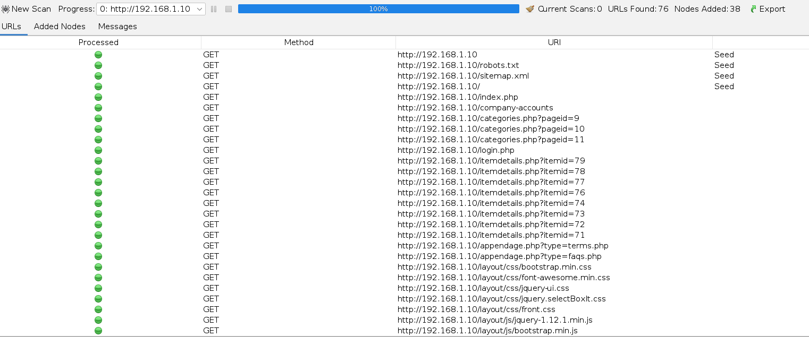

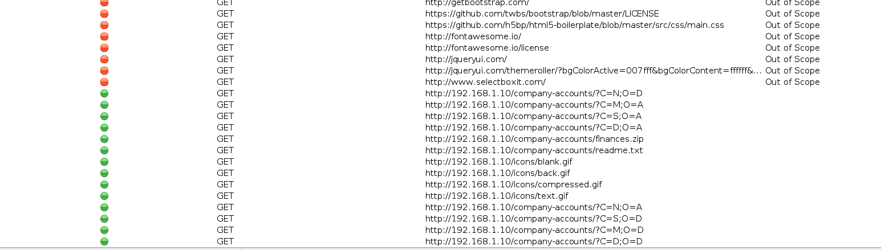

## Appendix D – Dirb Scan Outputs

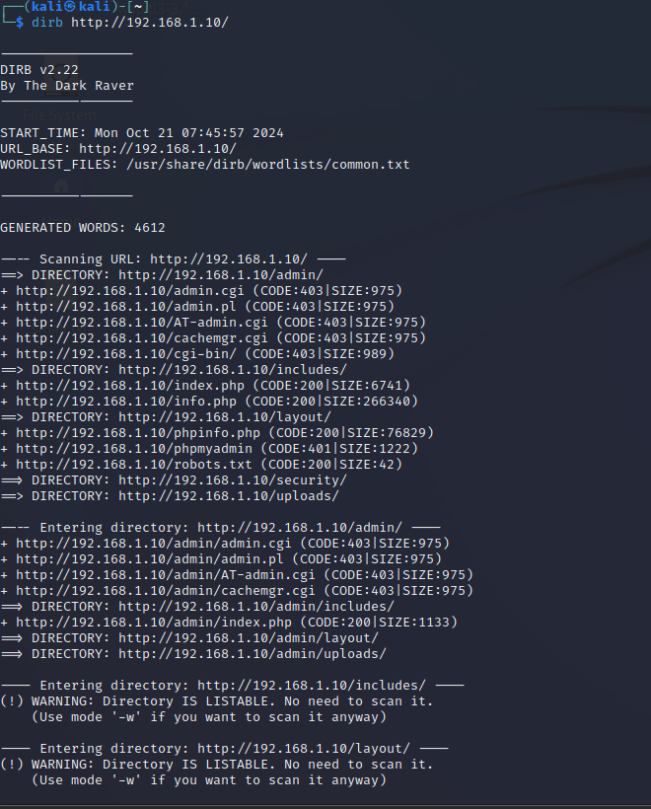

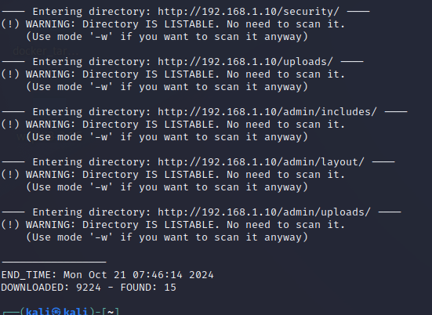

## Appendix E – Nikto Scan Outputs



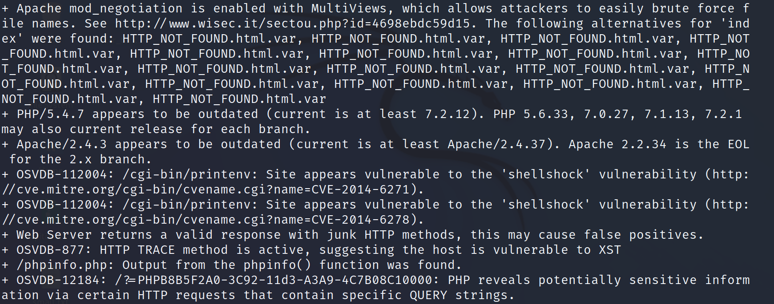

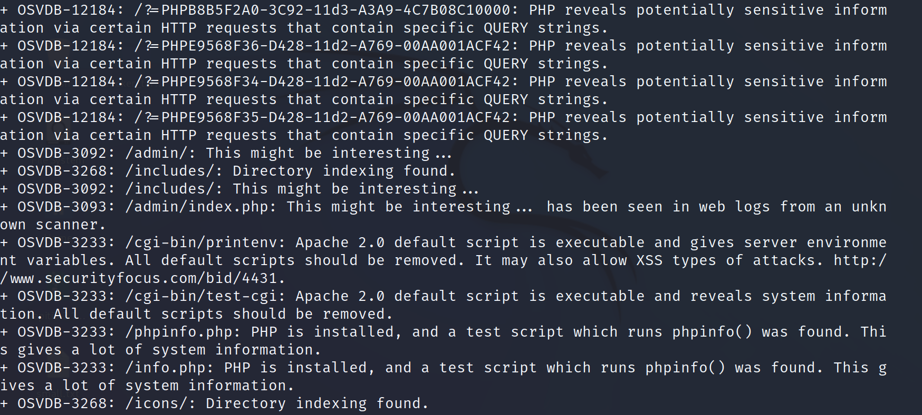

## Appendix F – OWASP Zap Scan Report

ZAP Scanning Report

Generated with The ZAP logoZAP on Sat 23 Nov 2024, at 19:19:52

Contents

About this report

Report parameters

Summaries

Alert counts by risk and confidence

Alert counts by site and risk

Alert counts by alert type

Alerts

Risk=Medium, Confidence=High (1)

Risk=Medium, Confidence=Medium (4)

Risk=Medium, Confidence=Low (1)

Risk=Low, Confidence=Medium (4)

Risk=Low, Confidence=Low (1)

Risk=Informational, Confidence=Medium (1)

Risk=Informational, Confidence=Low (1)

Appendix

Alert types

About this report

Report parameters

Contexts

No contexts were selected, so all contexts were included by default.

Sites

The following sites were included:

http://192.168.1.10

(If no sites were selected, all sites were included by default.)

An included site must also be within one of the included contexts for its data to be included in the report.

Risk levels

Included: High, Medium, Low, Informational

Excluded: None

Confidence levels

Included: User Confirmed, High, Medium, Low

Excluded: User Confirmed, High, Medium, Low, False Positive

Summaries

Alert counts by risk and confidence

This table shows the number of alerts for each level of risk and confidence included in the report.

(The percentages in brackets represent the count as a percentage of the total number of alerts included in the report, rounded to one decimal place.)

Confidence

User Confirmed High Medium Low Total

Risk High 0

(0.0%) 0

(0.0%) 0

(0.0%) 0

(0.0%) 0

(0.0%)

Medium 0

(0.0%) 1

(7.7%) 4

(30.8%) 1

(7.7%) 6

(46.2%)

Low 0

(0.0%) 0

(0.0%) 4

(30.8%) 1

(7.7%) 5

(38.5%)

Informational 0

(0.0%) 0

(0.0%) 1

(7.7%) 1

(7.7%) 2

(15.4%)

Total 0

(0.0%) 1

(7.7%) 9

(69.2%) 3

(23.1%) 13

(100%)

Alert counts by site and risk

This table shows, for each site for which one or more alerts were raised, the number of alerts raised at each risk level.

Alerts with a confidence level of "False Positive" have been excluded from these counts.

(The numbers in brackets are the number of alerts raised for the site at or above that risk level.)

Risk

High

(= High) Medium

(>= Medium) Low

(>= Low) Informational

(>= Informational)

Site http://192.168.1.10 0

(0) 6

(6) 5

(11) 2

(13)

Alert counts by alert type

This table shows the number of alerts of each alert type, together with the alert type's risk level.

(The percentages in brackets represent each count as a percentage, rounded to one decimal place, of the total number of alerts included in this report.)

Alert type Risk Count

Absence of Anti-CSRF Tokens Medium 4

(30.8%)

Application Error Disclosure Medium 81

(623.1%)

Content Security Policy (CSP) Header Not Set Medium 105

(807.7%)

Directory Browsing Medium 4

(30.8%)

Missing Anti-clickjacking Header Medium 104

(800.0%)

Vulnerable JS Library Medium 3

(23.1%)

Cookie No HttpOnly Flag Low 1

(7.7%)

Cookie without SameSite Attribute Low 1

(7.7%)

Server Leaks Information via "X-Powered-By" HTTP Response Header Field(s) Low 31

(238.5%)

Timestamp Disclosure - Unix Low 6

(46.2%)

X-Content-Type-Options Header Missing Low 163

(1,253.8%)

Content-Type Header Missing Informational 11

(84.6%)

Information Disclosure - Suspicious Comments Informational 7

(53.8%)

Total 13

Alerts

Risk=Medium, Confidence=High (1)

http://192.168.1.10 (1)

Content Security Policy (CSP) Header Not Set (1)

GET http://192.168.1.10/

Risk=Medium, Confidence=Medium (4)

http://192.168.1.10 (4)

Application Error Disclosure (1)

GET http://192.168.1.10/layout/

Directory Browsing (1)

GET http://192.168.1.10/layout/

Missing Anti-clickjacking Header (1)

GET http://192.168.1.10/

Vulnerable JS Library (1)

GET http://192.168.1.10/layout/js/jquery-ui.min.js

Risk=Medium, Confidence=Low (1)

http://192.168.1.10 (1)

Absence of Anti-CSRF Tokens (1)

GET http://192.168.1.10/login.php

Risk=Low, Confidence=Medium (4)

http://192.168.1.10 (4)

Cookie No HttpOnly Flag (1)

GET http://192.168.1.10

Cookie without SameSite Attribute (1)

GET http://192.168.1.10

Server Leaks Information via "X-Powered-By" HTTP Response Header Field(s) (1)

GET http://192.168.1.10/

X-Content-Type-Options Header Missing (1)

GET http://192.168.1.10/

Risk=Low, Confidence=Low (1)

http://192.168.1.10 (1)

Timestamp Disclosure - Unix (1)

GET http://192.168.1.10/layout/js/jquery-ui.min.js

Risk=Informational, Confidence=Medium (1)

http://192.168.1.10 (1)

Content-Type Header Missing (1)

GET http://192.168.1.10/layout/fonts/FontAwesome.otf

Risk=Informational, Confidence=Low (1)

http://192.168.1.10 (1)

Information Disclosure - Suspicious Comments (1)

GET http://192.168.1.10/layout/js/jquery-ui.min.js

Appendix

Alert types

This section contains additional information on the types of alerts in the report.

Absence of Anti-CSRF Tokens

Source raised by a passive scanner (Absence of Anti-CSRF Tokens)

CWE ID 352

WASC ID 9

Reference

http://projects.webappsec.org/Cross-Site-Request-Forgery

http://cwe.mitre.org/data/definitions/352.html

Application Error Disclosure

Source raised by a passive scanner (Application Error Disclosure)

CWE ID 200

WASC ID 13

Content Security Policy (CSP) Header Not Set

Source raised by a passive scanner (Content Security Policy (CSP) Header Not Set)

CWE ID 693

WASC ID 15

Reference

https://developer.mozilla.org/en-US/docs/Web/Security/CSP/Introducing_Content_Security_Policy

https://cheatsheetseries.owasp.org/cheatsheets/Content_Security_Policy_Cheat_Sheet.html

http://www.w3.org/TR/CSP/

http://w3c.github.io/webappsec/specs/content-security-policy/csp-specification.dev.html

http://www.html5rocks.com/en/tutorials/security/content-security-policy/

http://caniuse.com/#feat=contentsecuritypolicy

http://content-security-policy.com/

Directory Browsing

Source raised by an active scanner (Directory Browsing)

CWE ID 548

WASC ID 48

Reference

http://httpd.apache.org/docs/mod/core.html#options

http://alamo.satlug.org/pipermail/satlug/2002-February/000053.html

Missing Anti-clickjacking Header

Source raised by a passive scanner (Anti-clickjacking Header)

CWE ID 1021

WASC ID 15

Reference

https://developer.mozilla.org/en-US/docs/Web/HTTP/Headers/X-Frame-Options

Vulnerable JS Library

Source raised by a passive scanner (Vulnerable JS Library (Powered by Retire.js))

CWE ID 829

Reference

https://bugs.jqueryui.com/ticket/15284

https://github.com/jquery/jquery-ui/security/advisories/GHSA-gpqq-952q-5327

https://nvd.nist.gov/vuln/detail/CVE-2021-41184

https://nvd.nist.gov/vuln/detail/CVE-2021-41183

https://github.com/jquery/jquery-ui/security/advisories/GHSA-9gj3-hwp5-pmwc

https://nvd.nist.gov/vuln/detail/CVE-2021-41182

Cookie No HttpOnly Flag

Source raised by a passive scanner (Cookie No HttpOnly Flag)

CWE ID 1004

WASC ID 13

Reference

https://owasp.org/www-community/HttpOnly

Cookie without SameSite Attribute

Source raised by a passive scanner (Cookie without SameSite Attribute)

CWE ID 1275

WASC ID 13

Reference

https://tools.ietf.org/html/draft-ietf-httpbis-cookie-same-site

Server Leaks Information via "X-Powered-By" HTTP Response Header Field(s)

Source raised by a passive scanner (Server Leaks Information via "X-Powered-By" HTTP Response Header Field(s))

CWE ID 200

WASC ID 13

Reference

http://blogs.msdn.com/b/varunm/archive/2013/04/23/remove-unwanted-http-response-headers.aspx

http://www.troyhunt.com/2012/02/shhh-dont-let-your-response-headers.html

Timestamp Disclosure - Unix

Source raised by a passive scanner (Timestamp Disclosure)

CWE ID 200

WASC ID 13

Reference

http://projects.webappsec.org/w/page/13246936/Information%20Leakage

X-Content-Type-Options Header Missing

Source raised by a passive scanner (X-Content-Type-Options Header Missing)

CWE ID 693

WASC ID 15

Reference

http://msdn.microsoft.com/en-us/library/ie/gg622941%28v=vs.85%29.aspx

https://owasp.org/www-community/Security_Headers

Content-Type Header Missing

Source raised by a passive scanner (Content-Type Header Missing)

CWE ID 345

WASC ID 12

Reference

http://msdn.microsoft.com/en-us/library/ie/gg622941%28v=vs.85%29.aspx

Information Disclosure - Suspicious Comments

Source raised by a passive scanner (Information Disclosure - Suspicious Comments)

CWE ID 200

WASC ID 13